Student Guide
A step by step guide to completing a science fair project

Table of Contents

Part 1: Log Book Setup…..……………….…………..3
Part 2: Topic Selection……..…………………...…….4
Part 3: Research……………………………………….8
Part 4: Hypothesis…..………………………………...9
Part 5: Purpose.……………………………………….10
Part 6: Planning your Experiment….……………........11
Part 7: Conduct your Experiment……………………..12
Part 8: Data Collection…………………………….......13
Part 9: Data Analysis…..………………………….......13
Part 10: Results………………………………………..15
Part 11: Conclusion ………………………………………15
Part 12: Reflection/Future Study………….……….….16
Part 13: Abstract………………………………….…...16
Appendix A: Log Book Guide……………………......17
Appendix B: Triboard Guide……………………..…...19
Appendix C: Triboard Examples.………………….….20
Appendix D: Sample Graphs and Tables...……………21
Appendix E: Sites for Project Ideas……..……….……23

Georgia Science and Engineering Fair Official Site for Rules and Forms

Part 1: Log Book Setup
Before you begin, you should start a log book or project notebook. Your log book should contain accurate and detailed notes of EVERYTHING you do for your research project, even if you do not think it is important. Good notes will show you are consistent and thorough. It will also help you when you create your TRIBOARD or DISPLAY. Remember, your log book is a day-by-day account of your project activity. Another person should be able to read your log book and follow the same procedures. It is the most important tool while doing your experiment.

Setting up your logbook correctly will help ensure a complete project. Here are some guidelines:
- A log book is a notebook that must be bound with stitching or glue so that the pages are not removable. Never remove pages!
- Label the outside cover with the project question or title, your name, and your school.
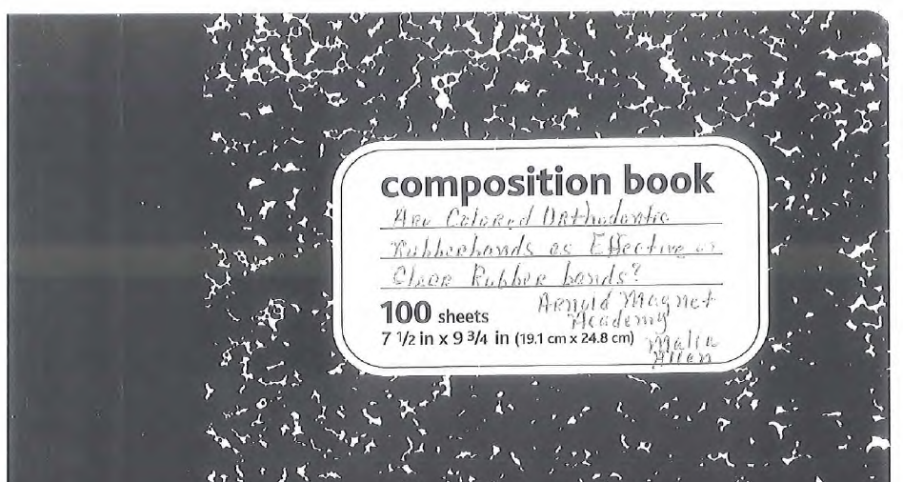

- Leave the first 2 pages blank. These will be used later for your table of contents.
- Write down everything that you do related to your project. Give as much detail as possible. Include notes on readings and bibliographic information. Each entry should include the DATE, TIME, and PAGE NUMBER.

Monday, 10/1/12
4:31 pm
Started looking for science fair topics. Visited www.sciencebuddies.org. Did not find a topic yet. Will continue looking tomorrow.

- Do not write on the back of any page. Use blue or black ink only. Do not use pencil or printouts from a computer (except graphs and charts in the data analysis section).
- Do not try to make your log book look perfect. It should be readable but no erasing allowed. Draw a single line through any mistakes you make and initial the change. Never remove pages from your log book.

Part 2: Topic Selection
Remember to record EVERYTHING you do in your log book! Include dates!
Columbus Regional Science Fair is affiliated with the Georgia Science and Engineering Fair (GSEF). All projects must follow state guidelines and rules. Before beginning any project you must contact your school science fair coordinator to help guide you with state rules and specific dates. You must have the appropriate forms and paperwork or you will be disqualified from participating in the Columbus Regional Science and Engineering Fair.
Your first step for the Science & Engineering Fair is to pick your topic. Ideas can come from hobbies, interests, problems needing solutions, etc. Many ideas are available through books and websites, but the BEST ideas come from your own head. Explore the areas of your interest. Look for questions within that area that might be worth exploring.
Along with interest, you should also choose a topic that can benefit your community or society in general. Look around your community and try to find something that you can discover, study, design, create or improve that will solve a troublesome problem. Why not choose a topic that will allow you to contribute to society and to make a difference?
Don't be afraid to try something even though it might not work. Let your imagination run wild and be creative. Sometimes the simplest solutions and the smallest contributions are the most important.
Read science magazines like and research on the Internet to see what is currently being done in science. Always choose a topic that interests you and make sure whatever you choose is possible to do in time and with the equipment available.
Read. Talk to people. You'll find out there's a lot of stuff out there you don't know that you would like to know by doing these things.
When developing a topic or purpose for your project you must remember:
- Your project should follow the scientific and engineering process which is supported by the Georgia Standards of Excellence.
- The best projects address a real world problem.
- Your topic/purpose will be stated in question form and must be open-ended (not answered with a yes or no).
- Your project must be testable and measurable.
- Choose a topic that interests you and have fun with it!

Topic Ideas Organizer
Part I: Generate Ideas
- List 3 testable science project ideas in the spaces provided below.
- Avoid simple projects that have been overdone like testing light, music, vitamins, minerals, and common substances on plants. If you choose a project that is found online it must be altered in some manner to make it unique to your experiment, without this change it is plagiarism.
Use the guided statement below to help you write out each of your ideas.
“The effect of ___________________ (independent variable/manipulated variable or what you change on purpose) on _________________ (dependent variable/responding variable…what you measure)”
Idea #1: ____________________________________________________________________________
Idea #2: ____________________________________________________________________________
Idea #3: ____________________________________________________________________________

Part II: Elaboration of the Idea and Experiment
Complete the guided outline of each project idea below. A description of each item has been included in order to help you.

Idea #1
  - Problem: Identify the specific problem you will be trying to answer. Who will benefit from this study? What is the social significance?: ________________________________________
____________________________________________________________________________
____________________________________________________________________________
  - Independent Variable (IV): The manipulated variable is what you change to see what will happen. What are the different levels of your manipulated variable? High School: You need to have different quantities tested (i.e. 0%, 10%, 20%, 30%) - USE METRIC for mass, volume and length measurements.
    - Manipulated variable with levels: ____________________________________________

  - Dependent Variable (DV): The responding variable is the result you are looking for and measuring in your experiment. Include how you will measure this - USE METRIC for mass, volume and length measurements. Do you have the tools needed?
    - Dependent Variable:_______________________________________________________
    - How will you measure the outcome (device, method or tool)?______________________

  - Control: The control is the experiment you will run under untreated conditions this will be your standard of comparison for your treated samples.

    - What will be your control? ________________________________________________

  - Hypothesis: A specific prediction about what you will be testing. (Ex. If I test this (IV) then this (DV) will change how?). Your hypothesis should predict a specific level of IV. Example: If light aids in the growth of plants, then plants exposed to light for longer durations will be consistently taller than plants exposed to less light.

    - My hypothesis:___________________________________________________________
_______________________________________________________________________

Idea #2

  - Problem: Identify the specific problem you will be trying to answer. Who will benefit from this study? What is the social significance?: ________________________________________
____________________________________________________________________________
____________________________________________________________________________
  - Independent Variable (IV): The manipulated variable is what you change to see what will happen. What are the different levels of your manipulated variable? High School: You need to have different quantities tested (i.e. 0%, 10%, 20%, 30%) - USE METRIC for mass, volume and length measurements.
    - Manipulated variable with levels: ____________________________________________

  - Dependent Variable (DV): The responding variable is the result you are looking for and measuring in your experiment. Include how you will measure this - USE METRIC for mass, volume and length measurements. Do you have the tools needed?
    - Dependent Variable:_______________________________________________________
    - How will you measure the outcome (device, method or tool)?______________________
  - Control: The control is the experiment you will run under untreated conditions this will be your standard of comparison for your treated samples.

    - What will be your control? ________________________________________________

  - Hypothesis: A specific prediction about what you will be testing. (Ex. If I test this (IV) then this (DV) will change how?). Your hypothesis should predict a specific level of IV. Example: If light aids in the growth of plants, then plants exposed to light for longer durations will be consistently taller than plants exposed to less light.

    - My hypothesis:___________________________________________________________
_______________________________________________________________________

Idea #3

  - Problem: Identify the specific problem you will be trying to answer. Who will benefit from this study? What is the social significance?: ________________________________________
____________________________________________________________________________
____________________________________________________________________________
  - Independent Variable (IV): The manipulated variable is what you change to see what will happen. What are the different levels of your manipulated variable? High School: You need to have different quantities tested (i.e. 0%, 10%, 20%, 30%) - USE METRIC for mass, volume and length measurements.
    - Manipulated variable with levels: ____________________________________________

  - Dependent Variable (DV): The responding variable is the result you are looking for and measuring in your experiment. Include how you will measure this - USE METRIC for mass, volume and length measurements. Do you have the tools needed?
    - Dependent Variable:_______________________________________________________
    - How will you measure the outcome (device, method or tool)?______________________
  - Control: The control is the experiment you will run under untreated conditions this will be your standard of comparison for your treated samples.

    - What will be your control? ________________________________________________

  - Hypothesis: A specific prediction about what you will be testing. (Ex. If I test this (IV) then this (DV) will change how?). Your hypothesis should predict a specific level of IV. Example: If light aids in the growth of plants, then plants exposed to light for longer durations will be consistently taller than plants exposed to less light.

    - My hypothesis:___________________________________________________________
_______________________________________________________________________

Part III: Final Project Question and Proposal

Question: _____________________________________________________________

Independent Variable:___________________________________________________

Dependent Variable:_____________________________________________________

Control:________________________________________________________________

Part 3: Research

If a hypothesis is an educated guess… then you must first get educated by doing research. Every good scientist reads up on the topic they are going to be testing. This should include published information about commonly held beliefs, the history of something, how a product/item came about, statistical data, etc.

Background research is also important to help you understand the theory behind your experiment. In other words, science fair judges like to see that you understand why your experiment turns out the way it does. You do library and internet research so that you can make a prediction of what will occur in your experiment, and then whether that prediction is right or wrong, you will have the knowledge to understand what caused the behavior you observed. You are not just searching for the answer to your hypothesis, but rather educating yourself about what you are studying. You may find the results of a similar experiment and it is certainly acceptable to discuss the findings in your research. However, you should be coming to your own conclusions based on your results.

Record all your research in your log book along with the date you did the research. Your research needs to include at least 5 sources from reputable websites (not Wikipedia, ask.com or EHow).

Step 1: formulate 5 questions to research. Example: What affects the speed of a car? How is speed calculated?

My Questions:
1. ________________________________________________________________
2. ________________________________________________________________
3. ________________________________________________________________
4. ________________________________________________________________
5. ________________________________________________________________

Step 2: Find your sources and record all the information. You may need to go back to this resource again, so you want to have accurate information on where to find it. Include: Type of source, title, author, date published, web address, page #, publisher and any other information you may need to locate the source.
Example: Online article: Giant Panda. Website title: National Geographic Kids, http://kids.nationalgeographic.com/animals/mammals/facts/giant-panda 2022.

Part 4: Hypothesis
For a science project you will use all of your knowledge and background research about your topic to predict the answer to the question you are asking. This is called a hypothesis.
Developing your Hypothesis
- Make your hypothesis an IF/THEN statement to show exactly what you are testing and what you expect to find.
- Make your hypothesis a TESTABLE statement. At the end of your experiment you want to be able to say whether your hypothesis was supported or rejected.
- NEVER change your hypothesis after experimenting. Remember, it is just an educated guess. The reason for a hypothesis is to remind you of the goal of your investigation. It forces you to think and plan before you begin. If your hypothesis is proved wrong, you have still learned something anyway.
- Your hypothesis should include the reasoning behind your prediction or question. Support your point of view with expert information.
A hypothesis should be written using the “if…then…because” format.
- The IF statement includes your independent variable (what you are going to change). For example, the hypothesis above indicates that you will be changing the mass of the car.
- The THEN statement includes your dependent variable (what you are going to measure). For example, the hypothesis above indicates that you will be measuring speed.
- The BECAUSE part of the hypothesis includes your research to help explain your prediction. You do not need to say “my research says…” just state the information.
Here’s an example…
Project Question: Under which color lights will lettuce seedlings grow the tallest?
Hypothesis: If I place lettuce seedlings under various colored lights, then I believe the seedlings under the red light will grow the tallest. I believe this is true because I read that the green chlorophyll in the plant leaf better absorbs the wavelength of red light.
Your hypothesis is your prediction, based on research, on the outcome of your project.
Use the following to help you format your hypothesis:
If _________________________________________________________________
Then ______________________________________________________________
Because ___________________________________________________________

Part 5: Purpose
In order to conduct a successful science fair project, you need to know why it is important to find the answer to your question. A purpose is a 3-5 sentence paragraph telling what you hope to learn from your project and what significance your research may have. In other words, it lets someone know about the usefulness of the study and why it will be done. Here are some examples:

Example 1: The purpose of my project is to find out if hair helps to keep us warm when it is cold. Research shows that we lose about 75-90% of our body heat through our head. Hats do a good job of helping us keep the heat in, but hats made of what material works best? I believe this topic is important in order to inform people living in colder regions about the best material to look for when buying a hat.
Example 2: The purpose of my project is to find out which color gets warmest in sunlight. Research shows that people believe they feel hotter or colder based on the color they are wearing. I believe this topic is important to better inform clothing manufacturers about the colors to market during certain seasons.

Your purpose should follow the format below. On a separate piece of paper, write the following paragraph with the blanks filled in. Have your teacher review your purpose before writing it in your logbook.

The purpose of my project is to ______________________________________________ (restate question). Research shows ___________________________________________ (give some kind of statistical information or interesting fact about your topic). I believe this topic is important to study because _____________________________.

Part 6: Planning your Experiment
Your plan is the complete written organization of your project before you do it. You will give this plan to your teacher to approve before you start your experiment. Additionally, your plan will go to the SRC/IRB committee if your project has anything to do with these subjects:

-human subjects -recombinant DNA
-animals -human or animal tissue
-pathogens -hazardous materials or devices
-controlled substances -bacteria

Here’s what your plan should contain:

VARIABLES
The variable is what you are changing or testing in your experiment. The variable you are changing is called the independent variable, while the dependent variable is what is actually being measured (height, weight, length, time, etc.) If needed, the control group and the experimental group should be explained. These can be written as a list.

MATERIALS
Give a detailed list of every item used during your experiment. DO NOT include items such as your logbook and pen in the list. You should use specific details. Include metric units for measurements of any substances.

For example:

- 3 AA Energizer batteries (NOT just batteries)  - 250 mL distilled water (NOT ½ cup water)  - Protective goggles (2 pairs)  - 2 20-liter buckets  - 1 4 liter pitcher  - 20 2 liter plastic containers  - 1 kitchen baster | - 1 stop watch  - 1 clock  - 1 black permanent ink marker  - 20 Wide Range pH Test Tabs  - 20 Dissolved Oxygen Test Tabs  - 20 Ammonia #1 Test Tabs  - 20 Nitrate #1 Test Tabs  - 60 Test bags with plastic roll top | - 4 1 mL Test Tubes with screw caps  - Latex gloves  - 1 metric gram scale  - 1 package 1.47 kg Miracle-Gro Nature’s Care Organic Bone Meal  - 1 package 1.47 kg Miracle-Gro Organic Blood Meal  - 1 package 20 kg Nature’s Pride Manure | - 1 package 1.47 kg Cottonseed Meal 7-3-2  - 1 Petri dish  - 1 large spoon  - 8 liters pond water from Challenger Swamp  - Pond water Tour Color Chart for analyzing pH, Ammonia, Nitrate, and DO  - 500 mL measuring cup

Part 7: Conduct your Experiment
Once your procedures are approved, you are now ready to begin your experiment. Explain in detail what you plan to do during your experiment. Be as specific as possible. Write it out as a step-by-step process, similar to how a recipe is written. If needed or important, use photographs or drawings of equipment to describe your experiment further. Remember, the idea is to write the steps without any room for interpretation as you might explain to someone else how to do it exactly the same to get the same results. You may want to have another person or a parent read it to make sure they can understand it. Any measurement you mention must be in metric units.

1. Follow your procedures carefully. Do not change it unless you get permission to do so.
2. Keep detailed log book notes in ink of every experiment, measurement, and observation you do. You will use all of this information later, so take good notes.
3. Record a dated day-by-day record of everything that you do, including the failures and unexpected results.
4. Keep your procedures controlled and exact. Think about what you are doing and how you might explain to someone else how to do it exactly the same to get the same results.
5. Repeat your trials many times to collect enough data to average and to demonstrate the validity of your method. The minimum for each group or set is 5 trials. However, the more trials you do, the better your data collection will be.
6. Keep all data or results in this section using tables or charts. Remember, all measurements must be in metric units.
7. Procedures need to include safety precautions, such as putting on goggles, parental supervision, or wearing oven mitts.
8. Procedures should be numbered in list form. Do not forget to include repetition (completing at least 5 trials) in your procedures.

Procedures Checklist:
_____ Procedure is listed step-by-step and numbered.
_____Procedure is written using command statements.
_____Procedures contain NO personal pronouns (I, you, your, me, my, etc.)
_____Materials included in specific detail (including size, type, brand, amount, temperature)
where used in procedure. (For example, if your step says “Cut….” be sure to state with
what you will be cutting—“Using scissors, cut…”)
_____Explains in detail how, with what instruments, and in what units dependent variable and
ALL other measurements will be made.
_____All measurements listed in metric units.
_____Number of trials included and adequate.
_____Describes how the independent variable will change throughout the experiment.
_____Another individual can duplicate this experiment based on procedure written.

Part 8: Data Collection
Tips for data collection:
- Get your journal ready so you can record all your observations and data!
- Record safety procedures in your journal before you begin. (Ex: Put on goggles, have parent supervise)
- Conduct your experiment and collect data using metric units.
- Complete at least 3 trials (the more the better!)
- Record all data in your journal on a data table.
- Record observation in your journal.
- Take pictures of EACH step of your project. Do not photograph your face or the face of anyone but show your work – this is your time to prove you did the work!
Once you have collected your data you will be creating computer generated data tables and graphs. However, your logbook should contain all of your data.
Part 9: Data Analysis
After conducting your experiment and collecting your data, you should organize your data in a logical manner. At a minimum, you should calculate the mean. Even better data analysis could also include: median, mode, range, highest extreme, lowest extreme, range, or average deviation. The more statistical calculations you correctly do and explain, the better your project will score with the judges.
Here are some suggested statistical calculations with an explanation:
Mean
The mean of a set of numbers is their average. You find the average of a set of numbers by adding them up and dividing by the number of numbers you have.
Median
The median of a set of numbers is the number in the middle. For example, in the set of numbers {4, 6, 25}, the median is 6. However the numbers must be in order for the median to be in the middle. If there is an even number of numbers, then the median is the average of the last 2 middle numbers. There are 2 ways to find the median of a set of numbers:
1. Rewrite the numbers in order, and then find the one in the middle
2. Cross off the highest number, then the lowest, then the highest, lowest, on and on, until only one number is left. That number will be the median.
Mode
The mode of a set of numbers is the one that occurs most often. So, in the set {1, 5, 7, 5, 9}, the mode is 5 because there are 2 fives and only one of each of the others.

Range
The range of a set of numbers is the highest number minus the lowest number. So, in the set {2,5,8,2,1,4,3} the highest number is 8 and the lowest number is 1, so the range is 8 - 1 =7.
Extremes
The highest value obtained when data is listed in order from least to greatest. The lowest value obtained when data is listed in order from least to greatest.
Average Deviation
The average deviation is one of several indicators of variability that statisticians use to characterize the dispersion among the measures in a given population. To calculate the average deviation of a set of scores it is first necessary to compute their mean and then specify the distance between each score and that mean without regard to whether the score is above or below the mean. The average deviation is defined as the mean of these absolute values. Algebraically the average deviation is specified as follows:
Charts/Graphs
The use of at least one chart is required. You may choose from bar graphs, pie charts, scatter graphs, stem-and-leaf plots, line graphs, X & Y axis graphs, etc. It might even be necessary to create more than one. The graph you choose depends on the type of data you have and how you want it displayed.
- Remember to label carefully and completely so that your graphs can be understood without explanation from you. Do your graphs or charts show the results the way you stated in your hypothesis or goal statement? Try different types of graphs to show the data in different ways.
- Print a copy of the graphs and tape them into your logbook. You can make larger printouts for your report and display board.
- After your graphs are created ask yourself: Did my experiment support my hypothesis or meet my goal? Should I go back and do more trials? In your log book, talk about your data and how it relates to your question, purpose, and hypothesis. Include any problems and what you might do next.
Data Tables:
- Each column should be labeled with the appropriate information and what units of measure are being used. (Ex: Distance in cm)
- Should include the mean (average) of all the trials)
- Give the data table a title
Graphs:
- The Dependent Variable goes on the Y-Axis (make sure it is labeled)
- The Independent Variable goes on the X-axis (also labeled)
- Include metric units
- Include data from all 3 (or more) trials and the mean (average)
- Make sure to include a key.
- Your graph needs to be colorful (color printing is available in the library)
- Give the graph a title

Part 10: Results
For the results section in your logbook, you will explain your data. You are putting the numbers into a format that provides an explanation on what you collected. This is NOT where you make conclusions or address your hypothesis. That will come in the conclusion section.
Part 11: Conclusion
Now that you have conducted your experiment and analyzed your data, it is time to decide whether the data you collected supports your original hypothesis or not. If it supports your hypothesis, then your hypothesis would be accepted. If the data does not support your hypothesis, then it would be rejected. **Remember, it is not a mistake or wasted effort if your hypothesis ends up being rejected.
Example:
Project Question: Under which color lights will lettuce seedlings grow the tallest?
Hypothesis: If I place lettuce seedlings under various colored lights, then I believe the seedlings under the red light will grow the tallest. I believe this is true because I read that the green chlorophyll in the plant leaf better absorbs the wavelength of red light.
Here is what the conclusion might look like based on the above project:
Conclusion: After testing whether lettuce seedling growth is different under various colored lights, I (accept/reject) my hypothesis that they will grow the tallest under red lights.
Write your conclusion in your logbook in a similar format to the example. Then write several sentences stating why you came to that conclusion based on the data and summarize the effectiveness of your experimental procedures.
The conclusion should be at least 3 paragraphs in length. It should include the following information:
- Was your hypothesis supported or not?
- Discuss trends you can see in the graphs.
- Discuss how your data supported or did not support your hypothesis.
- Discuss why your results turned out the way they did.
- Discuss application of your results (how this information is useful in the real world)

** Your conclusion should flow, use good transitions, be easy to read, and demonstrate an understanding of your project.

Part 12: Reflection/Future Study
Now it’s time to reflect on your project. Discuss how you feel the project went. What things would you change if you were to do it again? Is there a possibility that you can do a future project on the same topic based on what you learned?
Part 13: Abstract
A project abstract is a brief paragraph or two (limited to 250 words or 1,800 characters, including spaces) highlighting and/or summarizing the major points or most important ideas about your project. An abstract allows judges to quickly determine the nature and scope of a project. Most of the information has already been written into your log book. Your job will be to make it much shorter and write it in narrative form, like telling a science story. Use the Official GSEF Abstract Form provided by GSEF to complete your abstract.
You should include:
TITLE: This is your question.
STUDENT NAME(s): Full names of all students working on the project.
PURPOSE: Restate this using 1-2 sentences saying the same thing you wrote in your logbook and report.
PROCEDURES: You do not need to list the materials in an abstract. Keep procedures less specific than in your log book. Some details may be necessary in order to explain the process best. Explain the procedures in general.
DATA: Make this a short summary of the data collected (similar to what you wrote in the results).
CONCLUSION: Tell what the results mean and whether or not the hypothesis was supported or rejected.
Tips for writing your abstract:
- Emphasize these aspects: purpose (hypothesis), methods (procedures used), data summary or analysis, and conclusions.
- Focus only on the current year’s research.
- Omit details and discussions.
- Use the past tense when describing what was done. However, where appropriate use active verbs rather than passive verbs.
- Use short sentences. Don’t abbreviate by limiting articles or other small words in order to save space.
- Avoid jargon and use appropriate scientific language.
- Use concise syntax, correct spelling, grammar, and punctuation.

Appendix A
LOG BOOK QUICK GUIDE
*Must be done in ink.
*Do NOT write on the back of pages.
*Each page must have a date (even if it’s the same one) and page number
*If you make an error, draw a single line through and initial it.
*Leave the first page blank (you only need 1 blank page)

1. Table of Contents: Must include page numbers, must be in this order
Topic Selection/Notes
Question
Research
Hypothesis
Purpose
Variables
Materials
Procedures
Data Collection
Data Analysis
Results
Conclusion
Reflection/Future Study

2. Topic Selection
-Show your topic selection process.
-How did you come up with this topic? Did you talk to anyone about it? Where did you get the idea?

3. Question
-State a clear and concise question that identifies what you will be testing.
-Your question should be DIRECTLY related to what you are testing and/or measuring for.

4. Research
-Number your sources (minimum of 5, but more is better)
-Make sure you include your citations for each source at the beginning of the entry in your log book.
-You do not need to write full sentences. This can be notes you take from the source you are reading.

5. Purpose
-Why are you doing this project?
-What do you hope to learn?
-How/why will the information learned from your project be useful to society?

6. Hypothesis
-Needs to be an “if, then” statement
-Explain your reasoning behind your hypothesis

7. Variables
-Independent: What you are changing
-Dependent: What you are measuring for
*You should clearly state how you will measure your dependent variable!
-Control: What thing(s) will remain constant throughout your experiment
8. Materials
-Clear list of materials needed
-All measurements should be in metric
-All materials need to have a unit of measure (How much of each item will you need? BE SPECIFIC!)

9. Procedures
-Clear step by step list of how you conduct your experiment
-Someone should be able to replicate your project by reading your procedures

10. Data Collection
-Set up in a chart or notes.
-Make sure you are collecting data for what you are testing for!!
-Can be qualitative (observations) or quantitative (numerical measurements)
-5 to 10 trials (the more, the better)

11. Data Analysis
-Data calculations (mean, median, mode, etc)
-If using qualitative data, use this section to organize your data

12. Results
*This is NOT the same as a conclusion!
-Word description/explanation of your data.
-What observations did you make during your experiment?
-Explain what happened during your experiment in 1-2 paragraphs

13. Conclusion
*This is NOT the same as your results!
-Answer your project question
-Do you accept or reject your hypothesis?
-Why do you think you got the results you did?

14. Reflection/Future Study
-How do you feel about your project?
-What factors do you feel may have influenced your results?
-Would you do this project again? Why/why not?
-What would you have done differently?

Log Book Examples

Appendix B
TRIBOARD QUICK GUIDE

Left Side Center Right Side
*Question *Title (make it catchy) *Results
*Purpose *Materials *Charts/graphs
*Hypothesis *Procedures *Conclusion
*Pictures/Artifacts

*Do NOT put your background research on your board!
*Board should be neat and colorful but not too busy
*Avoid writing anything by hand unless it is absolutely neat
*Should not be too wordy…that is what your logbook is for!!

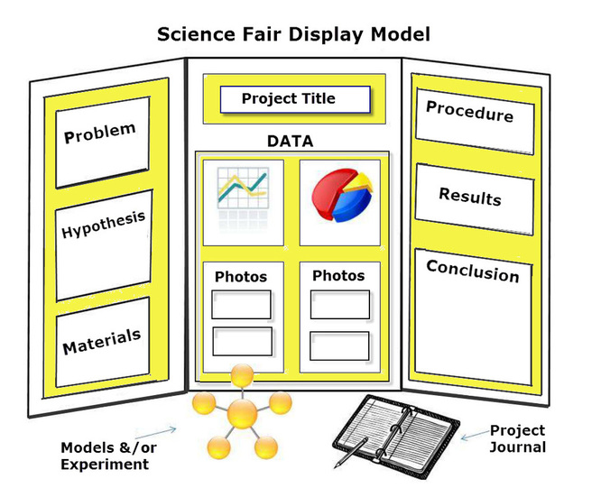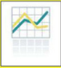

Title
Question/ Problem
Purpose
Hypothesis
Materials

Procedures

Pictures/Artifacts

Results
Charts/ Graphs
Conclusion
Appendix C
Triboard Examples

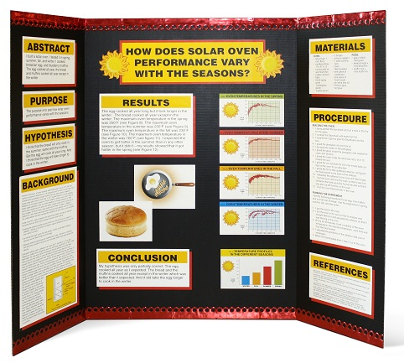
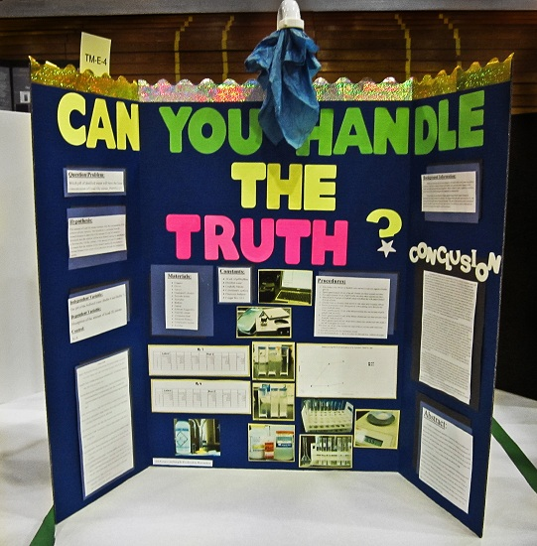

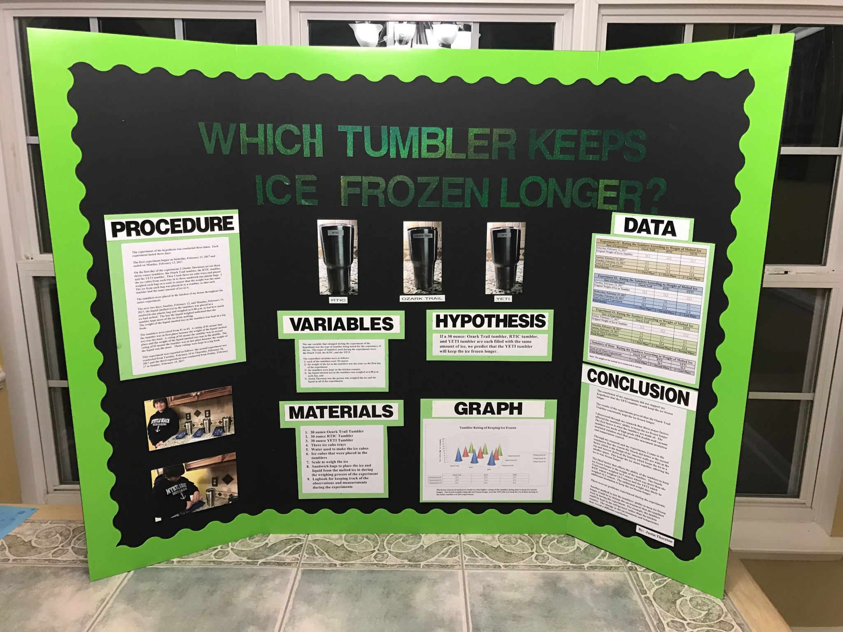
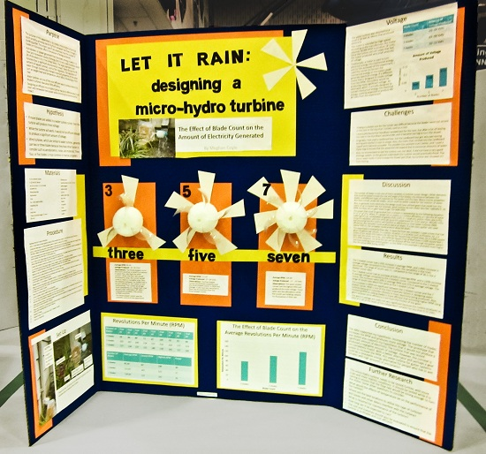

Appendix D
Sample Graphs and Data Tables
Results: Data Table
Effect of Different Physical Activities on Heart Rate
Heart Rate (measured in beats per minute)
Type of Activity | Trial 1 | Trial 2 | Trial 3 | Average
Running | 162bpm | 168bpm | 174bpm | 168bpm
Weight Lifting | 140bpm | 158bpm | 151bpm | 149bpm
Walking | 110bpm | 115bpm | 108bpm | 111bpm
Yoga | 102bpm | 94bpm | 98bpm | 98bpm
Control (at rest) | 68 bpm | 72 bpm | 70 bpm | 70 bpm

Results: Graph
Line Graph: a graph that shows information that is connected in some way (such as changes over time). It can also compare two or more data sets that are related in comparison to a common factor.
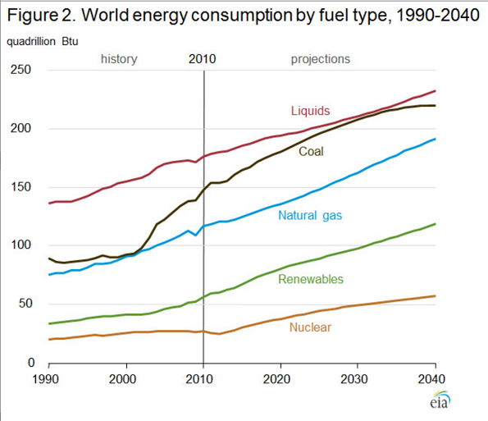
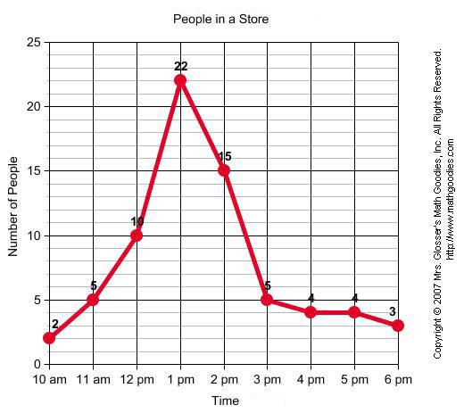

Bar Graph: A bar graph shows comparisons among defined categories. One axis of the chart shows the specific categories being compared, and the other axis represents a measured value. Multiple bars can be graphed together to show more comparisons.
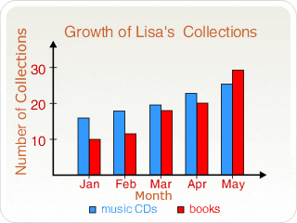
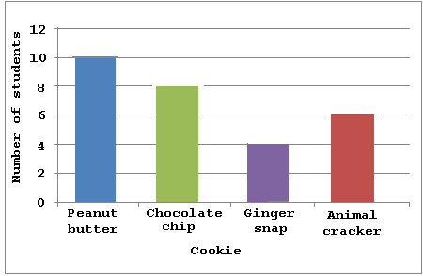

Pie Chart: Pie charts are best to use when Scatter Plot: a graph that uses dots to represent
you are trying to compare parts of a whole. the values obtained for two different variables.
The whole circle represents the complete Scatter plots show how much one variable is
data set (100%). Pie charts do not show affected by another (correlation).
changes over time.
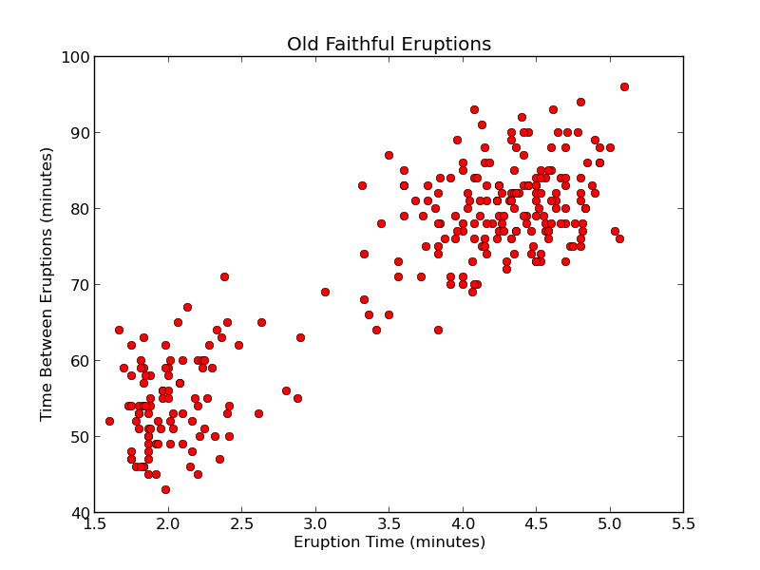
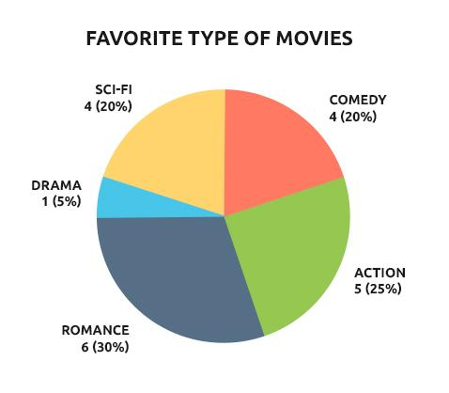

Graphing Tutorial

Appendix E
Sites for Project Ideas
- Science Buddies  - Science Kids  - Science Bob  - Home Science Tools  - Education.com  - Science Fair Topics | - Science Fair Central  - All Science Fair Projects  - High School Science Fair Projects  - 200 Science Fair Project Ideas  - Education.com  - Science Fair Projects
** Please note that not all of the experiments found on these sites are appropriate for science fair. You should consult with your teacher when choosing to see if your topic follows all of the state guidelines. It is best not to copy a project exactly. The sites are meant to give ideas for you to design your own!
Topics to Avoid
- Any topic that boils down to a simple preference or taste comparison. For example, "Which tastes better: Coke or Pepsi?"
- Most consumer product testing of the "Which is best?" type. This includes comparisons of popcorn, bubblegum, make-up, detergents, cleaning products, and paper towels.
- Any topic that requires people to recall things they did in the past.
- Effect of colored light on plants
- Effect of music or talking on plants
- Effect of running, music, video games, or almost anything on blood pressure
- Effect of color on memory, emotion, mood, taste, strength, etc.
- Any topic that requires measurements that will be extremely difficult to make or repeat, given your equipment.
- Graphology or handwriting analysis
- Astrology or ESP
- Any topic that requires dangerous, hard to find, expensive, or illegal materials.
- Any topic that requires drugging, pain, or injury to a live vertebrate animal.
- Any topic that creates unacceptable risk (physical or psychological) to a human subject.
- Any topic that involves collection of tissue samples from living humans or vertebrate animals.
Why?
- Such experiments don't involve the kinds of numerical measurements we want in a science fair project. They are more of a survey than an experiment.
- These projects only have scientific validity if the Investigator fully understands the science behind why the product works and applies that understanding to the experiment.
- The data tends to be unreliable.
- Several people do this project at almost every science fair. You can be more creative!
- Difficult or highly subjective to measure. Without measurement, you can't do science.
- The result is either obvious (the heart beats faster when you run) or difficult to measure with proper controls (the effect of music).
- Questionable scientific validity.

