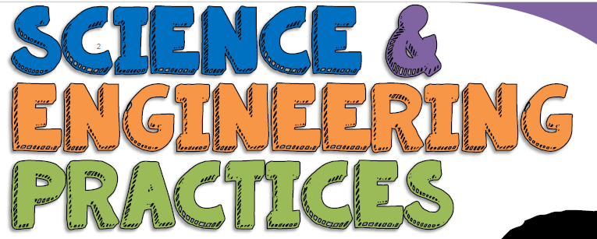

1. Asking questions – for science - and defining problems – for engineering
A practice of science is to ask and refine questions that lead to descriptions and explanations of how the natural and designed world(s) works and which can be empirically tested.

2. Developing and using models
A practice of both science and engineering is to use and construct models as helpful tools for representing ideas and explanations. These tools include diagrams, drawings, physical replicas, mathematical representations, analogies, and computer simulations.

3. Planning and carrying out investigations
Scientists and engineers plan and carry out investigations in the field or laboratory, working collaboratively as well as individually. Their investigations are systematic and require clarifying what counts as data and identifying variables or parameters.

4. Analyzing and interpreting data
Scientific investigations produce data that must be analyzed in order to derive meaning. Because data patterns and trends are not always obvious, scientists use a range of tools—including tabulation, graphical interpretation, visualization, and statistical analysis—to identify the significant features and patterns in the data. Scientists identify sources of error in the investigations and calculate the degree of certainty in the results.

5. Using mathematics and computational thinking
In both science and engineering, mathematics and computation are fundamental tools for representing physical variables and their relationships. They are used for a range of tasks such as constructing simulations; solving equations exactly or approximately; and recognizing, expressing, and applying quantitative relationships.

6. Constructing explanations – for science - and designing solutions – for engineering
The end-products of science are explanations and the end-products of engineering are solutions. The goal of science is the construction of theories that provide explanatory accounts of the world. A theory becomes accepted when it has multiple lines of empirical evidence and greater explanatory power of phenomena than previous theories.

7. Engaging in argument from evidence
Argumentation is the process by which evidence-based conclusions and solutions are reached. In science and engineering, reasoning and argument based on evidence are essential to identifying the best explanation for a natural phenomenon or the best solution to a design problem.

8. Obtaining, evaluating, and communicating information
Scientists and engineers must be able to communicate clearly and persuasively the ideas and methods they generate. Critiquing and communicating ideas individually and in groups is a critical professional activity.

