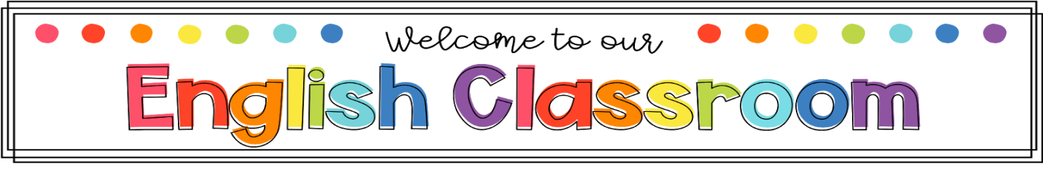
Course Description: Eighth grade English/Language Arts is designed to expose students to a variety of literary texts with adequate understanding, refine grammar skills, and improve writing skills through the writing process. The students will read in class at least one-two class novels. In this class, students will write for a variety of purposes. The students will study grammar and will use and understand both general and specific vocabulary.
Aaron Cohn Middle School 2020-2021

Teacher: TaKesha Lynn
Assignments: Assignments will be posted weekly on our collaborative website, Canvas, as well as presented to students in advance. Students will be notified a week ahead of upcoming assessments. A sample of assignments/assessments to look forward to are: class assignments, quizzes, weekly language review warm ups, articles of the week, group projects, novel projects, and presentations. It is essential for students to strive to do their best at all times.
Materials Needed:  1-Notebook Binder-Section OR Google Folder (Weekly language review warm ups, Assignments, Assessments, etc.)  Paper, Pencils, Pens, Markers, Glue sticks, Colored Pencils (Class Projects) | Class Schedule:  8:50-9:20am: ILT/SELT (Mon.-Fri.)  Orange Day Black Day  1st: 9:30-11:10am 4th: 9:30-11:10am  2nd: 11:20am-1pm 5th: 11:20am-1pm  3rd: 2:10-3:50pm 6th: 2:10-3:50pm
Grading:  Assignments (Class Participation/Projects, etc.): 50%  Assessments (Quizzes & Tests): 50%  Contact Information:  Email:Williams-lynn.takesha.l@muscogee.k12.ga.us  Phone: 706-569-3801  ILT/SELT: https://mcsd.instructure.com/courses/122746/assignments/syllabus  ELA 8: https://mcsd.instructure.com/courses/120668/assignments/syllabus  Gifted/Advanced ELA 8: https://mcsd.instructure.com/courses/120656/assignments/syllabus | Assignment Policies:  All work is to be turned in on time. Late work will be accepted for full credit in the event of an excused absence only. There will be a 15-point deduction taken each day for 3 days for late work. After three days, no late work will be accepted and the grade will result to a zero (0). Make-up work will receive a score no greater than 70 if turned in late (after 3 days). It is the student’s responsibility to ask the teacher, peers, or check teacher’s website for missing assignments upon their return to school.
Please sign and return: (Please keep this in your binder within your ELA Section)
Parent signature________________________________________________ Date___________________
Student signature_______________________________________________ Date___________________

