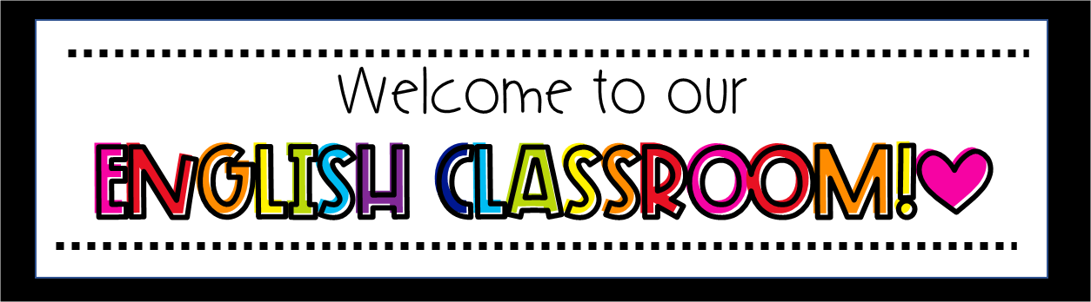

Welcome to ACMS for the 2020-2021 school year! This document will support you in your English Language Arts class. We are looking forward to working with you and your families! You can find your daily assignments on each teacher’s Canvas page. Teachers will communicate through Canvas and email.
EXPECTATIONS: Students should give their best every day regarding behavior and academics. Conduct each day with purpose and know that this moment matters! You are encouraged to be an advocate for yourself. Learning to communicate with your teachers and peers is an important life skill. You should email me anytime you need to communicate any difficulties you may be having in my class.

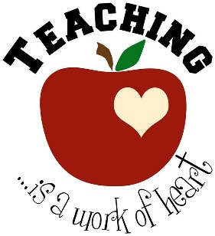
Mrs. Iris Jones Jones.Iris.M@muscogee.k12.ga.us
Zoom link: https://muscogee.zoom.us/my/jonesaaroncohn10

Step 1 - Logging in to Clever

Students need to access Clever in order to get to teacher Canvas pages. When you log into your Chromebook, you are taken directly to Clever. You can also access Clever from the MCSD Families and Students Page.

*If you access Clever through another device, you may have to type in the following: Your GTID (10-digit) number. Your password is your usual district password.

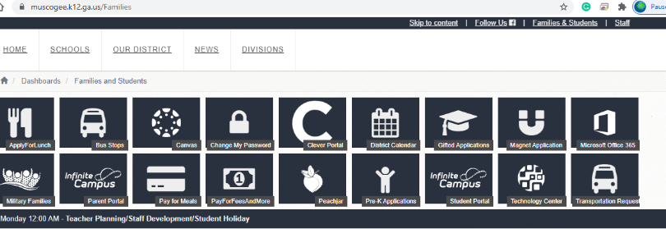

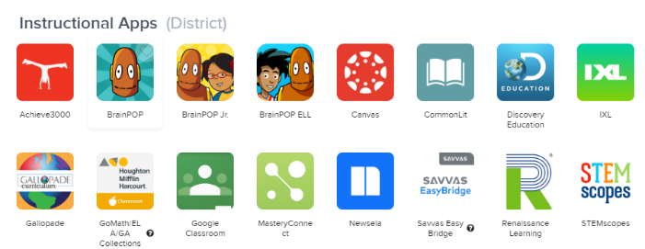
Step 2 – Click Canvas

Each teacher will have a Canvas page. You can access Canvas from the Clever Home Page as well as through the ACMS school website. Clever has all of the instructional apps you will need:

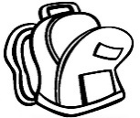
GA Collections and Achieve 3000 are apps you will use to get to your English Language Arts textbook and online resources for reading. We will use a variety of other applications (apps) through Clever, so please make sure to follow your teacher’s instructions. Once you click on the instructed app, you will have access to any assignments given by your teacher.

Zoom – See times below. Sessions are mandatory, and attendance will be taken.
A-Day | B-Day
1st: Zoom: 9:30 AM | 4th: Zoom: 9:30 AM
2nd: 11:20 AM | 5th: Zoom: 11:20 AM
3rd: Zoom: 2:10 PM | 6th: Zoom: 2:10 PM

