Pairing Parents with Student Classes in Canvas
Parents can always login as their child, using their child’s credentials to see activity in Canvas.
If a Parent would like to follow their child in Canvas as an “Observer” and receive updates of Announcements and Class Activities, they will need the “pairing code” to setup their account.
Step 1: Student must login to get code.
To locate the pairing code, the student must login to Canvas, click on Account, Settings, then Pair with Observer. The code will appear.
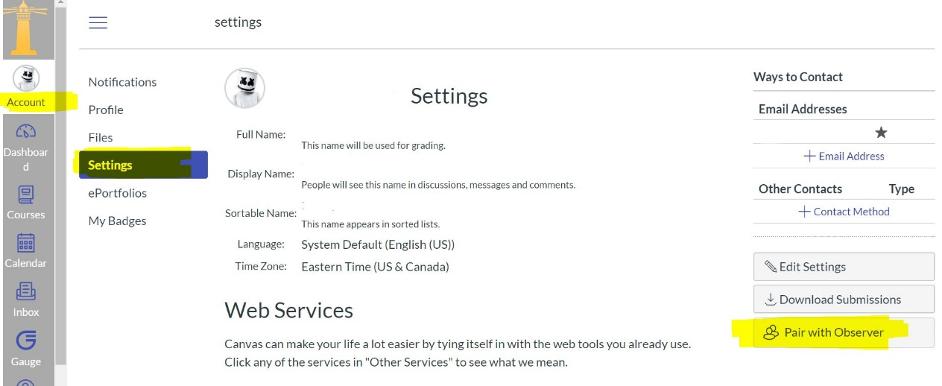
Step 2: Parent creates account and enters code.
The parent can then go to the Canvas website and click to create their account. The pairing code should be entered in the appropriate blank.
