1. Which of the following has a solution of 5?

A *y +* 10 = 5 B 30*y* = 6 C 6*y* = 30 D *y* -5 = 10

2. Which of the following has a solution of 102?

A *x* ÷ 6  17B 6*x*  712 C *x*  56  148 D *x*  95  8

3. What is the solution to the equation 20 = 5d?

A d=4 B d=25 C d=15 D d=20

4. What is the solution to the equation  
 = 6?

A d=4d B d=10 C d=2 D d=24

5. Solve the equation: w  2.1  4.7.

A w  2.6 B *w* = -2.6 C w  6.8 D *w* = -6.8

6. Solve the equation: 3m  16.8.

A m  5.6 B m  13.2 C m  19.8 D *m*  50.4

7. Zach removes 8 pounds of air so that his bicycle tire gauge now reads 53 pounds. Which equation can be solved to show the pounds of pressure he began with?

A p  8  53 C 53 – *p* = 8 B 53 + *p* = 8 D 53 – 8 = *p*

8. There are at least 51 visitors to the school store each day. Which inequality represents the number of visitors to the school store?

A *v* ≥ 51 B *v* > 51 C *v* < 51 D *v* ≤ 51

9. There are less than 30 patients waiting in the doctor’s office any given day. Which inequality

represents the number of patients today?

A *p* ≥ 30 B *p* > 30 C *p* < 30 D *p ≤* 30

10. There are at most 25 cars sold on the car lot a day. Which inequality represents the number

of car sold today?

A *c ≥* 25 B *c* > 25 C *c* < 25 D *c ≤* 25

11. Write an equation for a function that gives

the values in the table.

|  |  |
| --- | --- |
| *x* | *y* |
| 4 | 10 |
| 5 | 13 |
| 6 | 16 |

A  B  C  D 

12. Which equation represents the graph in the figure?

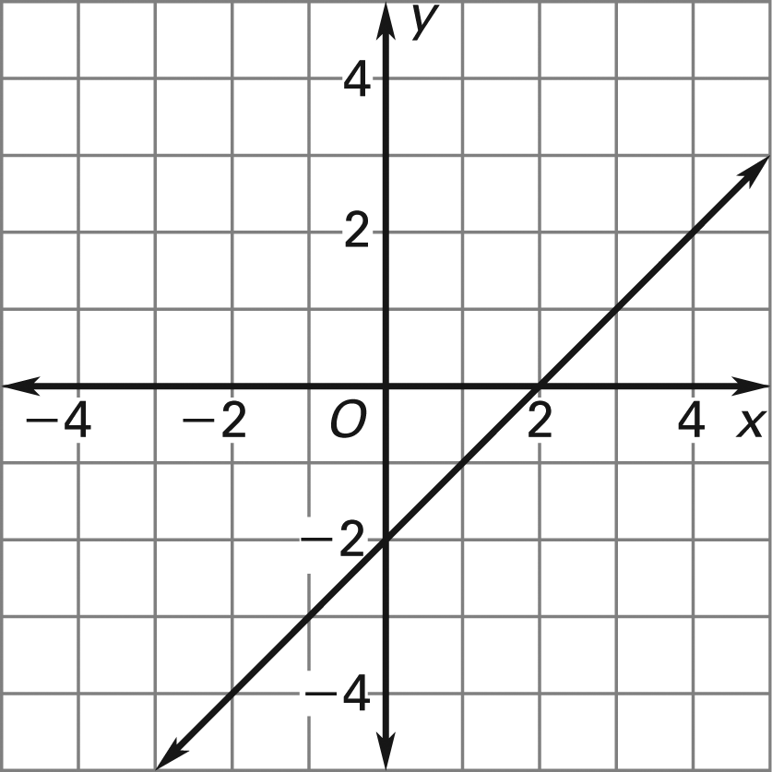

A  C 

B  D 

13. The almanac states that the Minnehaha Waterfall in Minnesota is 53 feet tall. A tour guide said the Minnehaha Waterfall is 636 inches tall. Determine if these two measurements are equal. **EXPLAIN AND JUSTIFY YOUR ANSWER.**

14. Write and graph an inequality for the following situation. Four boxes of candy contained more than 48 pieces total. **EXPLAIN AND JUSTIFY YOUR ANSWER.**

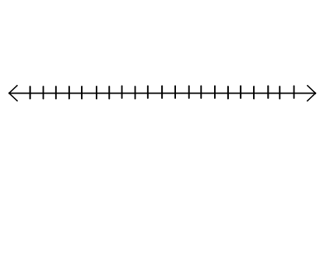

15. Write and graph an inequality for the following situation. With John’s 7 marbles and mine, we had no less than 20 marbles together. **EXPLAIN AND JUSTIFY YOUR ANSWER.**



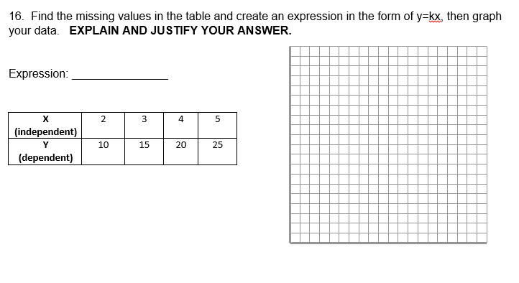

17. **6(3x + 4) + 2x -4 = 100 Solve the following equation and show each step**. **EXPLAIN AND JUSTIFY YOUR ANSWER. BE SURE TO DESCRIBE THE FOLLOWING: ISOLATING THE VARIABLE, INVERSE OPERATIONS, DISTRIBUTIVE PROPERTY, COMBINING LIKE TERMS**

18. **Explain direct proportion/direct variation using the equation y =kx.**

19. **Answer the following questions using the graph below.**

a. What two quantities vary proportionally in this situation?

b. What is the constant of proportionality in relation to the equation **y=kx**?

c. What is the value of the constant of proportionality in this situation?

d. What does this value represent in the context of this problem? 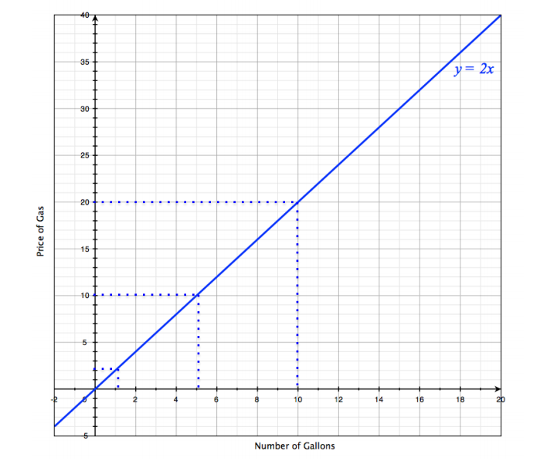

20. Suppose gas prices rose to $3.00 per gallon. Write an equation to represent this change. How would the graph above change? **EXPLAIN AND JUSTIFY YOUR ANSWER.**