Unit 4

1. What is the solution to the equation 4j = 24?
2. Determine whether the ordered pair (3, 15) is a solution of the equation .
3. What is the solution to the equation 16  x 8?
4. Lada’s three older brothers each drove an average of 7 hours. How many total hours was the trip?
5. Write an equation for a function that gives the values in the table.

|  |  |
| --- | --- |
| *x* | *y* |
| 4 | 10 |
| 5 | 13 |
| 6 | 16 |

1. Solve x + 3 = 7.
2. Solve 2 = y − 1.
3. Solve g = 4.
4. Solve 3 = y − 2.
5. Write the compound inequality represented by the graph

hmsm_c2ch12-art01

1. What is the slope of the line in the graph below?

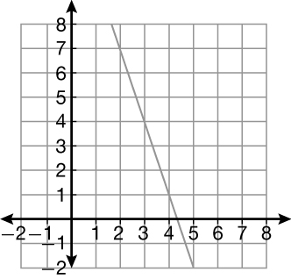

1. Write the compound inequality represented by the graph

hmsm_c2_ch12_mcA_art01

1. Solve the equation: p  6.4  9.3
2. What is the slope of the line in the graph below?

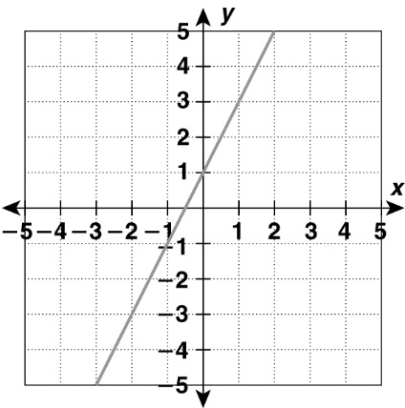

1. Solve r + 5 = 12
2. Solve p = 8.
3. Solve the equation: 7r  43.4
4. Casandra’s family drove 275 miles at 55 miles per hour. How many hours was their trip?
5. Solve for hif 6h  36
6. Write an equation for the function and tell what each variable represents: Nicholas is 2 years younger than his sister.

\_\_\_\_\_\_\_\_\_\_\_\_\_\_\_\_\_\_\_\_\_\_\_\_\_\_\_\_\_\_\_\_\_\_\_\_\_\_\_\_\_\_\_\_\_\_\_\_\_\_\_\_\_\_\_\_\_\_

1. Determine whether the ordered pair (2, 13) is a solution of the equation .
2. Jasmine wrote the table of values below. Determine the equation of the line

|  |  |  |  |  |  |
| --- | --- | --- | --- | --- | --- |
| *x* | 2 | 4 | 6 | 8 | 10 |
| *y* | 10 | 12 | 15 | 17 | 20 |