**Unit 4 Study Guide KEY**

1. Diagram of transverse wave with crest, trough, wavelength, and amplitude labeled correctly.

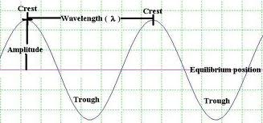 **Example:**

1. Convex, concave
2. Sound, mechanical, water
3. The sound is reflecting off the canyon

walls and bouncing back for you to hear



again.

1. pitch
2. resonance
3. infrared, red light
4. any electromagnetic wave
5. We see objects because light is reflected off of the object and into our eyes.
6. Solids, gases
7. Radio, microwave, infrared, visible light, ultraviolet, x-ray, gamma
8. The higher the amplitude the more energy it has. The lower the amplitude the less energy it has.
9. White light hits the object. All colors (ROYGIV) except blue are absorbed by the object. Blue is reflected into our eyes.
10. Energy, matter (particles)
11. Light refracts as it changes the medium it is going through. As the medium changes, the speed of light also changes with ends up bending the light rays.
12. pitch
13. amplitude
14. air, wood, steel, water….any example of solids, liquids, or gases
15. the distance from the resting point to the crest or trough.
16. energy
17. compression
18. the sun
19. all electromagnetic waves travel at the same speed, all have varying wavelengths, all have varying frequencies, all have varying amounts of energy, and all can travel through space.
20. Ultraviolet waves can cause a sunburn, can cause cancer, can make certain minerals glow, some insects can see in UV, we should protect our eyes and skin from too many UV rays, UV rays help our bodies make Vitamin D
21. Gamma, x-ray, ultraviolet, visible light, infrared, microwaves, radio
22. It changes the direction of the light ray by bending it.
23. The light ray is reflected off at the same angle it arrived at.
24. 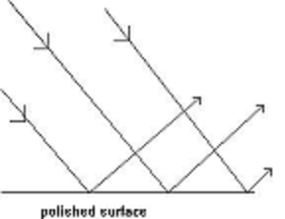The bending of light as it passes through an opening or around an obstacle.
25. Diagram should include and understanding of law of reflection. **Example:**
26. medium
27. 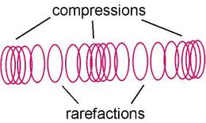 diagram should include compression, rarefaction, and wavelength

**Example:**

1. Shortens, lengthens
2. Increases, decreases

wavelength

1. The length of the string, The tension on the string, The thickness on the string