Each year, millions of people bathe in the most sacred river in India. Because the river is known as a source of sacred healing, people with sicknesses and diseases bathe themselves hoping to be cured. For others, such as Hindu priests, bathing in the river is a sacred tradition. As a result of some religious practices, lack of sanitation infrastructure in certain areas, and the difficulty of regulating factories, cremated bodies, raw sewage, and industrial waste from factories float down the river.

- Based on the passage above, what environmental issue are the people of India facing?
- In South Asia, air pollution is a very serious problem. The primary cause of the serious indoor air pollution problem in South Asia is the ____ and ____ with biomass fuels.
- The Himalaya Mountains affected India and Pakistan by isolating India and Pakistan from _____.
- What identifies a person as a member of a religious group?
- A major difference between Hinduism and Islam is their views of the _____.
- What effect does an increase in a country’s literacy rate have on the people who live there?
- In Japan, the prefectures (Japan’s word for states or provinces) do not have any independent authority. Instead, they carry out the laws and policies of the national government. This is an example of what system of government?
- In a parliamentary government, unlike the presidential system, the head of government belongs to which branch?
- How does a democratic government differ from an oligarchic government?

- a national government as well as 28 state governments

- the leader of each state legislature's majority is appointed governor by the president

- citizens of each state elect state legislatures

- Based on the information above, what term identifies India's government?

- The emperor holds a ceremonial role as head of state

- The prime minister is the head of government

- The government’s true power lies with the Prime Minister and the Cabinet

- Based on the information above, what term identifies Japan’s government?
- Why did the United States believe it was necessary to become involved in both Korea and Vietnam?
- One role the U.S. play in rebuilding Japan after World War II was that it developed a plan to help Japan’s _____ recover.
- What is the role of the emperor in modern Japan?
- How are new leaders of India's government chosen today?
- The United States sent armed forces to support South Vietnam during the 1960s and early 1970s in an attempt to prevent the expansion of _____ throughout Southeast Asia.
- Why do countries have mixed economies?

The North Korean government determines:
- What to produce
- How to produce
- For whom to produce

- According to the information box, North Korea’s economy is MOST LIKE which economic system?
- In order to protect a nation’s car manufacturing industry from foreign car producers, the government charges the importer a fee for each imported car. This is an example of what kind of trade barrier?
- Jiang wants to sell his products manufactured in his country to consumers in several other Asian countries. This will involve him in international trade. What needs to be in place so Jiang can accurately determine the price of his products in these other nations?

Microsoft Corp, the world's largest software company, said that the company will invest $1.7 billion in India over the next four years to expand its operations. The money will be spent to make India a major hub for Microsoft's research, product and application development, and services and technical support. India's highly skilled software professionals, low-cost operations, a booming economy, good telecommunications links, and a rapidly growing market have made many foreign companies announce plans to expand their operations in India.

- Which is an example of human capital in the above passage?
- China’s economy has begun to change from a command economy to a more market economy. This has resulted in increased investment both by the Chinese and by foreign entrepreneurs. How will this investment in capital affect China’s GDP?
- China’s economy is growing at a very rapid pace. One reason that entrepreneurs are important in the growth and transition of China’s economy is that they build new _____.
- The theme that ties The Great Leap Forward, the Cultural Revolution, and Tiananmen Square Massacre together is that they all led to fewer _____ for people of China.
- How did Mohandas Gandhi challenge British rule in India?
- How has China attempted increase its GDP since end of the 20th century?
- During China's Cultural Revolution, led by ____ in the 1960s and 1970s, many Chinese intellectuals were persecuted, exiled, and sometimes executed.
- Which leader was responsible for establishing communism in China?
- Why did the United States become involved in Vietnam during the 1960's and early 1970's?
- Since the end of World War II, one way the seas and oceans most benefited Japan's economy was by providing _____ routes.
- The MAIN purpose of Mao Zedong's Great Leap Forward program was to place productive resources under central _____ control
- The main reason the United States became involved in the _____ and _____ wars was the containment of communism.
- After World War II, the United States helped Japan rebuild its economy in all the following ways except by sharing its _____ knowledge, providing large sums of money through _____, and providing much needed _____ for their industries.
- Before the late nineteenth century, Japan was an isolated nation. The main reason Japan has become involved in the world community since that time was it limited ____ forcing Japan's growing population to seek foreign markets.

- The containment of communism was an important part of American foreign policy in the twentieth century. The idea of containing communism was involved with America's entry into which wars?
- In 1958, Mao Zedong introduced an economic plan for China called the Great Leap Forward. A result of this plan was that it caused a severe _____ depression.
- What statement would describes India’s federal form of government?
- What must be present for international trade to be successful?
- Of those studied in Asia, which would not be considered a religion?
- In 1954, Vietnam successfully gained their independence from which European country?
- Who led the independence movement in Vietnam?
- Mohandas Gandhi led the independence movement in which country?
- List some reasons for the United States’ role in rebuilding Japan after World War II.
- In 1957, Mao Zedong implemented a plan to advance China economically and technologically. This plan, which ended up being a huge failure, was known as _____.
- In 1989, a group of Chinese students and intellectuals gathered in a public area to protest the communist government of China. The army forcibly ended the protest and many people were injured or killed. This event is generally referred to as ____.
- Several nations, including the United States, became involved in Korea and Vietnam during the 1950s-1970s. The reason for this was to _____.
- A major cause of air pollution in India is the use of fuels, such as coal, for cooking and heating. As a result of this is that there are over 500,000 _____ each year due to air pollution.
- The topography of Western China is primarily deserts, mountains, and plateaus. Given this fact, what type of population density would you expect to find here?
- A limit on the amount of goods imported or exported is known as a ____.
- Currency exchange refers to the practice of trading one form of _____________ for another.
- Due to internal conflicts and government instability, a certain Asian county has not maintained nor upgraded their factories, machinery, and technology. This will most likely result in a(n) ____ in this country’s Gross Domestic Product?
- Japan imports a large amount of raw materials which it then uses to produce products for other countries. What is the most likely reason that Japan imports so many raw materials?
- Taking a risk by investing resources into a new business is known as _____.
- The Mongols are an East-Central Asian group who originated in Mongolia and China. The Mongols are defined by a common heritage, lifestyle, and language. The Mongols are best described as a(an) _____ Group.
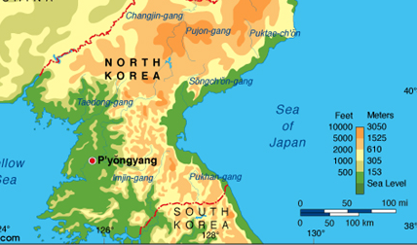

- Referring to the above map, most of the people of North Korea live on the western side of the country because the area has more _____ and fewer _____.
- Shintoism in considered a religion, but Confucianism is not because Confucius taught good _____ and _____, not supernatural/spiritual beliefs.
- A government system in which power is held by the central authority with little or no decisions being made at the regional level is _____.
- How does a democratic government differ from an oligarchic government?
- If the citizens of a country elect both the legislative and executive leaders, that country has a _____.
- A democratic country with high levels of citizen participation and freedom; but which also has a symbolic monarch in place, best describes ____.
- A communist country with a unitary distribution of power and relatively low personal freedoms for its citizens best describes _____.
- A theoretical economic system in which all decisions were made by the government would be referred to as a __________________ economy.
- An economic system which is based on customs handed down from generation to generation is referred to as a ___________________ economy.
- Most countries have a ________________ economy located on the continuum between pure market and pure command.
- Which of the Asian country studied in class can best be described as having a near-command economy in which citizens have very little freedom to engage in entrepreneurship?
- The primary reason that specialization encourages trade between countries is that it ____ prices.
- How do the governments of Japan and China treat their citizens differently?
- Meera believes in reincarnation relates to a _____ group rather than an _____ group?
Chinese officials predict the river’s remaining plant and wildlife species will be killed off completely if the dumping of sewage and industrial and agricultural waste is not stopped.
- According to the information, what environmental issue is China facing
- Because Japan has limited natural resources, it specializes in producing electronic goods. What does this MOST enable Japan to do?
- What is the difference between a religious group and an ethnic group?
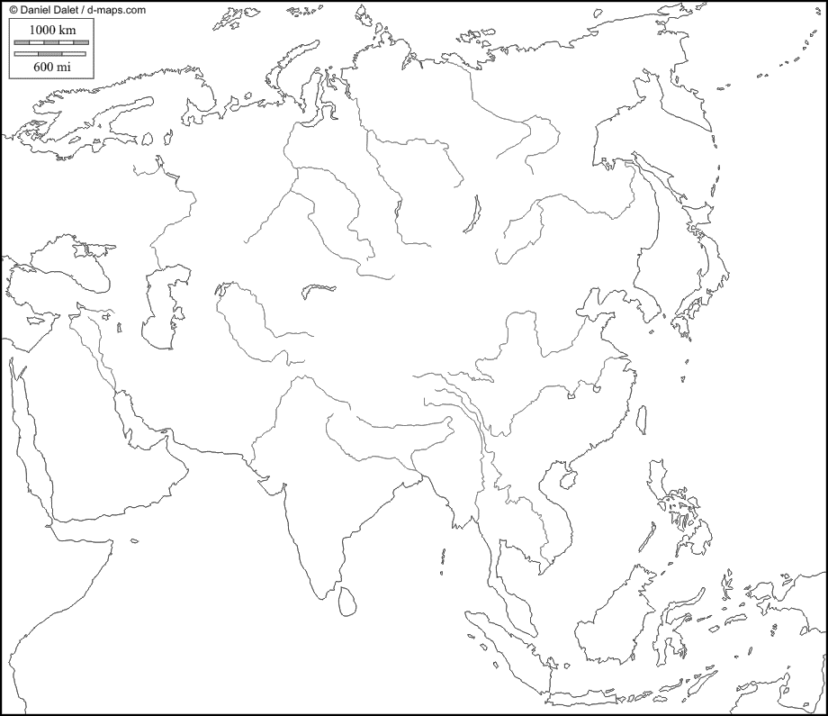
Use the letters from the work bank to correctly identify their location on the map.

Word Bank
- Bay of Bengal  - Ganges River  - Gobi Desert  - Himalayan Mountains  - Huang He | - Indian Ocean  - Indus River  - Korean Peninsula  - Mekong River | - Sea of Japan  - South China Sea  - Taklimakan Desert  - Yangtze river  - Yellow Sea

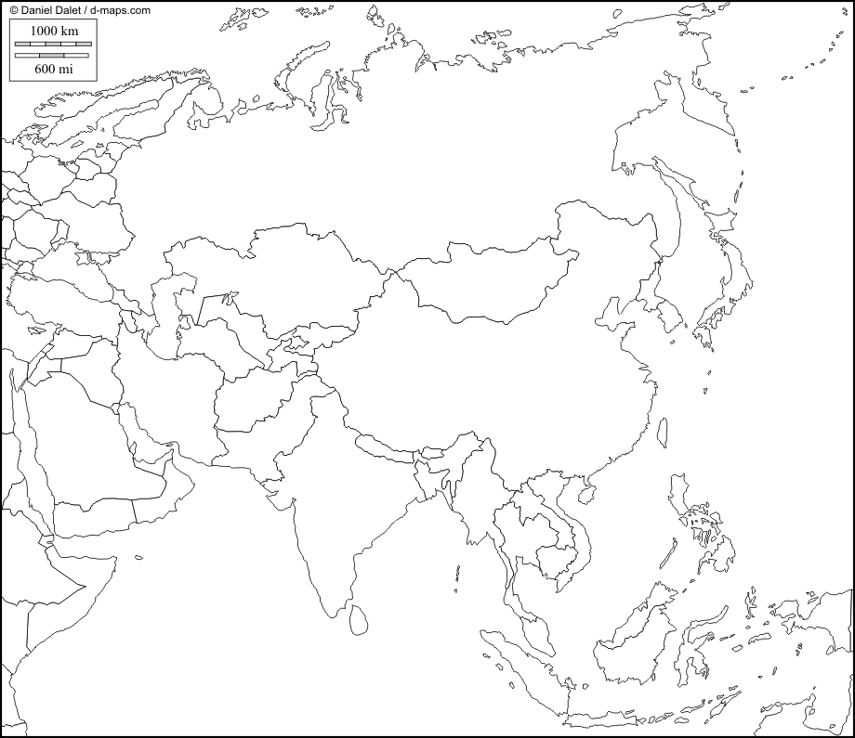
Use the word bank to identify the number on the map. Place the correct number from the map next to its match country in the word bank.
Word Bank
_____ China
_____ India
_____ Indonesia
_____ Japan
_____ North Korea
_____ South Korea
_____ Vietnam
4
2
3
5
7
6
1

