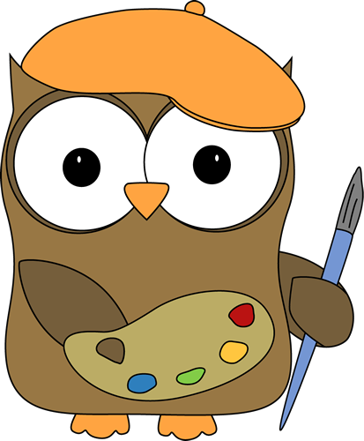
Ms. Butler
8th Grade Art

Mission:
The purpose of this class is to further your knowledge and understanding of visual arts. We will explore and create with different kinds of art media, such as drawing, painting, printmaking, and sculpture. We will also cover art appreciation, art history, and art criticism.

Materials:
You will be provided with most of the supplies, although you will need to purchase the following materials:
- Sketchbook: You can purchase these from any art supply store, but Walmart also has several sketchbooks in their school supplies section for under $5. Hobby Lobby and Michaels both have coupons that you can print off of their websites.
- Eraser: vinyl or plastic (Pentel Hi-Polymer erasers work great and can be found at Walmart)
- Pencils: You can purchase actual graphite drawing pencils, but a #2 wood pencil will also work fine.
- 2 Sheets of Posterboard (no foam core): We will use these to create a portfolio of our work. You may pick any color.

Grading:
We will be using a “total points” grading system. The majority of your class points will come from studio art projects, which give you the possibility of scoring 100 points per assignment. Daily activities such as classwork, participation, bell work, homework, and sketchbook assignments will also be graded and added into your total class points. These activities are worth anywhere from 10-30 points.

Grades will be assigned by the following scale:
A =100-90
B = 89-80
C = 79-70
D = 69-65
F = 64 and below

Make-Up Work:
Make-up studio work, daily assignments, bell work, sketchbook assignments, and homework will only be accepted for excused absences. It is your responsibility to find out what work was missed on the days you were absent. All make-up work will need to be turned in before the next grading period. If you miss any notes or any bell work, then you will need to get the information from me or a classmate.

Resubmitted Work:
If you are not satisfied with a grade you received on a studio assignment, then you will have an opportunity to resubmit it before the next grading period. During class you may only work on the studio assignment that you plan to resubmit if all other work is completed. You may also take the assignment home to work on.

Sketchbooks:
Throughout the semester, you will be given sketchbook assignments; this might be practice drawing assignments to prepare you for an upcoming studio assignment, written reactions to videos and articles, or bell work assignments. Periodically, I’ll check your sketchbooks and give you daily grades for these assignments.

Entering and Leaving:
All students will enter the classroom quietly, read the board, and begin working on the bell work assignment. You will only be dismissed from the classroom by me, not by the bell. When we are working on studio assignments, I will give you enough time to clean up your work area. Please wait for instructions before you begin cleaning your area. Failure to clean your area will result in loss of participation points. As artists, you are responsible for the work you create as well as your messes!

Hall Passes:
Only one student will be allowed to leave the room at a time. You must ask permission before leaving the room and you must fill out the hall pass completely. If you are caught roaming the halls, socializing, or doing anything else other than what you asked permission to do, then you will lose all privileges of leaving my classroom during class. If you habitually try to leave my classroom then you will also lose the privilege to leave my classroom during class.

Studio Guidelines:
During studio projects, you will be allowed to talk quietly to other classmates. If the class gets too noisy, I will give a verbal reminder. If more than one reminder is needed, the class will spend the rest of the period working in silence.

Other Classroom Rules and Procedures:
- Respect yourself, others, and classroom materials.
- Listen and follow directions when they are given.
- Bring all of your supplies to class.
- Do not begin cleaning up or getting ready to leave until I give you permission.
- Leave all bad attitudes at the door.

Studio Safety Guidelines:
- Act responsibly during studio assignments
- Follow all instructions for the assignment and ask questions if you do not understand.
- Do not touch any materials until instructions are given.
- No food or drinks are allowed in class.
- Keep your work area neat and clean.
- Keep your art in your work area not your neighbors’.
- No horse play.
- Clean your area before leaving class.
- Ask permission before leaving your seat.
- Work quietly.

Cell Phones:
From time to time, students will be permitted to use their personal devices as an image or idea reference for their projects. Students must ask permission before using their device. If a student is caught using his or her device for anything other than the class art assignment, the phone will be turned in.

Agreement
Student
I have read the following guidelines and consequences listed above. I promise to follow these guidelines and understand the consequence that will happen if I fail to follow them.

________________________________________________________________________
Student Signature Date

Parent/Guardian
I have read the following guidelines listed above and understand the consequences which will occur if my child fails to abide by these guidelines.

________________________________________________________________________
Parent/Guardian Signature Date

________________________________________________________________________
Parent E-mail and/or Daytime Phone Number

