Waves and Currents Notes
Activating Strategy: Watch the video then answer the questions.
Where is this event happening? ________________________________________________________________ ___________________________________________________________________________________________
What causes the condition shown in the video? ___________________________________________________
______________________________________________________________________________________________________________________________________________________________________________________
What do you think is the importance of the condition shown? ________________________________________ ______________________________________________________________________________________________________________________________________________________________________________________
Waves
A ______________ is a rhythmic movement that carries ___________ through matter and space. In the ocean, waves move through ________________.
Causes of Waves
- When ___________ blows across a body of water, wind __________ is transferred to the ______________.
- If the _____________________ is great enough, the water begins to pile up, forming a _____________.
- The ________________ of a wave depends on:
  - The _______________ of the wind.
  - The _______________ over which the wind blows.
  - The ______________ of ___________ the wind blows.
Causes of Waves
- Once set in ______________, waves continue moving for long distances, even if the wind stops ___________________.
- The __________________ you see lapping at a beach could have formed halfway around the __________________.
Ocean Currents
________________________________________ are a mass flow of ocean water. Remember the “Finding Nemo” clip.
There are two main types of currents we will be discussing: _______________ Currents and ________________ Currents.
Surface Currents
- Surface currents move water ________________________ – parallel to Earth’s surface.
- Surface currents are powered by ______________.
- The _____________ forces the ocean to move in huge, ________________ patterns.
- There are _______________ surface currents and _____________ surface currents.
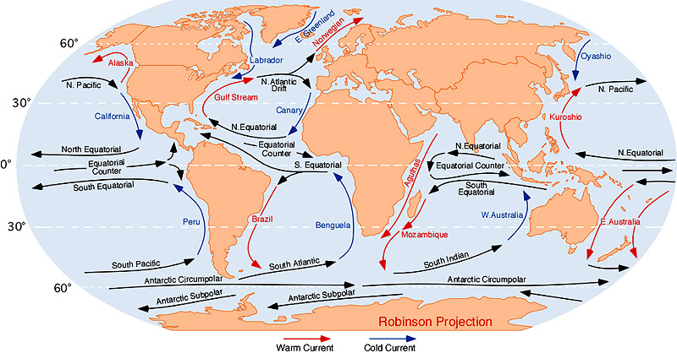

- Surface winds and surface currents are affected by the rotation of the Earth (the _____________________________________).
- Because Earth rotates toward the ______________, winds appear to curve to the ________________ in the ____________________ hemisphere and to the _________ in the ______________________ hemisphere, this is called the Coriolis Effect.
- So, currents _________________ of the equator turn to the right and currents _____________ of the equator turn to the left.
Coriolis Effect on Surface Currents
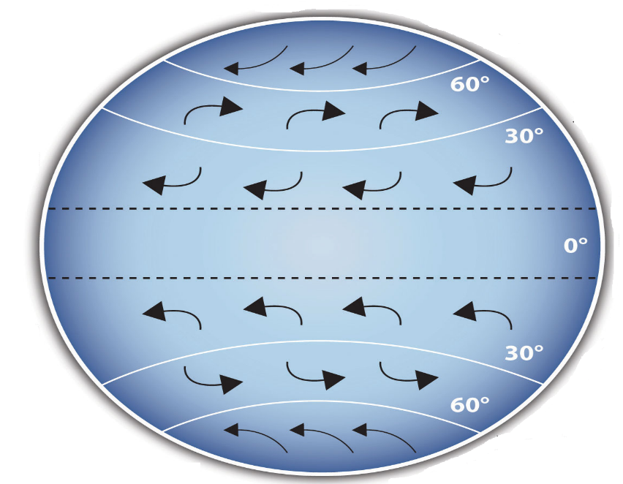
Curving of _____________________________ winds
due to the Earth’s ____________________________.

Surface Currents Affect Climate
- The ________________ absorbs, stores, and moves the _______________ heat (energy).
- Surface____________________ transport this _________________ all over the world.
- _____________________ currents move warmer water into cooler regions and _____________ cooler water to the warmer regions (tropics).
- _______________________ can have a _________________ effect on an area’s
climate or a __________________ effect on an area’s __________________.
- As __________________ water flows from the equator, _____________ is released into the atmosphere and the air is ____________________.
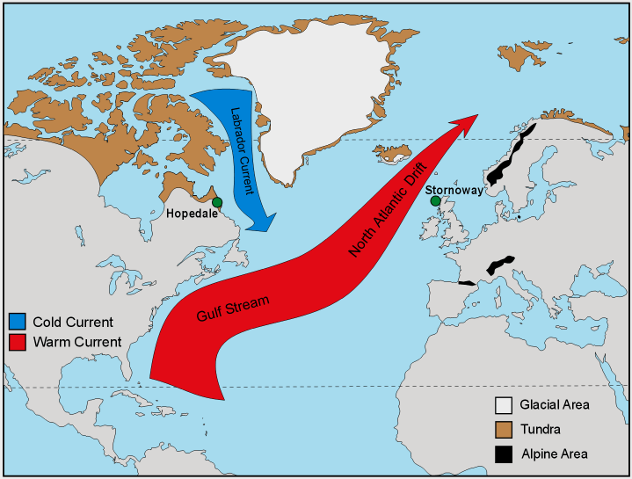
Surface Currents Affect Climate

Think about what you learned in social studies about Europe’s climate. What surface current makes Europe’s climate temperate (mild)? ________________________________________________________ The _______________________________is a surface current that moves warm water from the tropics to the cooler regions around _____________________.
The video reminded us that the masses of water are moved by wind, but what did they say was the primary cause of ocean currents? _________________________________________________________
__________________________________________________________________________________________________________________________________________________________________________
What factors did we learn influence ocean water’s density?
_____________________________________________________________________________________

Temperature, Salinity and Density

Density Currents
- _______________ in the ocean, waters circulate not because of wind but because of _______________________________________________.
- A ____________________ current forms when a mass of seawater becomes ________________ dense than the surrounding water.
- More dense seawater ________________ beneath less dense seawater.
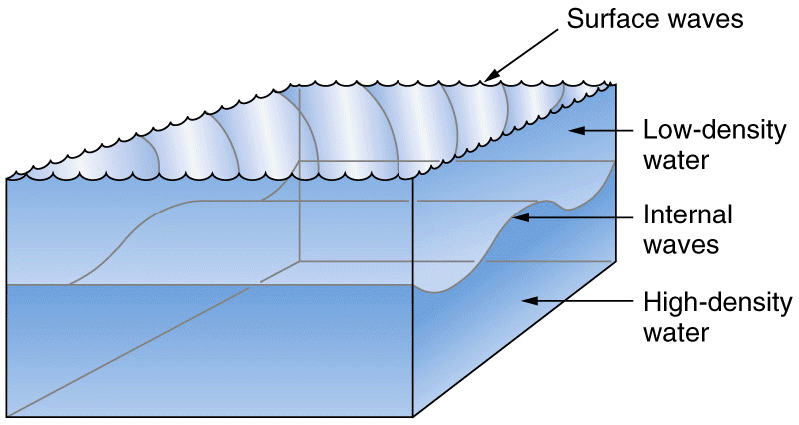
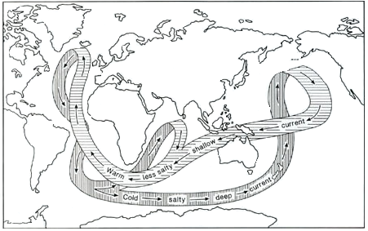
- Density currents circulate ocean water __________________.

