Name: ____________________________
Date: _______________ Pd: __________
Erosion Notes
- Erosion _____________ weathered rock material.
- What are some ways that weathered material can be __________________?
  - Erosion by ________________:
Rocks and other matierials, especially on ________________ are pulled toward the center of Earth by ________________.
Examples: __________, _____________________, _______________.
  - Erosion by _______________:
When air ___________, it picks up loose _______________ and ________________ it to other places.
Examples: _____________________, _________________________, ______________________________.
  - Erosion by ______________:
When _______________ moves, it picks up loose ___________________ and _________________ it to other places.
Examples: ___________________ or ______________, _____________, ____________, __________________.
  - Erosion by _____________:
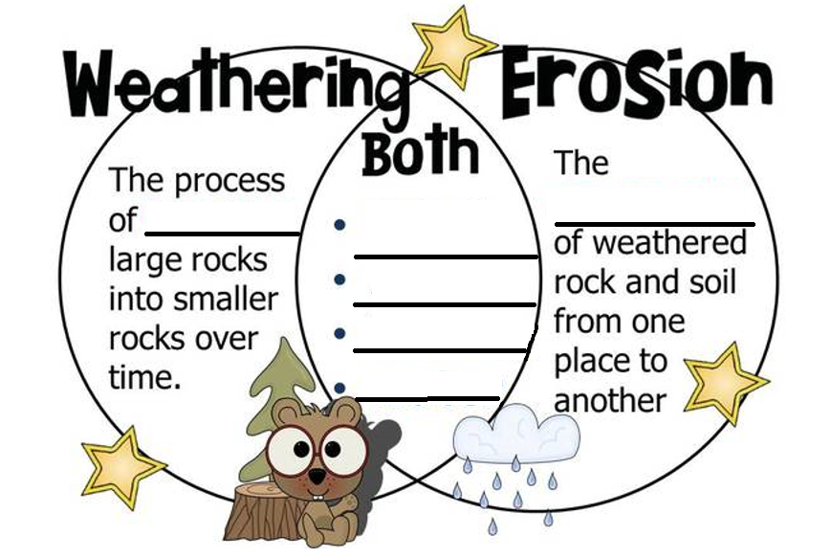
When a __________________ moves, it picks up loose _________________ and _____________________ it to other places.

- _____________________ is the result of _____________________ and ____________________ changes of rock and mineral material; the resulting products might, or might not be ____________________________.
- Deposition: ____________________ occurs where the accents (_____________) of _______________ lay sediment down.
  - ___________________________ and _________________ wear down, and _____________________ fills in the Earth’s surface.
  - Deposition by ____________________:
As _____________ moves through a river, it loses some of its _____________ and it can no longer carry some of its ______________. As a result, it drops or is ___________________ to the bottom of the stream.
Water also loses energy and deposits sediment when it empties into an ___________ or ____________. Sediment that is deposited as water empties into an ocean or lake forms a __________________ shaped deposit called a __________.
The Mississippi River flowing into the Gulf of Mexico forms the ________________________ delta.
_________________, ______________, and ________________ carry and deposit sand along beaches.
Examples: ______________, ___________________________
  - Deposition by ______________:
______________________ blown away by __________ are eventually deposited. Over time, these deposits develop into landforms.
  - Deposition by ______________:
When _______________ begin to melt, they deposit _______________ on the land.
After your discussion, record why you think the brick house was not as good as the straw or wood house? __________________________________________________________________________



