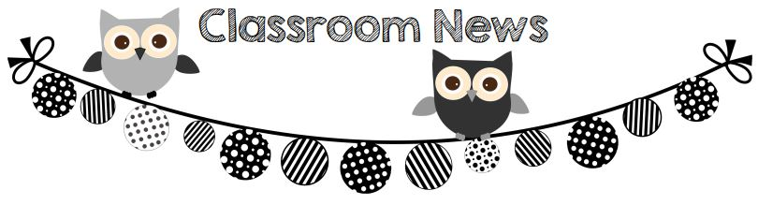

**Upcoming Events:**

12/5 Chic fil A night 5-8 at Bradley Park

12/7 PTO Christmas play at Shaw High School 7:00

12/11-15 Secret Santa Shoppe

**Spelling List:**

1. **rice**
2. **nice**
3. **page**
4. **age**
5. **wedge**
6. **ledge**
7. **like**
8. **ride**
9. **from**
10. **once**

**Reminders:**

1. Check agenda book for daily behavior. Parents need to initial it.
2. Wear house colors on Mondays and wear yellow on Fridays!
3. Wear or bring tennis shoes in book bags everyday.

**Wish List**

Gluesticks!!!

**What We’re Learning:**

**Reading/ELA:** Reading Wonders Unit 3 week 3- see backside

**Math:** Topic 3 – simple add/subtration **Specials:** Week D

**Science/Social Studies:** Historical Figures

**Homework:** Homework is due on Fridays. Please leave in folders and I will take out completed homework on Friday. Study sight words and read AR books to take a test when homework is completed!!

1. Math page 2. Write spelling words in ABC order

3. Reading workbook pg. 125-126 and 127-128