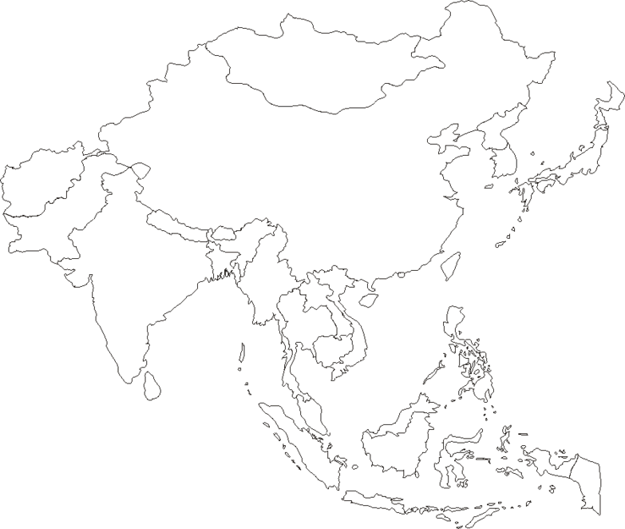

**Label** the following using pages A16, A17, 295 & 345

**Countries**

1. China
2. India
3. Japan
4. North Korea
5. South Korea
6. Vietnam

*\*\*Draw a compass rose!*