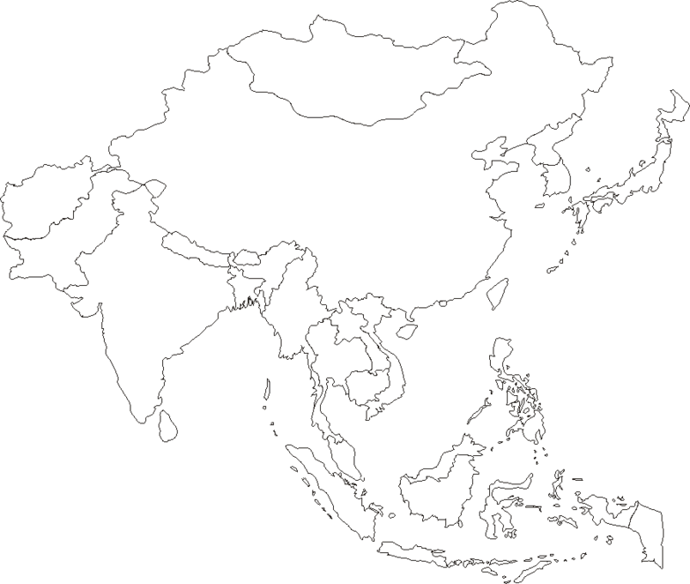

**Draw** in and **label** the following using pages A16, A17, 295 & 345

Physical Features

1. Ganges River
2. Huang He (or Yellow River)
3. Chang Jiang (Yangtze) River
4. Bay of Bengal
5. Indian Ocean
6. Sea of Japan
7. South China Sea
8. Yellow Sea
9. Gobi Desert
10. Taklimakan Desert
11. Himalayan Mountains
12. Korean Peninsula