Country | Structure of Government | Form of Leadership | Role of Citizens and Personal Freedoms
India | India has a ________________ democracy. This means the people elect the _________________, and the legislature chooses the _____________ of government. | Head of government is called the ___________________. | _________________ are _____________ and fair and people have _____________ freedoms, such as the right to a trial, right to privacy, and freedom of speech.
Japan | India has a ________________ democracy. This means the people elect the _________________, and the legislature chooses the _____________ of government. | Head of government is called the ___________________.  Has a symbolic (no real power) monarch - ______________ Akihito. | _________________ are _____________ and fair and people have _____________ freedoms, such as the right to a trial, right to privacy, and freedom of speech.
China | One-party ____________________ state (oligarchy – group) run by the Chinese ____________________ Party  (CCP). The CCP has 86 million members. | China’s head of government is the ________________ and is head of the ruling party, the Chinese Communist Party (CCP). | The communist constitution gives rights to Chinese citizens, including the right to vote for every person over the age of 18.  However, these rights are __________________ because in communist China the actions of citizens are _______________ by the _________________.
North Korea | North Korea is an ____________________ ruled by a ________________. | North Korea is ruled by a __________________, who has ________ the power. Current _______________ is Kim Jung-Un. | The people ______ _________ select their leader and are __________ to voice their opinions. Because it is a dictatorship, the people have very __________ _________________.
South Korea | South Korea has a _____________________ democracy. The ________________ elect the _____________ of government (chief executive) and a national legislature _________________. | Head of the government in South Korea is called the __________________. Current leader is Moon Jae-in. | The people of South Korea have ___________ rights and ________________, such as ability to __________, to engage in political speech, and to run for office.
SS7CG4 Compare and contrast various forms of government. a. Explain the role of citizen participation in autocratic and democratic governments [i.e. explain the role of citizens in choosing the leaders of China (communist state), Japan (parliamentary democracies), North Korea (autocracy), South Korea (presidential democracy), and India (parliamentary democracy)]. 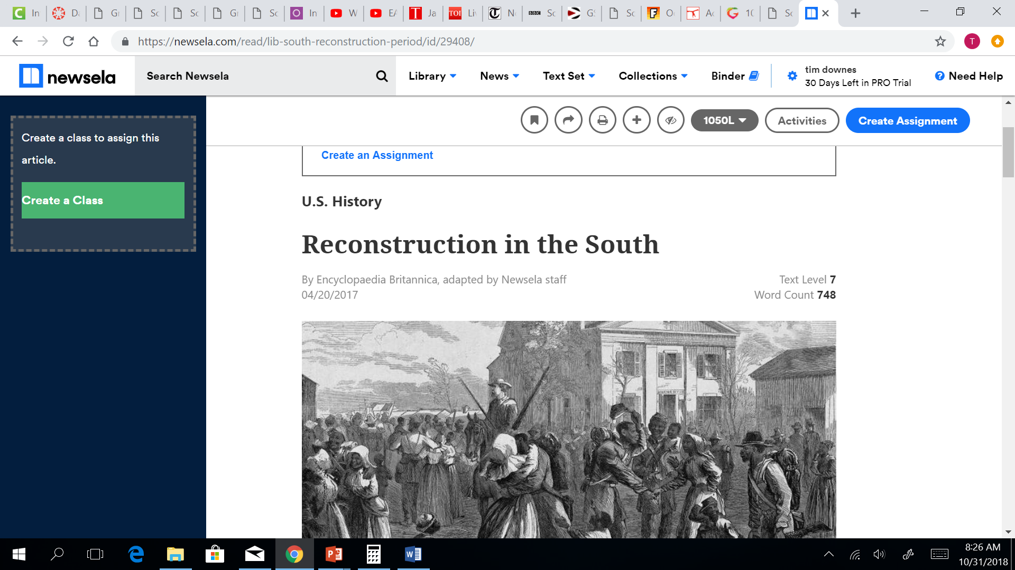

Additional information:
Although South Korea chooses its leaders differently than Japan and India, they are all democracies. The people tend to have a lot of freedom and choose their leaders. North Korea is an autocracy, which means that people do not get to choose their leaders. People in an autocracy have very little freedom. China is an oligarchy (single party state) which means that only some people have a say in the government. These people who have a say in the government receive preferential treatment by the government and frequently the government is unfair to people who don’t have a say in what it does.

