Mexico is a land of extremes. In the center of this large country are high mountains and deep canyons. There are sweeping deserts in the north and dense rainforests in the south and east.
Mexico has many mountains and four major mountain ranges. In the east is the Sierra Madre Oriental mountain range. In the west is the Sierra Madre Occidental range. Between them lie the deserts and dry scrublands of the Central Plateau. A mountain range with very high volcanoes runs across the central part of the country. These regions are rich with valuable metals such as silver and copper.
The Yucatán Peninsula is a stretch of land in southeastern Mexico. It juts out into the Gulf of Mexico. This land was once part of the Maya civilization, an ancient culture whose amazing buildings can still be seen today.

Nature
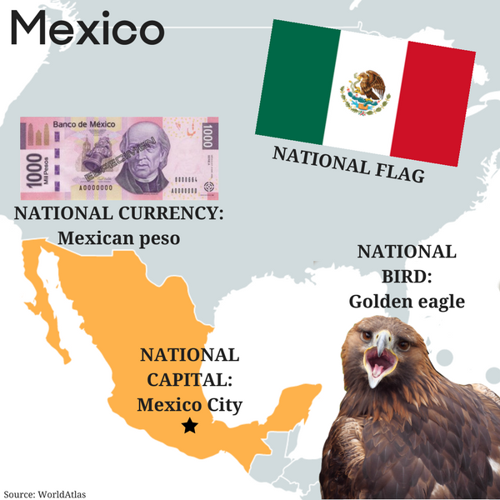
Few countries on Earth have as many plant and animal species as Mexico does. The country is located partway between the equator and the Arctic Circle. As a result, it has a great variety of ecosystems. These habitats support a huge range of wildlife and plant life.
In northern Mexico, deserts are full of plants and animals that have found ways to survive the harsh environment. On Mexico's west coast, gray whales swim down from Alaska. They come to breed in the waters off Baja California.
In eastern Mexico, there are rainforests and coastal wetlands. These areas are home to thousands of different tropical plants. Rare animals such as jaguars and quetzal, a colorful bird, are found here, too.

People and Culture
Mexico is the product of a rich native heritage and 300 years of Spanish rule. Today, most Mexicans are mestizos. That means they have a mix of native and Spanish ancestry.
Throughout its history, Mexico has been home to great artists. The Maya and other native groups made amazing sculptures, murals and jewelry. Modern Mexican artists include great painters, photographers and sculptors.
In ancient times, Mexicans took sports seriously. Sometimes the captain of a losing team in a ball game would be put to death! A few dangerous sports are still practiced today in Mexico. They include bullfighting and rodeo.

Government and Economy
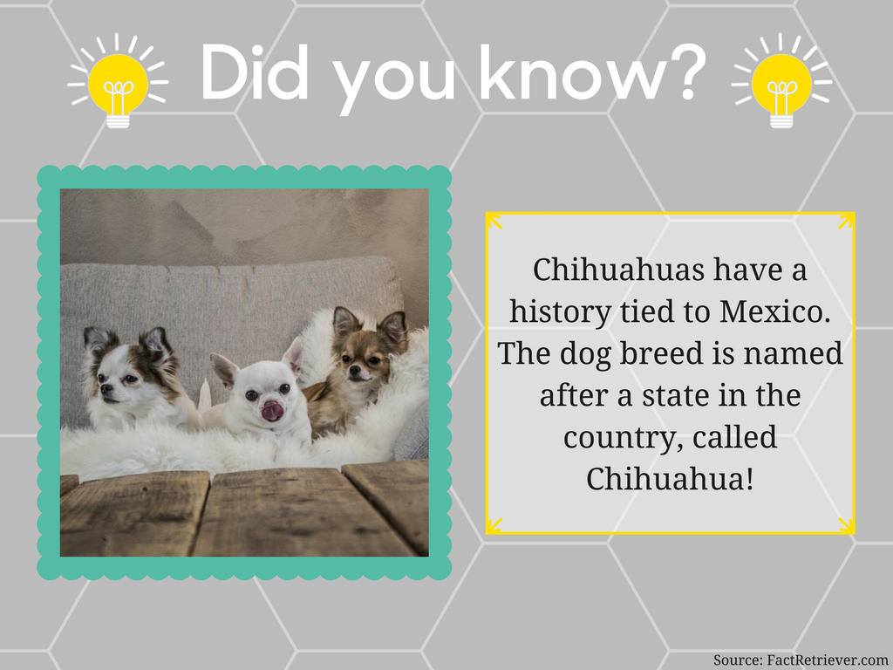
The government of Mexico has three branches: executive, legislative and judicial. The executive branch is led by a president. This leader is elected to serve a single six-year term. Most lawmakers in the legislative branch are also directly elected by the people. The judicial branch is made up of federal and state courts.
Mexico is a country with great problems and great potential. It is rich in natural resources, such as oil, silver, copper and farmland. But political and economic failings have kept many people in poverty.
The Mexico-United States border is one of the great economic divides on Earth. Some Mexicans feel that their best chance for a better life lies in the United States. Hundreds of thousands of Mexicans come to the United States each year in search of work.

History
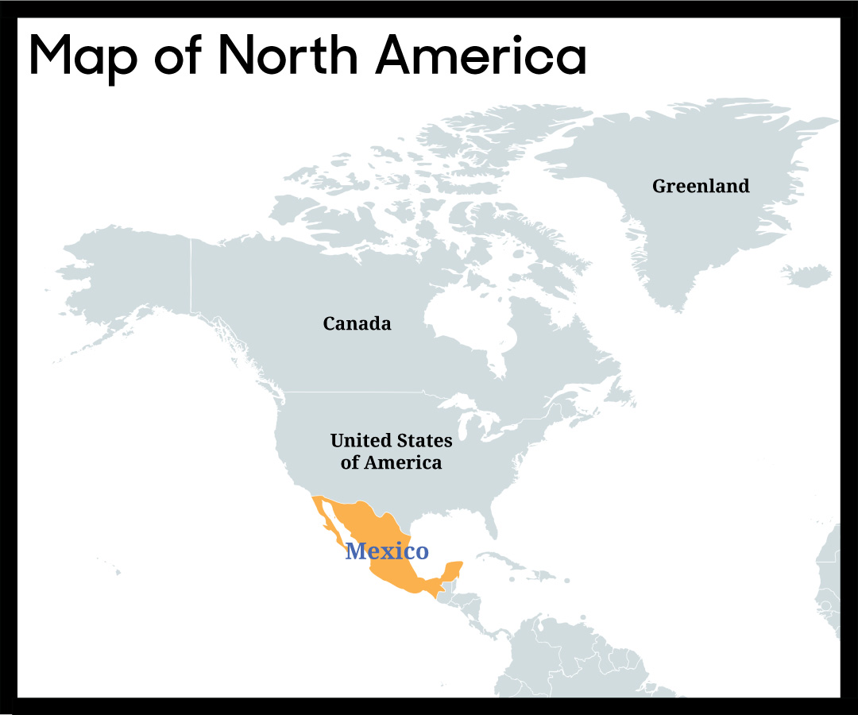
The Olmecs were the first known civilization in Mexico. They emerged in the southeastern part of the country about 3,200 years ago. The Olmecs were later followed by the Maya, the Toltec and the Aztec peoples.
Mexico's ancient societies built great cities and huge pyramids. They created remarkable works of art. They even studied the stars and planets to determine when to plant crops and hold ceremonies.
In the early 1500s, the Spanish arrived in Mexico. The Aztec people got sick from smallpox and other diseases that the Spanish brought with them. The Spaniards also seized and destroyed the Aztec capital, called Tenochtilán.
In 1810, the Mexican War of Independence began. The people of Mexico fought for their independence from Spain. Spanish rule finally ended in 1821.

