Countries of the World: Brazil
Word Count 794
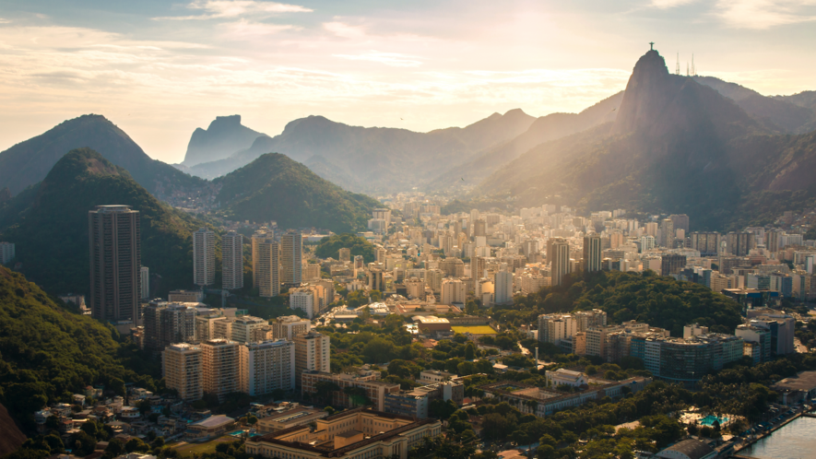Image 1: Rio de Janeiro is a large city in Brazil. The city itself sits next to the Atlantic Ocean. It is a tourist spot because of its beaches, hiking and famous statue, Christ the Redeemer.

Brazil is the largest country in South America and the fifth largest nation in the world. It forms an enormous triangle on the eastern side of the continent with a greater than 4,600-mile coastline along the Atlantic Ocean. It has borders with every South American country except Chile and Ecuador.
The Brazilian landscape is very varied. It is most well-known for its dense forests, including the Amazon jungle, the world's largest rain forest, in the north. But there are also dry grasslands (called pampas), rugged hills, pine forests, sprawling wetlands, immense plateaus and a long coastal plain.
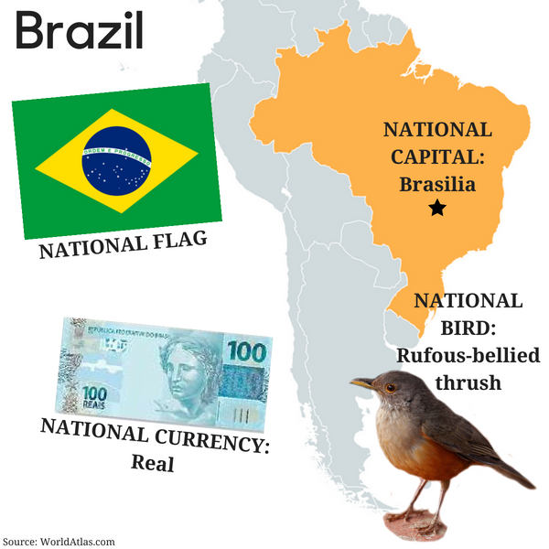
Northern Brazil is dominated by the Amazon River and the rainforest that surrounds it. The Amazon is not one river but a network of many hundreds of waterways. Its total length stretches at least 4,000 miles, making it the longest river on Earth, according to some scientists. Thousands of species live in the river. They include the infamous piranha and the boto, or pink river dolphin.
Southeastern Brazil was once completely covered with dense forest. Now it is the country's industrial capital, home to Brazil's biggest cities: São Paulo and Rio de Janeiro. The area consists of only 11 percent of the country but houses 43 percent of its population.

Nature
Brazil has the greatest variety of animals of any country in the world. Every year, in fact, scientists discover more diversity in Brazil. The country has more than 750 mammal species and 3,200 or more fish species. It is also home to some 1,800 bird species and at least 100,000 different types of insects (though some scientists say there are four times that many!). Most of Brazil's animal life live in the country's jungles, but many unique species also live in the pampas and semi desert regions.
In the central-western part of Brazil sits a flat, marshy area called the Pantanal. This patchwork of flooded lagoons and small islands is the world's largest wetland. Here live giant anacondas, huge guinea pig relatives called capybaras and fierce South American alligators called caimans.
For thousands of years, people have been using the resources of the jungles of Brazil. But since Europeans arrived about five centuries ago, forest destruction has been rampant. Most of Brazil's Atlantic rainforest is now gone. Huge tracts of the Amazon are disappearing every year. The government has established many national parks and refuges. These cover about 29 percent of the country's land.

People and Culture
Most Brazilians are descended from three ethnic groups: Amerindians, European settlers (mainly from Portugal) and Africans. Starting in the 19th century, waves of immigrants from Europe, the Middle East and even Japan added to this mix. This diversity of cultures has created a rich religious, musical and culinary culture.
Brazilians are soccer crazy, and their country has produced some of the best players. Perhaps the most famous of all is Edson Arantes do Nascimento, better known as Pelé. Brazil has won the World Cup soccer finals five times, more than any other nation.

Government and Economy
Brazil is a federal republic with a president, a National Congress and a judiciary. From 1888 until recently, the country struggled with democracy. But in 1985, the military government was peacefully removed, and by 1995, Brazil's politics and economy had become fairly stable.
Brazil has many different soils and climates, so it can produce a great variety of crops. Its agricultural exports include sugarcane, latex, coffee, cocoa beans, cotton, soybeans, rice and tropical fruits.
Brazil is also South America's most industrial nation. The country produces chemicals, steel, aircraft and cars.

History
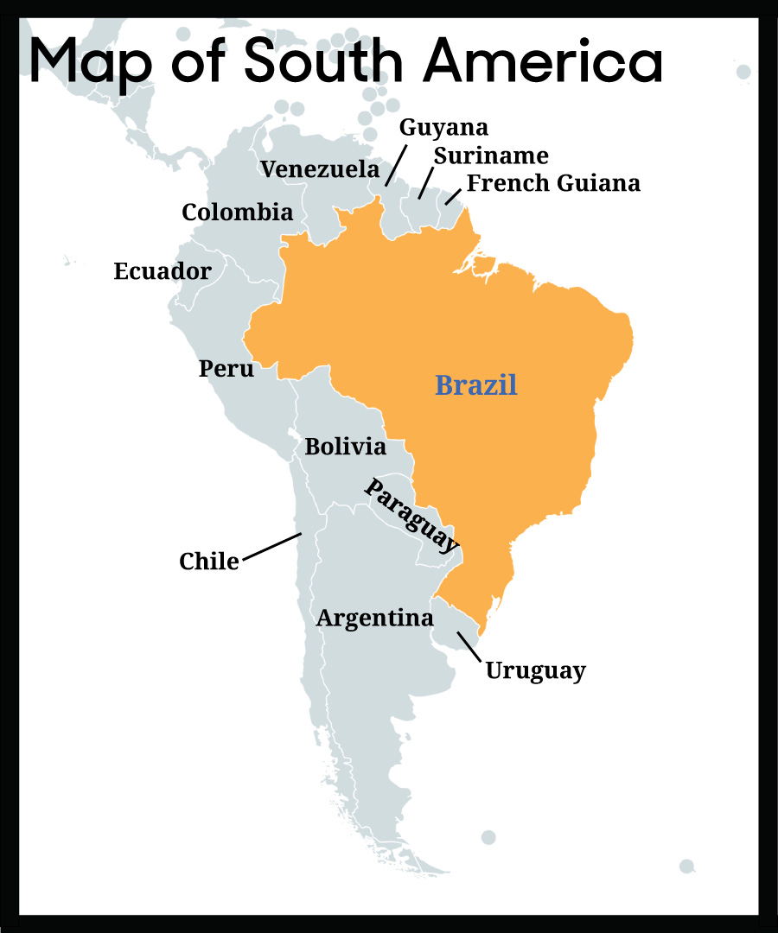
The earliest proven settlement in Brazil dates from 11,000 years ago. These were the ancestors of the indigenous people who still live in Brazil today.
Brazil was added to the map of the world during the great European explorations in the late 15th century led by Portugal and Spain. When Europeans first reached the coast of Brazil in 1500, the country was home to several million indigenous people, or Amerindians. Today, about 817,000 remain, living primarily in Brazil's remotest places.
Portugal began colonizing Brazil in 1530. Colonists created sugarcane plantations along the coast. Soon, people from West Africa were brought to Brazil to work as slaves. In the 1690s, the discovery of large inland gold reserves brought thousands of people from the coasts and as far away as Europe to the interior of the country.
In 1789, a small uprising broke out against the Portuguese. The rebellion was soon put down, but it started a movement toward independence. By 1822, Brazil proclaimed independence from Portugal. Kings of Portuguese blood ruled until 1889, when military leaders and landowners expelled the king, and Brazil became a federal republic

