Canada is a vast and rugged land. From north to south it spans more than half the Northern Hemisphere. From east to west it stretches almost 4,700 miles across six time zones. It is the second-largest country in the world, but it has only one-half of one percent of the world's population.
Canada features black-blue lakes, numerous rivers, majestic western mountains, rolling central plains and forested eastern valleys. The Canadian Shield, a hilly region of lakes and swamps, stretches across northern Canada. This region has some of the oldest rocks on Earth.
Canada's far north lies in the frozen grip of the Arctic, where ice, snow and glaciers dominate the landscape. Few trees grow here, and farming is not practical. Native Canadians, called First Nations people, live in this region by hunting and fishing.

Nature
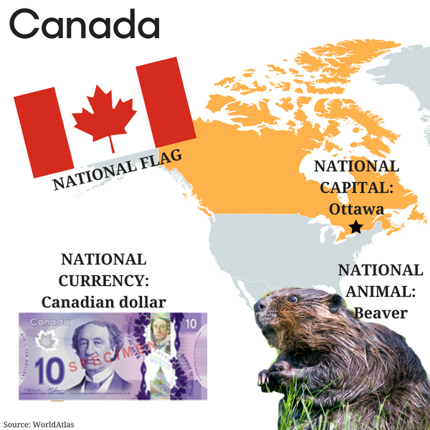
Canada's remote north and extensive forests are home to wildlife, from bears, wolves, beavers, deer, mountain lions and bighorn sheep to smaller animals like raccoons, otters and rabbits. The country's lakes and rivers contain about 20 percent of all fresh water on Earth. They are full of fish such as trout and salmon.
Canada's prairies in the south are home to bison and pronghorn antelope. Farther north are Canada's sprawling evergreen forests, which have lots of wildlife, including moose and black bears. Even farther north is the cold, bare tundra, where herds of caribou and musk ox live.
Canadians work hard to protect the native wildlife. Canada has 41 national parks and three marine conservation areas. Nevertheless, species like wolves, lynx and Atlantic fish have been overhunted and overfished.

People and Culture
In some ways Canada is many nations in one. Descendants of British and French immigrants make up about half the population. They were followed by other European and Asian immigrants. First Nations peoples make up about four percent of the population.
Inuit people live mostly in the Northwest Territories and Nunavut. Many Native Canadians live on their traditional lands, but many others have moved to cities across Canada. First Nations artwork is widely recognized and is seen as a symbol of Canadian culture.

Government and Economy
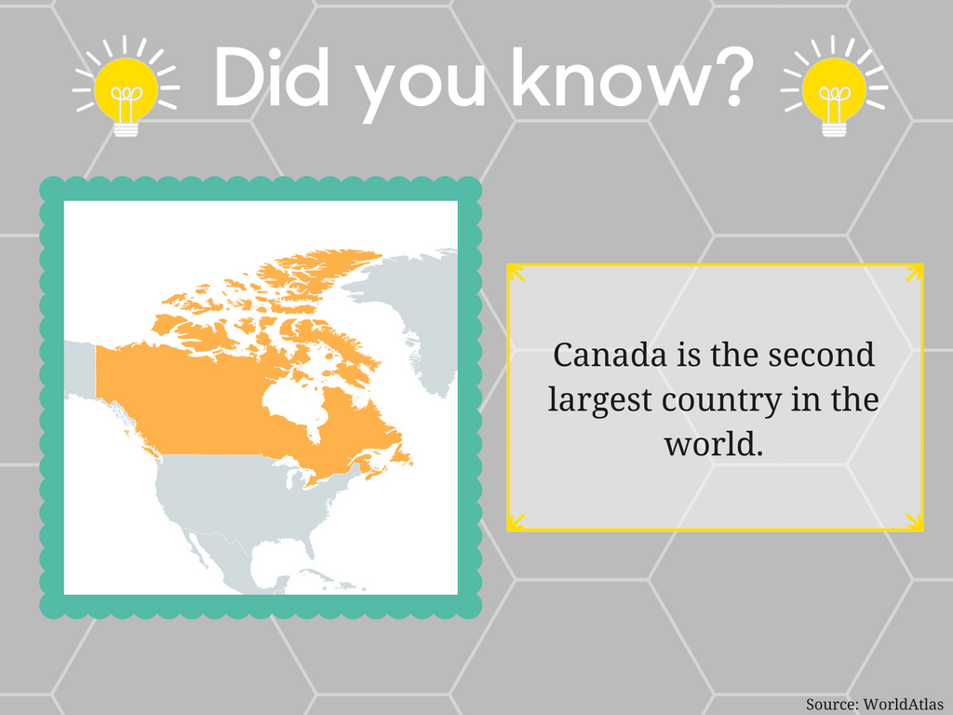
The British monarch is the head of state of Canada. The monarch is represented by a governor-general, who has very limited powers. Laws are made by Canada's elected federal government, which includes a parliament and a prime minister.
Britain's Quebec Act of 1774, granted Quebec its own legal and religious rights. Despite this concession, many Quebec citizens have long sought independence. In votes held in 1980, and 1995, Quebec decided to stay in Canada. But the second vote was very close, and the debate is still alive.
Canada has provided fish, furs and other natural resources to the world since the 1500s. Today, it is a world leader in agricultural production, telecommunications and energy technologies. The vast majority of Canada's exports go to the United States.

History
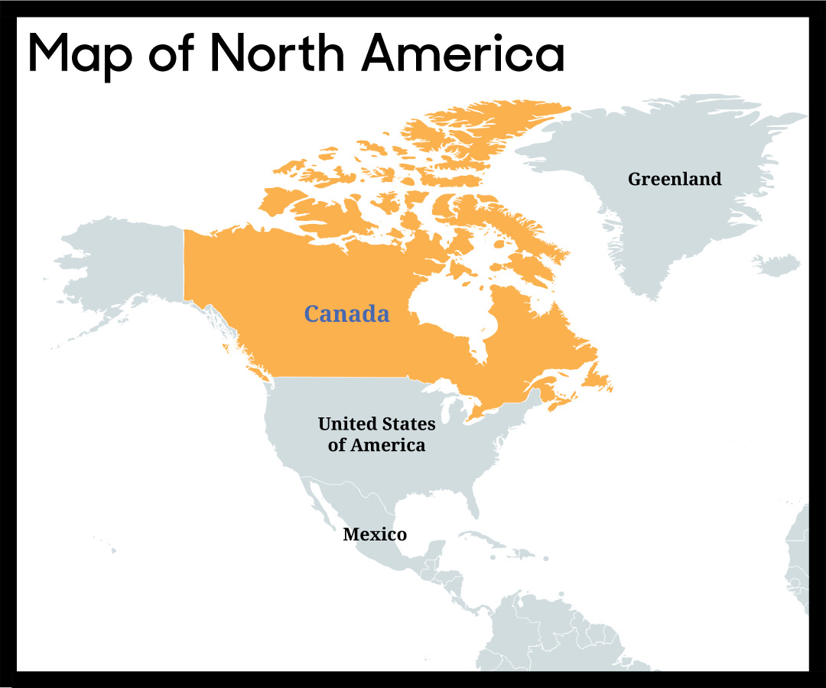 The first people to come to Canada arrived between 15,000 and 30,000 years ago across a land bridge that joined Asia and North America. Around A.D. 1000, the Viking explorer Leif Erikson reached Newfoundland, Canada. He tried to establish a settlement, but it didn't last.
In the 16th century, French and British settlers arrived. Land disputes between farmers and fur traders led to four wars between 1689 and 1763. The final war, called the French and Indian War, left the British in control of Canada, but French influence remains strong even today.
In 1867, Ontario, Quebec, Nova Scotia and New Brunswick combined to form a dominion with its own government, parliament and prime minister. Manitoba joined soon after. In 1931, Canada became an independent nation.

