How the Canadian Provinces and Territories Got Their Names
BY MATT SONIAK

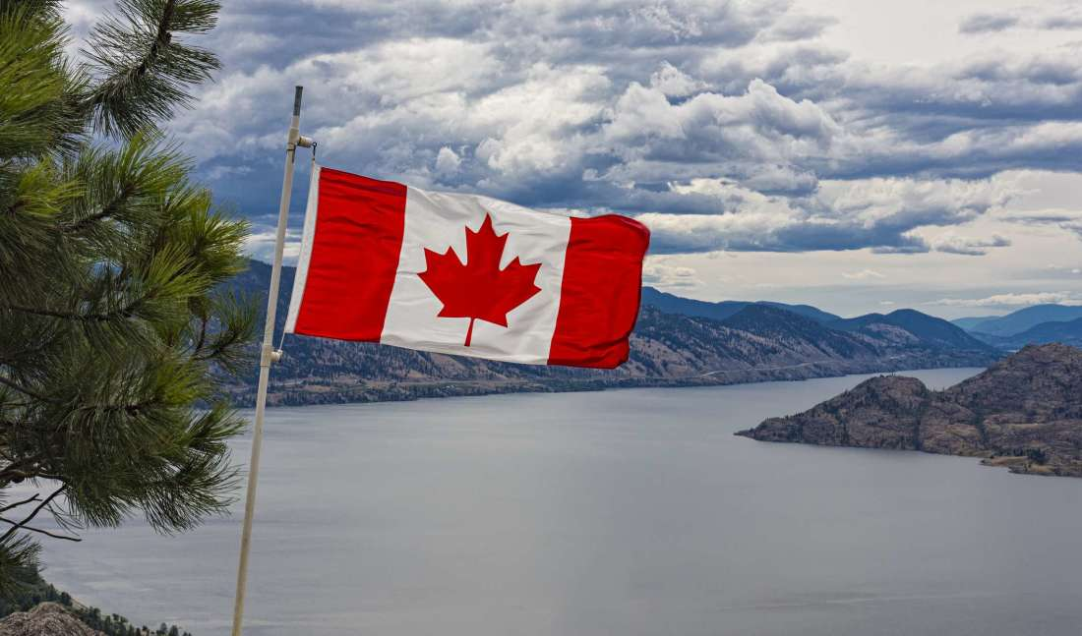

Alberta
Named in honor of Princess Louise Caroline Alberta (1848-1939), the fourth daughter of Queen Victoria and Prince Albert and the wife of the Marquess of Lorne, Governor General of Canada from 1878 to 1883. Lake Louise, the village of Caroline, and Mount Alberta are also named after her.

British Columbia
The name refers to the Columbia District, the British name for the territory drained by the Columbia River. Queen Victoria specified that the area be called British Columbia to distinguish the British section of the District from that which belonged to the United States (which became the Oregon Territory). The river, in turn, took its name from the Columbia Rediviva (formerly the Columbia; the Latin rediviva, or “revived,” was added to the name after the ship’s 1787 rebuilding), a privately owned ship that was the first American ship to circumnavigate the globe and was used extensively in the Pacific Northwest maritime fur trade.

Manitoba
Believed to be derived from the Ojibwa manito-bah (sometimes written as manitobau) or Cree manito-wapow (also written as manitowapow), both of which translate to “the spirit straits” and probably refer to the straits of Lake Manitoba.
New Brunswick
Refers to Brunswick, the English translation of Braunschweig, the city in northern Germany that was the ancestral home of King George III of Great Britain.

Newfoundland and Labrador
Newfoundland is derived from the English translation of its original Latin name, Terra Nova or “new land” and is the oldest European place name in North America. Labrador is likely named for João Fernandes Lavrador, a Portuguese navigator who explored the area in the late 1400s and whose honorific “lavrador” means “landholder.”

Northwest Territories
Named for its location in the northwest area of the country. There was talk of changing the name, possibly to a term from a native language. Among the popular proposals were “Denendeh,” an Athabaskan word meaning “our land,” and “Bob.”

Nova Scotia
From the Latin nova, feminine of novus (“new”), and Scotia (“Scotland”), literally “New Scotland.”

Nunavut
From an Inuktitut (the language of the Inuit) word meaning “our land.”

Ontario
Named after Lake Ontario. The word is thought to be derived from either the Wyandot ontarí: io (“great lake”) or Iroquoian skanadario (“beautiful water”).

Prince Edward Island
Named after Prince Edward, Duke of Kent and Strathearn, son of King George III and Commander-in-Chief of the British army in North America.

Quebec
Derived from the Algonquin kébec, which has been translated as “where the river narrows,” “strait narrows” and “it narrows,” and refers to the area around Quebec City where the Saint Lawrence River narrows to a cliff-lined gap.

Saskatchewan
Named after the Saskatchewan River, which takes its name from the Cree word kisiskāciwani-sīpiy or “swift flowing river.”

Yukon
Named for the Yukon River, the name of which is derived from the Gwich'in word for “great river.”

