The decline — and possible comeback — of a small but important fish - By National Geographic, adapted by Newsela staff 07/06/2017
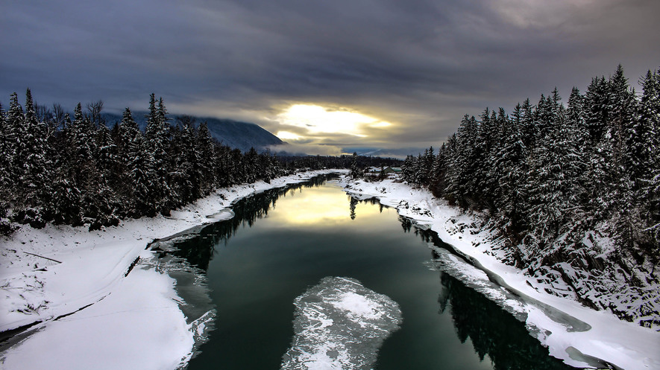
You may have never heard of eulachon. Yet, this small silver-blue fish has long been central to the lives of many Native American people.
Each year, ocean-living eulachon return to the rivers of the Northwest to release their eggs, or spawn. They arrive at the end of winter. In the past, food supplies would be running low by that point. In lean years, eulachon meant the difference between life and death for people up and down the Pacific coast.
Eulachon gets eaten by Native peoples. The fish's grease is also important. The oily grease is very nutritious to eat.
Today, though, the fish are fast disappearing. In many places where they were once common, they live on only in memory.
There is still a chance eulachon will be able to stage a comeback. If they do, it will be thanks to the Native people they once kept alive.

Rivers Were Once Full Of Eulachon
Eulachon were once found in great numbers along the Pacific coast. They swam in waters from northern California all the way up to Alaska. The lower Columbia River was one of the greatest eulachon rivers of all. The river marks the border between Oregon and Washington.
For hundreds of years, the Cowlitz tribe fished eulachon on the Cowlitz River, which flows into the Columbia. However, in 1993, the fish didn't come back to the Cowlitz. Meanwhile, in the Columbia River, there were far fewer fish than before.
When the fish failed to bounce back in the years that followed, the Cowlitz and other coastal Native groups began worrying. They were the first to start asking questions.

Changes in the Ocean
Megan Moody is a member of the Canadian Nuxalk tribe. She grew up catching eulachon in the Bella Coola River on British Columbia's central coast. She is also a scientist.
Some years ago Moody decided to study the problem of the eulachon's disappearance. She quickly discovered that very little was known about the fish. She believes this is because eulachon have very little value for non-Indians.
Moody believes the eulachon's disappearance is related to changes taking place in the ocean. After all, eulachon spend more than 95 percent of their lives in the Pacific.
The Pacific Ocean's average temperature has been steadily rising. Warming oceans can lead to shifts in food supplies and the increase of certain predators.

A Series of Problems
Scientists say the rise in ocean temperature is due to climate change. Climate change is also known as global warming. It is caused by the burning of coal, gas and other fossil fuels.
Moody thinks climate change was only the first problem. Ocean shrimp fishing made things even worse, she says. Shrimp nets were killing large numbers of eulachon unintentionally.
Today, both the U.S. and Canada are taking important steps to protect the eulachon. The change is due in part to Moody's work.
The dangers threatening eulachon continue to grow.
Across the Pacific Northwest, the coast areas are becoming busier. There are now plans to move far more oil and gas through these areas. If that happens, it would increase the danger of oil spills. One bad oil spill could wipe out an entire eulachon population.

Welcome Back, Eulachon
Yet there are also signs that eulachon could be making a comeback. In part, this could be because shrimp boats are taking new steps to avoid catching eulachon by accident. These changes have been working very well.
In some locations, the fish seem to already be returning. In 2013, Nuxalk people along the Bella Coola River saw schools of eulachon arriving. Their appearance was a shock in a place where no one under the age of 20 could remember such a scene.
Over the following months, the community prepared to bring back the tradition of the eulachon welcoming ceremony. The ceremony hadn't been performed in decades.
Last year, the eulachon returned to the Bella Coola in great numbers. Hundreds of people sang and danced to welcome them, and a totem pole was raised to face the sea.

Liquid Gold
That same season was a hard one on the Nass River.
There were enough fish to make grease, but not as many fish as the tribe was used to.
To make the grease, the aged eulachon are ultimately loaded into what the Nisga'a call pots. They are huge, sealed tubs that can cook more than 4,000 pounds of fish at a time.
During the cooking, the eulachon oil separates to form a see-through layer. Strained into buckets, the grease ranges in color from palest gold to nearly black, depending on how long it has been aging.
A single round of cooking can be what one grease camper calls "an all-dayer, all-nighter." After so many hours in the smelly steam, many men simply throw their clothes in the garbage.

