North America: Physical Geography

By National Geographic, adapted by Newsela staff
North America is the third-largest continent. It extends from Canada in the north to Panama in the south. Like an upside-down triangle, it is wide at the top, stretching halfway around the world. In the south, it narrows to just 31 miles across.
North America can be divided into five physical regions: the mountainous west, the Great Plains, the Canadian Shield, the eastern region and the Caribbean.
Within these regions are all the major types of biomes in the world. A biome is a community of animals and plants that share the same environment. Some of the biomes found in North America include desert, grassland, tundra and coral reefs.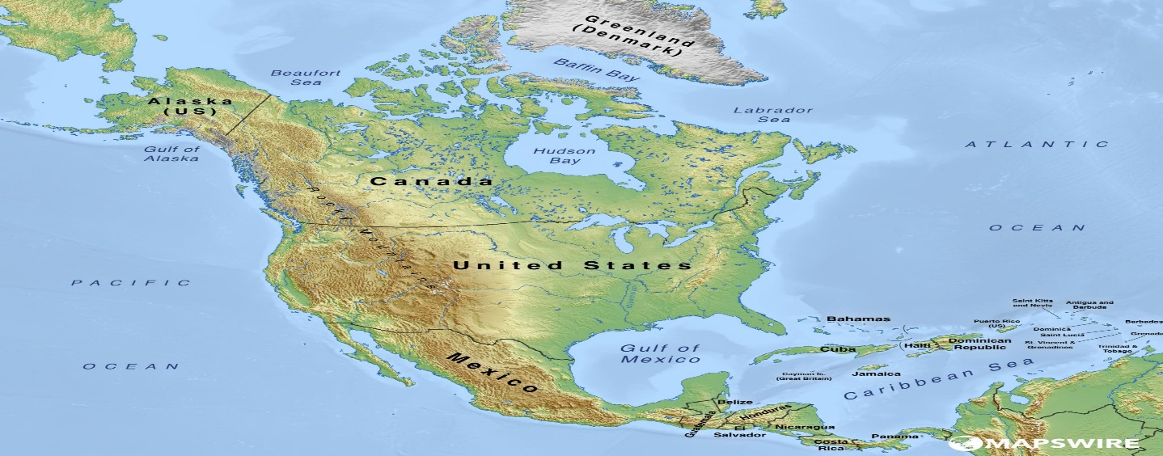

Western Region
North America's western region is marked by mountains and deserts. The most familiar of its mountain ranges are the Rockies, North America’s largest mountain chain. The Rockies stretch from Canada in the north to the U.S. state of New Mexico in the south.
The Rocky Mountains are part of a system of mountain ranges known as the Cordilleras. They continue all the way south to Panama. They include the Sierra Madre mountain system, which stretches from the southwestern United States to Honduras.
Some of the Earth’s youngest mountains are in the U.S. states of Washington, Oregon, and California. Some peaks began to form only about a million years ago. The mountains include a rare biome called a temperate rainforest. This area gets an amazing amount of water and supports a wide variety of life. Some trees there grow to more than 300 feet tall. Black bears, elk and marmots are native animal species. 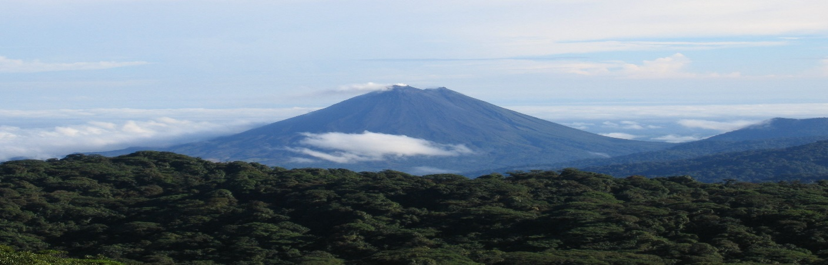Arenal Volcano as seen from the Montverde Cloud Forest Reserve in the Cordillera de Tilarán, Costa Rica. The three major desert regions of North America, the Sonoran, Mojave, and Chihuahuan, are all in the American southwest and northern Mexico. They are located near mountain ranges. The mountains block rainfall and move hot, dry wind over these regions.

Great Plains
The Great Plains lie in the middle of the continent. These areas have rich, deep soil. This makes it easy to grow grain, like wheat, there. That's how the area became known as the “Breadbasket of North America.”
Much of the fertile soil was formed from material deposited during the most recent glacial period. This ice age reached its peak about 18,000 years ago. As glaciers retreated, streams of melted ice left behind rich soil.
The grassland or prairie regions of the Great Plains make up the largest biome in North America. Extreme weather prevents the growth of large plants but is perfectly suited to the growth of native grasses. Grass in the plains varies in length, growing up to seven
feet in some places. Native animal species include bison, prairie dogs and grasshoppers.
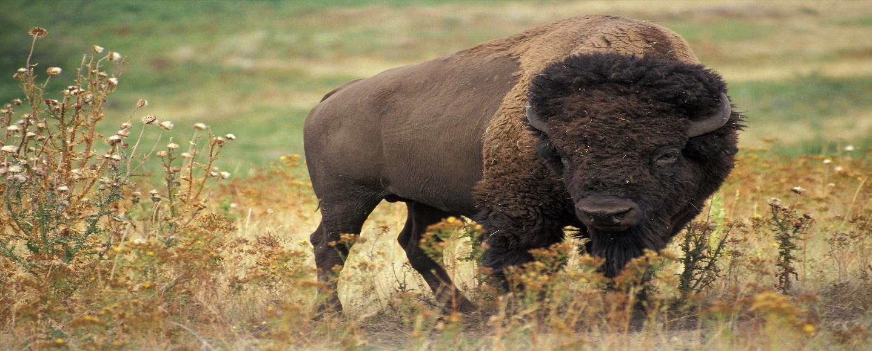

Canadian Shield
The Canadian Shield is a raised but relatively flat plain. It extends over eastern, central, and northwestern Canada. The Canadian Shield is rocky and dotted with lakes.
Tundra stretches along the northern borders of Alaska and Canada to the Hudson Bay area. A tundra is a biome in which low temperatures, along with snow and ice, keep trees from growing. The soil is frozen in the tundra. Some plants can grow in it, though.
During the summer, the top layer of soil starts to melt, forming lakes, ponds, and bogs. Plant life grows in these shallow waters. They provide food for local animals, like caribou.

Eastern Region
The eastern region includes the Appalachian Mountains and the Atlantic coastal plain.
North America’s older mountain ranges, including the Appalachians, rise near the east coast of the United States and Canada. The Atlantic coastal plain includes river, marsh, and wetland regions east of the mountains. It also includes the sandy beaches of the Atlantic coast.

