New France is the name given to France's colonies in North America. New France existed for nearly 230 years from 1534 to 1763. At first, it was made up of regions bordering the St. Lawrence River, along with Newfoundland and Acadia, which today is called Nova Scotia. Over time, it expanded from these areas, now part of Canada, to include much of the land that is now part of the Midwestern United States. People in the Canadian province of Quebec still speak French.

Putting New France on the map
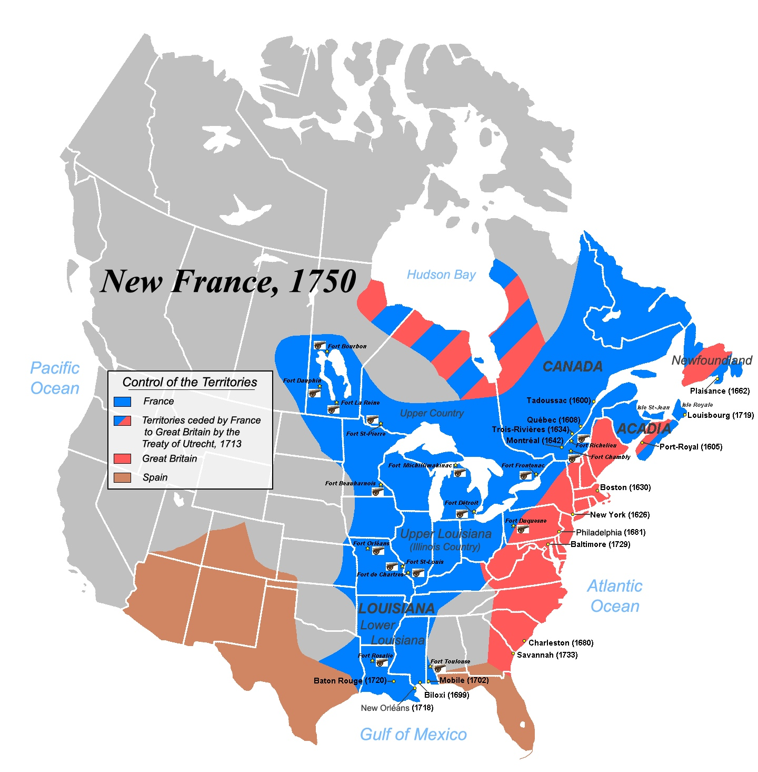
The name New France first appeared on a map in 1529. Five years earlier, Giovanni da Verrazzano had explored the coasts of North America for France. He traveled from what is now the Carolinas north to Nova Scotia.
In 1534 the French explorer Jacques Cartier entered the Gulf of St. Lawrence. He claimed the land around it for France and named it New France. Cartier then sailed up the St. Lawrence River as far as the Lachine Rapids, to where Montreal now stands. He later founded a colony in what is now Quebec City, though it quickly failed.

Fur trade, the founding of Quebec
Cartier's explorations led to the beginning of the French fur trade with the Native Americans. The fur trade later became the most important commercial activity in New France.
Samuel de Champlain was the next key figure in the history of New France. Champlain was employed by various fur-trading companies and sailed into the St. Lawrence River in 1603. In 1604 he helped found the first permanent French colony in North America: Port-Royal, which is now called Annapolis Royal, Nova Scotia. In 1608, he began a settlement named Quebec, which was situated on the banks of the St. Lawrence River.
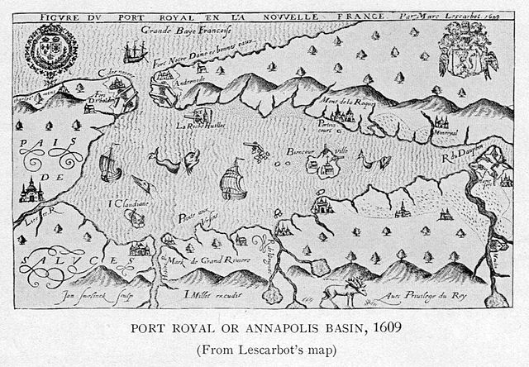A map of Port-Royal. This was the first French colony in North America. Photo from Wikimedia.
In 1627, the colony was granted to a fur company, the Company of New France. The company focused on the fur trade and did little to attract permanent settlers.

New France becomes a royal province
In 1663 King Louis XIV decided to take control of the colony away from the Company of New France. The king made New France into a royal province, overseen by a governor and an intendant. In addition, the King sent a regiment of soldiers to the colony. In 1666, these soldiers defeated a group of Iroquois Native Americans and forced them to make peace. It then became possible to develop New France. More than 3,000 settlers, including girls of marriageable age, were sent out to this area from France in the 1660s, and the population soon began to expand rapidly.
The first intendant was Jean Baptiste Talon in 1665. He pushed for the exploration of the far west. Louis Jolliet explored the Mississippi River. In 1671 Simon François d’Aumont took possession of all the interior of the North American continent for France. At least on French maps, the huge stretch of land all became part of New France.

Fighting the British and the Iroquois
Meanwhile, Britain and France were competing intensely for land and trade on the American continent. During King William’s War, British forces seized Acadia, but the French fought back attempts to take Quebec in 1690.
The French then began a series of border raids on New England, and finally marched into the areas of the Iroquois Native American tribe. Meanwhile, the brilliant young Canadian Pierre le Moyne d’Iberville had conquered British posts, taken back Acadia and overrun Newfoundland.

Adding Louisiana to New France
The war was ended by the Treaty of Rijswujk in 1697. New France now controlled Hudson Bay in Canada and had taken back all its former possessions. These victories were the work of Canadians, with little help from France.
D’Iberville then set off to found Louisiana, another part of New France, in 1699. In 1700 and 1701 peace was made between the Iroquois tribe and New France. There were to be no more Iroquois wars, and New France stood at the height of its fortunes.
Then New France's decline began almost at once. In little more than 60 years, the English and their American colonists were able to conquer all New France.

Another war with Britain
Initially, most of the fighting was done in Europe. As part of the Treaty of Utrecht, which was signed in 1713 after the English won battles in Europe, the British reclaimed Hudson Bay and took control of Acadia.
In 1756, the Seven Years’ War began in Europe. The American part of this conflict, the French and Indian War, brought about the downfall of New France. In 1758, the Fortress of Louisbourg in Acadia fell to the British. In 1759 James Wolfe captured Quebec and in 1760 Montreal surrendered to Jeffery Amherst.
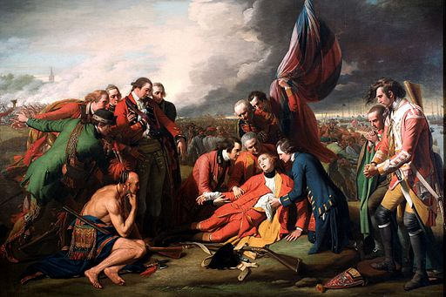British General James Wolfe is fatally wounded at the 1759 Battle of Quebec during the French and Indian War. Photo from Wikimedia.
The war finally ended in 1763. Under the Treaty of Paris, all New France east of the Mississippi, except New Orleans, was given to Great Britain. Only two little islands, St. Pierre and Miquelon, both near Newfoundland, were left to France. In what now is called the province of Quebec, more than 60,000 French-Canadians became British subjects.

