Canada's Wonderland: Record-breaking Yukon Striker coaster announced
By Arthur Levine, USA Today, adapted by Newsela staff 08/22/2018

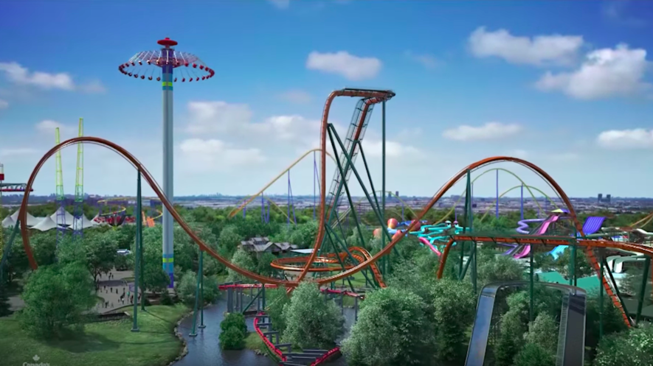 The Yukon Striker is set to be a big thrill ride!
What a dive.
That may not sound like a compliment. But Canada's Wonderland, located near Toronto in Vaughan, Ontario, will welcome the declaration beginning in spring 2019. That's because the theme park announced today that it would open the Yukon Striker. It will be the world's tallest, fastest and longest dive coaster.
What, you may wonder, is a dive coaster? It's a thrill machine that takes advantage of the nervous anticipation riders experience as they scale the lift hills of coasters. Instead of click-clacking up and immediately dropping down the other side into a gravity-fed frenzy, a dive coaster stalls and halts the train just over the peak to let passengers think over the impending mayhem for a few knee-knocking seconds.
The Yukon Striker's riders will stare down a 245-foot, 90-degree drop that will accelerate them to 80 mph. What a dive, indeed.
The coaster's massive trains will include three rows of eight riders. The floorless design will allow passengers to dangle their legs. The cantilever trains will extend beyond the track and will leave riders in the seats at both ends of the rows feeling especially open and vulnerable.
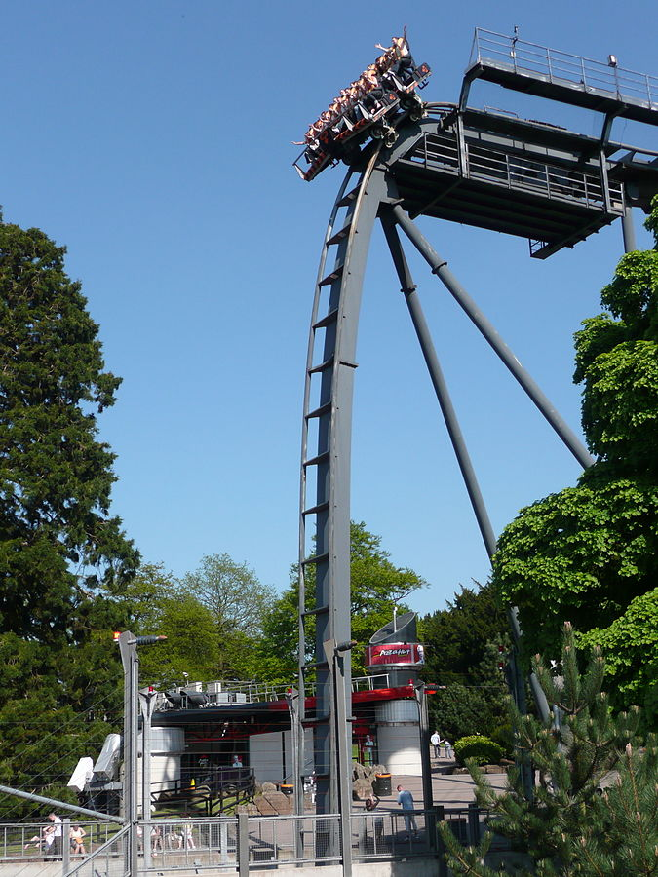 The main drop on a diver coaster called Oblivion at Alton Towers in the United Kingdom. Photo: Wikimedia
After climbing the lift hill, Yukon Striker will perform a slow half-carousel turn at its apex. This will offer dramatic views of the park as well as the Toronto skyline. Although it will dive 245 feet, the coaster won't climb quite that high. That's because the drop will extend below the ground into an underwater tunnel. Riders will then experience four disorienting inversions that will deliver both sensations of weightlessness and bone-crushing positive G-forces. They will also get a second dive and navigate a helix before returning to the station.
The coaster will be part of Frontier Canada. It's a newly themed land that will evoke the Klondike Gold Rush of the late 19th century. It will incorporate other existing rides, too. These include the wooden coaster, the Mighty Canadian Minebuster and the river raft ride, White Water Canyon.
The Yukon Striker will be the park's 17th roller coaster. That's a lot of coasters. In fact, it will give Canada's Wonderland international bragging rights.
A few years back, Six Flags Magic Mountain in Valencia, California, and Cedar Point in Sandusky, Ohio, were engaged in a heated dispute. Both wanted to lay claim to the most coasters. There were debates about whether certain rides could really be deemed coasters. Six Flags ultimately pulled ahead and holds the world record, with 19 coasters.
In typical north-of-the-border fashion, however, Canada's Wonderland politely opened a bunch of rides and discreetly entered the fray. With the Yukon Striker, it will tie Cedar Point for second place on the number of coasters chart. Not that it's bragging too loudly.
The park may not seem very familiar to people outside of Toronto. However, it is actually quite popular. "We're among the top seasonal parks in the world for attendance," says Dave Phillips. He's in charge of marketing for Canada's Wonderland.
With so many other coasters on its midways, how will the park's latest entry stand apart? "When people see the Yukon Striker, they'll very quickly realize it's a unique and different ride," Phillips notes. He adds that it will include stadium-style seating. It will also be the first coaster in the park with a 90-degree drop, and will be the first dive coaster in Canada. Compared to similar dive coasters at Cedar Point, Busch Gardens Williamsburg in Virginia and Busch Gardens Tampa in Florida, the Yukon Striker will be the only one to dive underground and include a 360-degree loop. In addition, it will go taller, faster and longer than its counterparts. Knott's Berry Farm in Buena Park, California, opened what it called a dive coaster this year, but a different manufacturer built the ride.
Along with its reveal of the Yukon Striker, Canada's Wonderland made another announcement. The park will remain open through December in 2019 and offer its first holiday event, WinterFest. The event will include ice skating, live shows, seasonal treats, loads of lights and, weather-permitting, a selection of the park's rides.
With the Great White North weather, some disbelievers may be wondering how an outdoor Canadian theme park could be open in December. "It gets cold," acknowledges Phillips. "But people who live here, we're used to it."

