Buried Tools and Pigments Tell a New History of Humans in Australia
By The Conversation, adapted by Newsela staff
08/18/2017
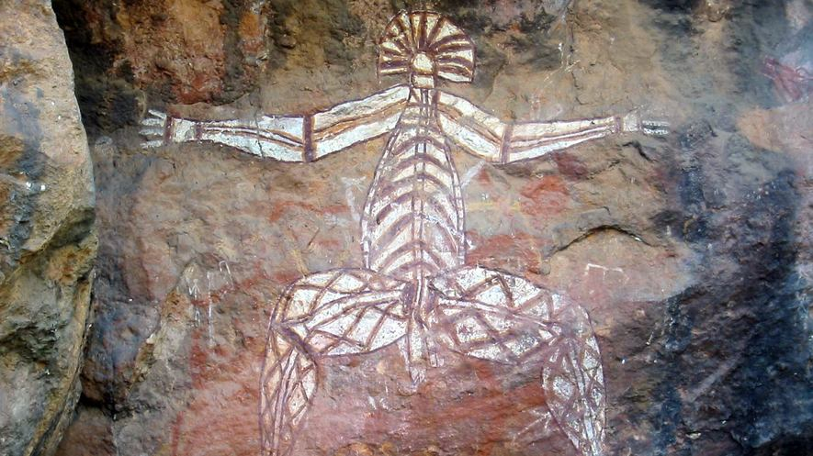
Native rock art at the Anbangbang Rock Shelter in Kakadu National Park, Australia.
Photo by: Thomas Schoch/Wikimedia.
Many years ago, humans arrived in Australia for the first time. This event was remarkable for many reasons.
At the time, it was the largest movement of people across the sea. These people also settled the driest land on Earth. They had to live in a very different environment than they were used to.
So when did people first arrive in Australia?
The question has been debated by archaeologists for years. We know that modern humans were in Africa before 200,000 years ago. They were in China around 80,000 years ago. Many archaeologists believed that Australia was not occupied until 47,000 years ago.
Our studies show something different. We believe humans landed in Australia at least 65,000 years ago.

Questions about measurement accuracy
Our team dug through a site called Madjedbebe in the north of Australia. To do this, we partnered with the Mirarr, an Australian native group that still lives around Madjedbebe.
This site was previously dug up in 1989. At that time, some archaeologists suggested that humans were there about 50,000–60,000 years ago.
But other archaeologists said the measurements were not exact enough. They also mentioned the fact that certain large animals disappeared at a specific time.
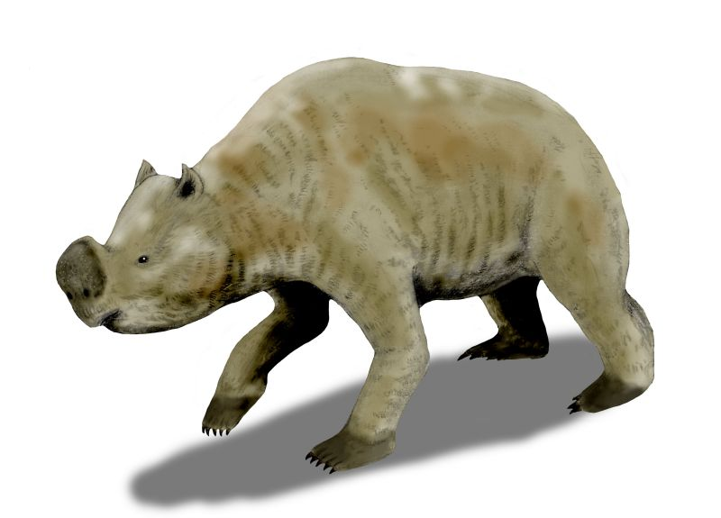Zygomaturus trilobus, a large animal who lived in Australia tens of thousands of years ago. Image: Nobu Tamura/Wikimedia. Megafauna, or huge animals including giant kangaroos and lizards, used to roam Australia. It appears that megafauna started to disappear about 45,000 years ago. Some believe it was humans who caused this, which means they must have arrived in Australia around that time.

New digs, new dates
In 2012 and 2015, our team dug up an area of about 22 square yards at Madjedbebe. That's a bit more than the size of a parking lot.
We found more than 10,000 stone artifacts. We used a laser device to carefully measure where they were placed. Lasers are very precise rays of light. We used these measurements to see how much the artifacts had moved in the sand.
During the excavation, we used special technology to find out how old the artifacts were. We measured when the sand around these items had seen the light for the last time.
Another lab also checked that our measurements were right. The result? We believe that the settlement of Madjedbebe, and of Australia, happened 65,000 years ago.

The global story of human evolution
This discovery answers some of the mysteries about early humans.
Some scientists think that humans quickly caused megafauna to disappear. Now, it appears that humans and megafauna may have lived among each other for 20,000 years. Also, it seems that humans and a humanlike primate may have lived among each other for 15,000 years. This means that when humans arrived they may not have caused other ancient humanlike species to disappear.
We were also able to learn more about how the first Aboriginal, or native, people lived. Like humans today, they were good at solving problems. They also expressed themselves using art and symbols. Symbols are objects or signs that are used to stand for something else.
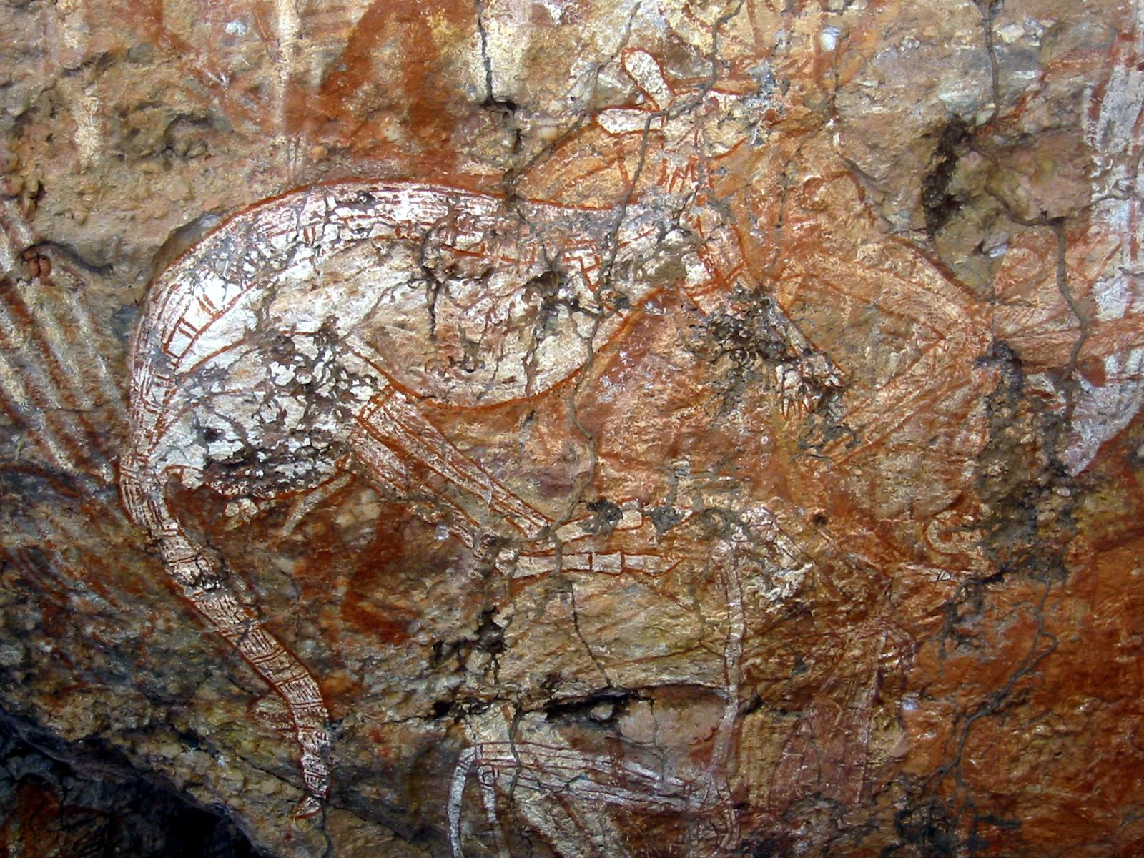Native rock art, similar to that found in Madjedbebe. This one is at Anbangbang Rock Shelter, Kakadu National Park, Australia. Photo: Thomas Schoch/Wikimedia. It appears that these peoples made paints. They ground up mica, a shiny rock. They mixed it with ochre, a reddish dust that comes from the clay soil, to make a paint that looked shiny.

Ancient food and tools
The grinding stones show that fruits, seeds, animals and other plants were ground up for food. These are the oldest known examples of seed-grinding stones found in Australia, and maybe the whole world.
We found ancient fireplaces on the site. In these fireplaces, there were pieces of burnt nuts, fruit seeds and yams. Some of these foods are still eaten today by native Australians.
Scientists usually use artifacts and art from Europe to understand the life of early humans. But the first humans entered Europe around 45,000 years ago. This doesn't help us understand how people lived in southern Asia, Australia and islands in the Pacific Ocean. Our results show that the eastern part of Earth can give us a better picture.

