Australia and Oceania: Human geography
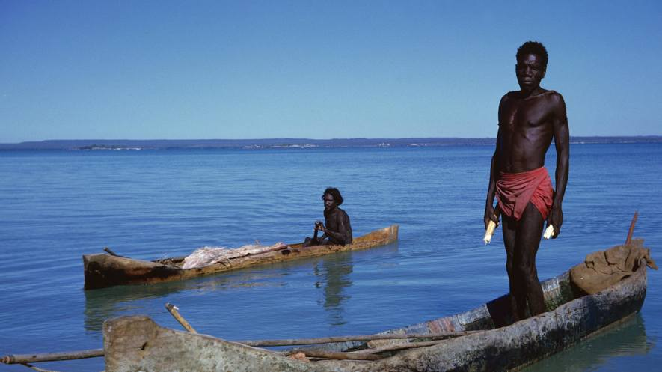
Dugout canoes, introduced by Macassan sailors hundreds of years ago. Northern Territory, Australia.
Oceania is a region made up of thousands of islands. It sits in the Pacific Ocean, a vast body of water larger than all of the landmasses on Earth combined. The name "Oceania" comes from the fact that the Pacific Ocean is the defining part of the region.
Australia, the smallest continent, takes up much of Oceania. There are two other major landmasses. One is the country of New Zealand. The other is the island of New Guinea, which includes the nation of Papua New Guinea. 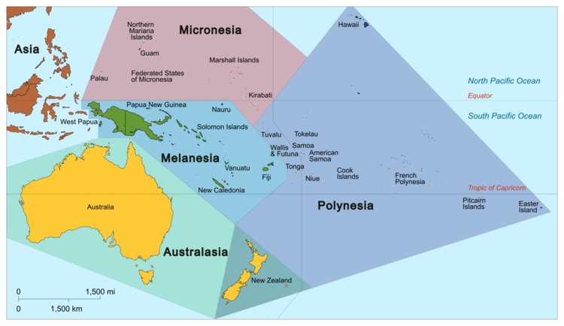
Map of Oceania based on the United Nations classification.
Oceania also includes three island regions: Melanesia, Micronesia and Polynesia (which includes the U.S. state of Hawaii). They are each made up of many islands. Some are independent nations. Others belong to countries like France and the United States.

Historic Cultures
Indigenous cultures are closely tied to the geography of Oceania. Polynesian culture, for example, developed as Southeast Asian sailors explored the South Pacific. This seafaring culture developed almost entirely from its geography.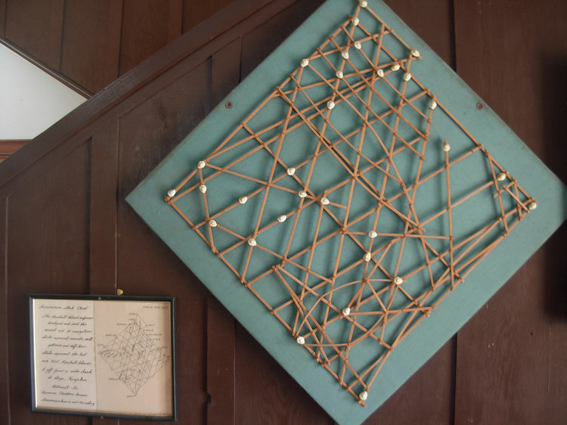
A Micronesian stick chart. The Marshall Island seafarers developed and used this ancient aid to navigation. Sticks represent water currents swell patterns, and drift lines. Shells represent the East and West Marshall Islands.
Beginning about 1500 B.C., sailors began moving east from the island of New Guinea. The farther they traveled, the more advanced they became. Polynesian culture also relied on a sophisticated traveling system based on the stars, oceans and birds.
Polynesians were able to farm plants and animals. Then they took them to islands that lacked them. This allowed Polynesians to establish communities all over the islands of the South Pacific. By the year A.D. 1000, these travelers had colonized the islands of Melanesia, Micronesia and Polynesia. They built an ocean-oriented culture that continues today.
Indigenous cultures of Oceania also changed the environments in which they lived. As they explored the South Pacific, Polynesians brought agriculture to different islands, for example.
In another example, the Maori people had an important effect on New Zealand's forests and animals. Between the 130os and 1800s, Maori cleared about half of New Zealand's forests for agriculture.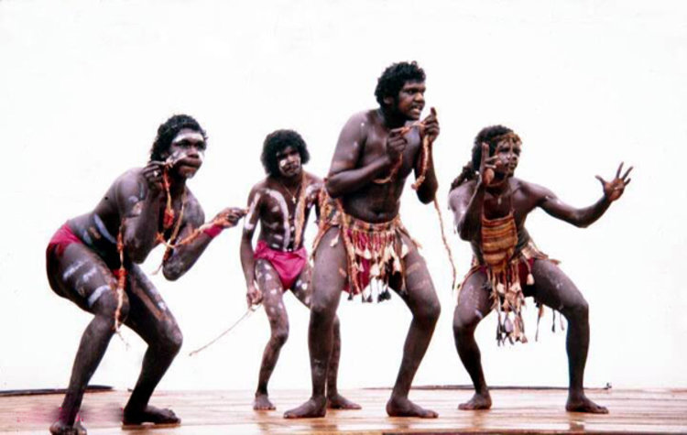Nambassa, Australia, in 1981, Arnhemland and Torrest Strait dance company. Reports say that aboriginals feel the need to abandon their traditions in order to succeed in Australia.
Nearly 40 kinds of birds died out during this period of time. This was due to forest loss, hunting and new animals. Dogs and rats, for example, were introduced to the islands of New Zealand by the Maori, and killed some animals. The Maori also hunted some giant birds until they became extinct.
The native people of Australia are called Aborigines. Aboriginal Australian cultures had strong relationships with their environment. They developed stories to explain the land. Modern science has proven that many of these stories about how the environment and land changed are fairly accurate.

Contemporary Cultures
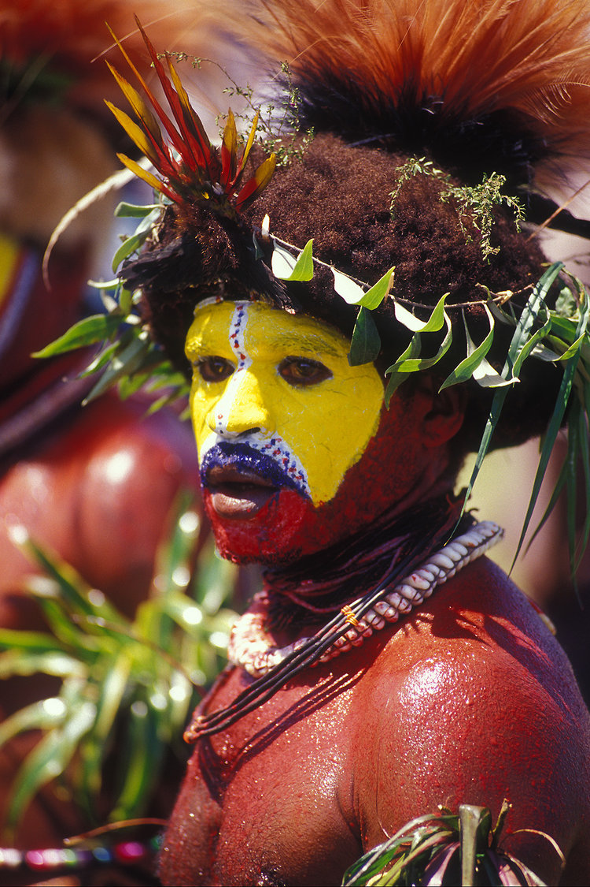
Huli Wigman from Hela Province of Papua New Guinea.
Oceania has a vast, ocean-focused geography. This continues to influence modern cultures. Cultural groups and practices focus on uniting their separate locations and small populations.
Papua New Guinea has more than 700 indigenous groups and 850 languages. Almost all of the land in Papua New Guinea is traditional, tribal land. The government recognizes that this belongs to the indigenous community. But there are disagreements over land use and rights to farm and do mining between indigenous groups, the government and corporations.
Rugby is a very popular sport all over the continent. It is more popular than soccer, baseball or cricket. The rugby games between these countries help bring people together in Oceania.
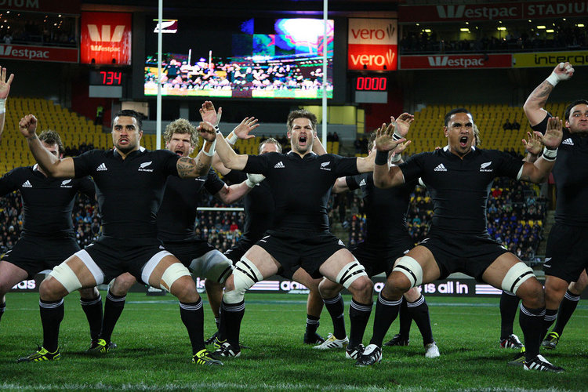
The All Blacks New Zealand rugby team performs the haka before a match against the Springboks South Africa team at Westpac Stadium, Wellington, New Zealand, July 30, 2011.
The arts are another important cultural practice in Oceania. The Festival of Pacific Arts is a festival hosted every four years in a different country. The festival encourages different expressions of Pacific-wide culture, focusing on traditional song and dance.
Tourism is Oceania's largest business. It gives people jobs and money around the Pacific Islands.
Tourism, however, also can hurt. It can lead to overcrowding. The waters have been overfished. Pollution from boats can harm the ocean. Runoff from the islands may also contain pollutants.

Historic Issues
Europeans began colonizing Oceania in the 1500s and took over many islands. Today, many countries in Oceania have majority European populations and a strong European culture. English is the main language around most of the continent.
Indigenous populations were treated harshly during the colonial period. The indigenous groups and their cultural systems have never fully recovered.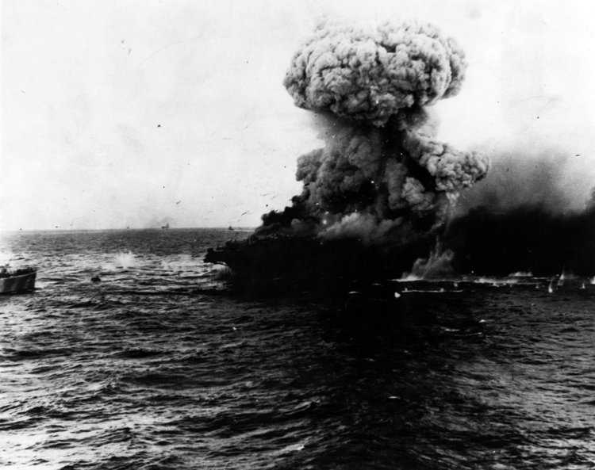
A mushroom cloud rises after a heavy explosion on board USS Lexington, May 8, 1942. Photo: U.S. Navy.
Starting in the 1940s, the U.S., Great Britain and France often tested nuclear bombs in Oceania. The most famous of these experiments were carried out on the Bikini Atoll, part of the Marshall Islands. The U.S. began testing nuclear weapons there in 1946. These tests had terrible human and environmental impacts on the islands.

Contemporary Issues
Over the last half-decade, Oceania's indigenous groups have fought to extend their rights.
The Maori Party represents the rights of the Maori in New Zealand. It works to make sure Maori can get jobs and healthcare.
A Maori Party rally was organized in 2006 to demand better worker's rights.
Aboriginal Australians, much like the Maori, are a marginalized population. They are a group of people who are treated as less important than the majority population. Aborigines are more likely to get sick, go to prison or be jobless. Their life expectancy is almost 20 years less than non-indigenous people.

Future Issues
Oceania will be greatly affected by climate change. That is due to its climate and geography.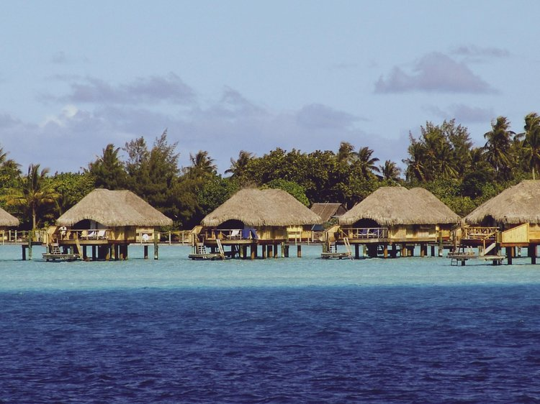Sea level is the base level for measuring elevation and depth on Earth. These hotel bungalows in Bora Bora, French Polynesia, have stilts to take them inches above sea level.
The people of the continent's small islands mostly live near the coasts. They are in danger because of sea level rise. Warming temperatures have severely damaged many coral reef ecosystems. They have also led to major droughts. Glaciers are melting faster, too. That increases the height of the sea level.
Oceania is trying to minimize the effects of climate change.

