Animal Atlas: Meet the animals of Australasia and Oceania By Rachel Williams and Emily Hawkins, "Atlas of Animal Adventures," adapted by Newsela staff

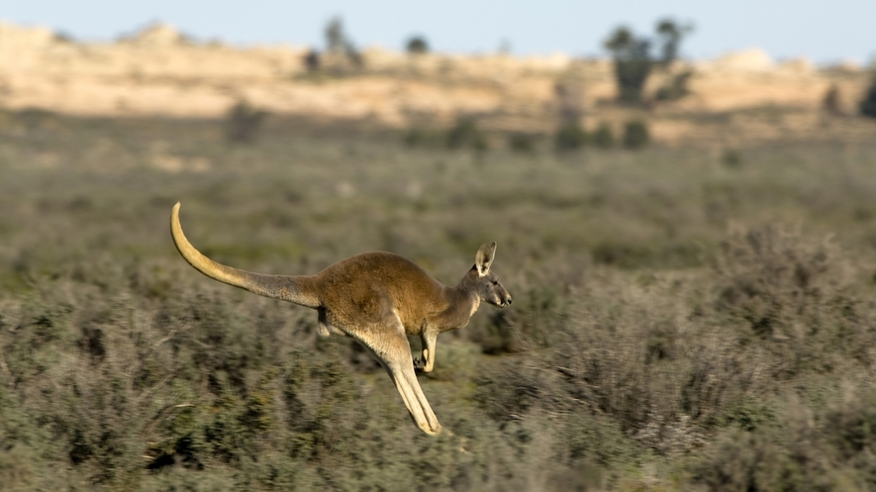
A red kangaroo hops across the open land in Australia's Mungo National Park.
Australia, the world's smallest continent, packs a powerful punch where wildlife is concerned. With tropical oceans, colorful rain forests and spectacular mountains, Australasia, and the nearby region of Oceania, have some of the most unusual and fascinating wildlife on Earth.

Hitting the Dance Floor with the Birds-Of-Paradise In New Guinea
High in the hilltop rain forests of New Guinea, you will find a dance floor devoted to an extraordinary creature: the bird-of-paradise. With feathers that extend from his beak, wings and head, the male of this family makes his own stage on a tree trunk or a patch of dry ground. He shows off his colorful plumage with special moves to attract females.
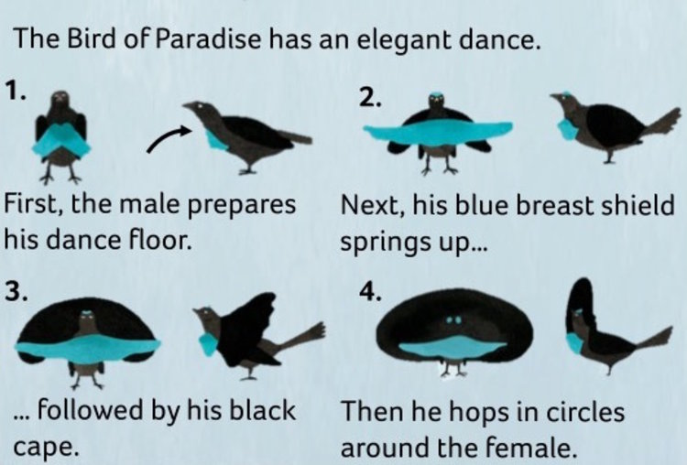
After meticulously preparing his dance floor, the male calls out to the ladies of the rain forest, letting them know the show is about to begin. Each species performs a unique dance: the superb bird-of-paradise fans out his plumage and snaps his tail feathers against each other as he hops around in circles. The western parotia species does a ballet-like dance, shaking his neck to show off his brilliant head feathers; the blue bird-of-paradise hangs upside down to create an arch with his long tail feathers. What a show!

Building With the Bowerbirds of New Guinea and Australia
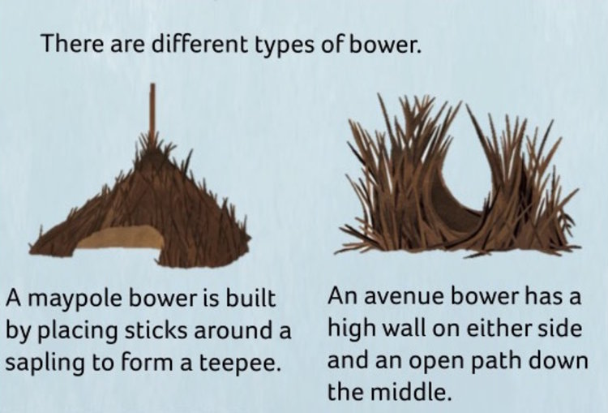
In the forests of New Guinea and Australia, one of the most unusual courtship rituals in the world takes place. Here, you may come across a master of building and home decoration: the bowerbird. This cousin of the bird-of-paradise shows off some unexpected skills to attract a mate. First, he builds a bower out of twigs. This isn't a nest — this is his showcase to impress the ladies! Once the bower is complete, the male decorates it with colorful objects. He spends hours scouring the forest for trinkets: berries, feathers, stones, flowers, and even bottle tops, drinking straws and other plastic knickknacks. To find a mate, a female tours the nearby bowers, checking to see which meets her high standards. Each time a female appears, the male puffs up his feathers, flicks his wings and makes buzzing noises, all in order to thrill her. The male with the most impressive bower and display is the one who will bag the most mates. May the best bird win!

Diving With the Platypus in Australia
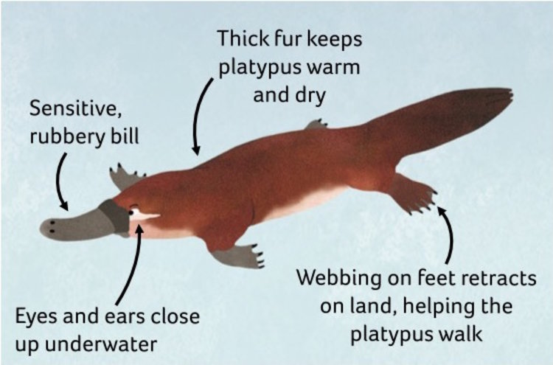
Which creature has the beak and flippers of a duck, the tail of a beaver, and the body of an otter? The platypus! The platypus is such a bizarre-looking animal that when specimens were first sent to Europe in the late 1800s, scientists thought they were stitched-together hoaxes. The platypus is perfectly designed for its watery life on the riverbanks of Australia. To hunt, it leaves its burrow and plunges beneath the water. It is a skillful swimmer, using its webbed front feet for power, and its back feet and tail for steering. As it paddles, it moves its rubbery bill from side to side like a metal detector. This bill is covered in sensors so the platypus can feel its way around and detect prey. It scoops up mouthfuls of insects, shellfish and worms from the riverbed, coming back to the surface to chew its meal.
The platypus's duck-like beak and flippers aren't the only strange things about this creature: It is also one of only two mammals on the planet to lay eggs!

Kick-Boxing with the Red Kangaroos in Australia
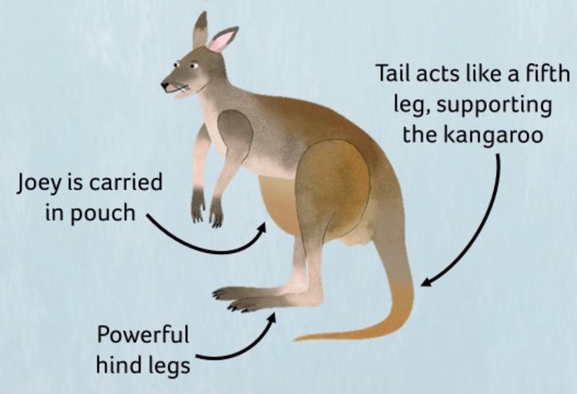
The Australian Outback is home to the country's most iconic animal: the red kangaroo. Temperatures in the Simpson Desert can reach over 122 degrees Fahrenheit, and water is in short supply, but the bouncing roos here have some cunning ways of beating the heat. In the warmest part of the day, they take cover in the shade, digging away the topsoil to rest on the cooler earth beneath. They also have a habit of licking their wrists to cool their blood vessels. But things really start heating up when it's time to choose a mate! In a battle over a female, rival males often come to blows. A kangaroo's best weapons are its muscular hind legs and enormous feet. When fighting, two males grapple with their forearms, then deliver powerful kicks with their hind legs. The loser will retreat to lick his wounds, while the winner gets the girl!
