The bright colors of the Great Barrier Reef are fading as the oceans warm By Ben Doherty and Christopher Knaus, The Guardian, adapted by Newsela staff
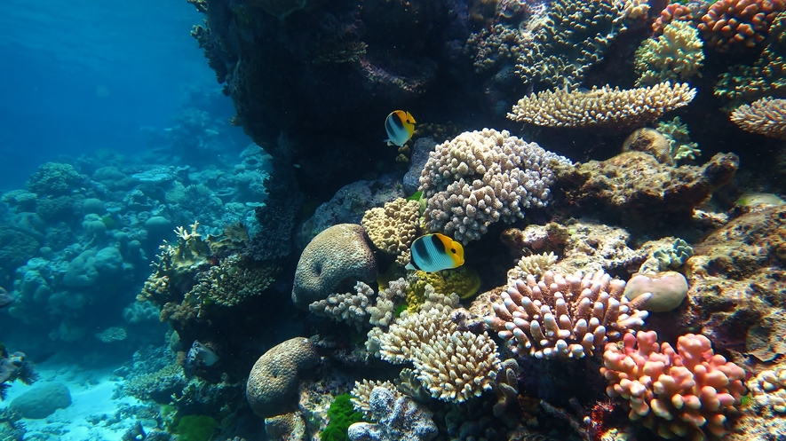
The Great Barrier Reef is a colony of brightly colored coral reefs and the largest living thing in the world. Coral is a plant-like creature that lives on the ocean floor. More than 1,500 different kinds of fish and countless plants make their home in the reefs.
These reefs are known for their bright colors. Lately, the colors have been fading. Since 2014, a huge stretch of the coral has turned bone-white, which scientists call "bleaching." The great reef is in danger of dying.

The Color of Coral or The Color Of Money
There is a new report from Australia's Climate Council that says we are likely losing more than just the reef's beautiful colors. Australian businesses will lose a lot of money, too.
People from all over the world visit the Queensland region of Australia every year. The Great Barrier Reef lives off the coast of Queensland. Visitors bring money to area businesses, which creates jobs in the tourism industry, such as for hotels and scuba-diving tour companies.
The Climate Council estimates that the loss of coral reefs could cost businesses worldwide about $1 trillion.
Losing the Great Barrier Reef alone will mean that 1 million fewer travelers come to Queensland each a year, the report says. This could put 10,000 jobs in danger of being lost. As much as $1 billion dollars could be lost from the economy.

A "Wake-Up Call"
The Earth is getting hotter. Higher heat from the sun is damaging the coral reefs. The heat is too stressful for the coral.
Much of the coral has turned from colorful purples and oranges into white. The white comes from the algae the coral releases. Bleaching has happened to the Great Barrier Reef in the past, but never for this long or this strongly.
The longer the bleaching lasts, the harder it is for reefs to heal.
This Climate Council report should be a “wake-up call” to fight climate change, said Lesley Hughes. She is part of the Climate Council.
The report shows that the reef should be appreciated for more than just its natural beauty, she said. It is also very valuable and creates jobs for people.

Reef Bleaching Will Keep Happening
Australia was recently hit by a storm called Cyclone Debbie. It cooled the water temperatures. This could help the reefs recover a little. But temperatures are expected to rise again.
Will Steffen is a climate scientist and a former professor at the Australian National University. He says bleaching events were likely to happen more often and get more severe in Australia over the next 20 to 30 years. This could hurt the long-term health of the reef and its ability to re-grow.
The only way to protect coral reefs is by stopping greenhouse gas emissions, Steffen said. Greenhouse gasses cause global warming.
Greenhouse gasses are released when we burn fossil fuels. Fossil fuels are natural fuels like oil, gas and wood.
Steffen says Australia is falling behind other countries in trying to fight climate change.
"We’ve got to stop and then reverse this trend and we’ve got to do it now,' he said.

The Government Thinks It Has A Plan To Help
This week, a government report was released about coral reefs.
The surveys show that two-thirds of the reef have been bleached. That is a stretch of reef about 500 miles long. Only the reef’s southern third has avoided bleaching.
The government has a long-term plan to save the reef by 2050.
Last month, the Australian government announced new ideas to stop bleaching. They are offering money to farmers to dump less nitrogen and sediment into the reef, said Josh Frydenberg. He studies the environment for the government. Nitrogen is a chemical sometimes used in farming.
The use of nitrogen can help plants grow better. However, it is terrible for the coral and can lead to too much algae growth. Algae is a water organism, like a plant. Some algae live within coral and make it colorful while other types of algae can compete with coral for space and nutrients.

Another Coal Mine Could Spell Trouble
The government is joining with businesses and towns to protect the Great Barrier Reef, Frydenberg said.
Adani is a huge company that wants to build a coal mine in the Galilee Basin, in Australia's central Queensland. It would not be far from the reef.
The country's government supports the construction of the mine. But environmental groups and climate scientists have argued it will increase greenhouse gasses. It could hurt local animals and water supplies, they say.
The reef's sea life depends on the coral to feed in and around it.

