"The Grapes of Wrath" and the Dust Bowl
By National Geographic, adapted by Newsela staff 10/04/2017
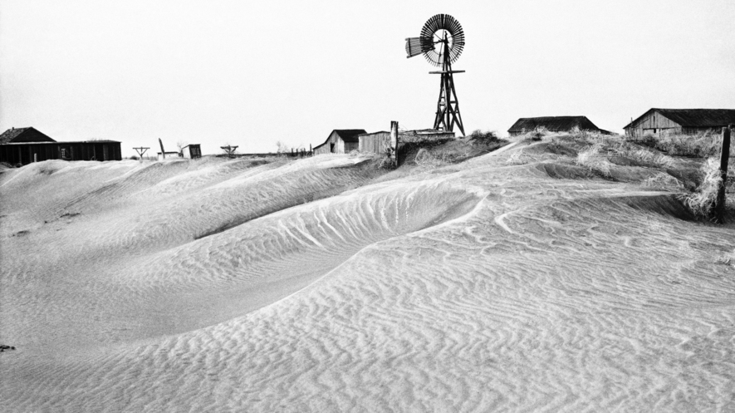Desolation in this part of the Dust Bowl is graphically illustrated by these rippling dunes banked against a fence, farmhouse, barn and windmill in Guymon, Oklahoma, in 1937. This property was abandoned by its owner when destructive dust clouds forced him to seek fortune elsewhere.
In 1939, author John Steinbeck published "The Grapes of Wrath." In the novel, Steinbeck writes about the Joads, a family of sharecroppers from Sallisaw, Oklahoma. They were forced to migrate west during the Dust Bowl years.
Steinbeck describes an important period in American history. Its setting is the Great Depression, the Dust Bowl and the American West. Steinbeck won the National Book Award and the Pulitzer Prize for "The Grapes of Wrath." He won the Nobel Prize for Literature in 1962.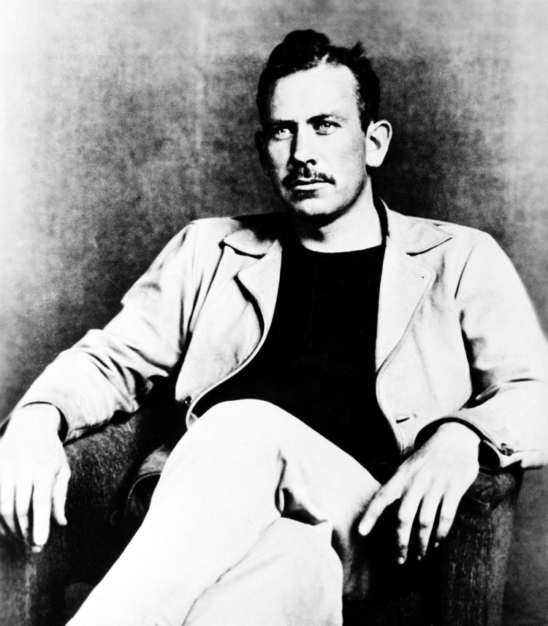American author John Steinbeck, winner of the 1940 Pulitzer Prize for his novel "The Grapes of Wrath," is seen in this undated photograph.

What was the Dust Bowl?
It is impossible to understand the Joads without understanding the Dust Bowl. The Dust Bowl was a series of dust storms brought on by drought and erosion in the Great Plains region in the 1930s. It was both a human and an environmental disaster.
Chad Kauffman is a professor of earth sciences at California University of Pennsylvania. He explains that drought was not the only factor at play, however.
"There was a human influence on the Dust Bowl, as well," he said. Farmers used bad agricultural methods and did not understand the nature of the Great Plains.
The region saw less rainfall than usual in the 1930s. It was really the modifications humans made to the landscape that led to erosion, though. Farmers plowed up native grasses, which exposed the topsoil. The deep roots of the grasses held the soil in place. Without the plants, the soil was exposed to the weather and blew away.
"We didn't understand how important natural grasses were to the ecology and physical landscape of the Great Plains," Kauffman said.
At the same time, the Great Depression was taking place. It was a worldwide economic collapse that left many families devastated, especially farmers. For many, the only choice they had was to leave and go to California.

Steinbeck's social lens on environmental history
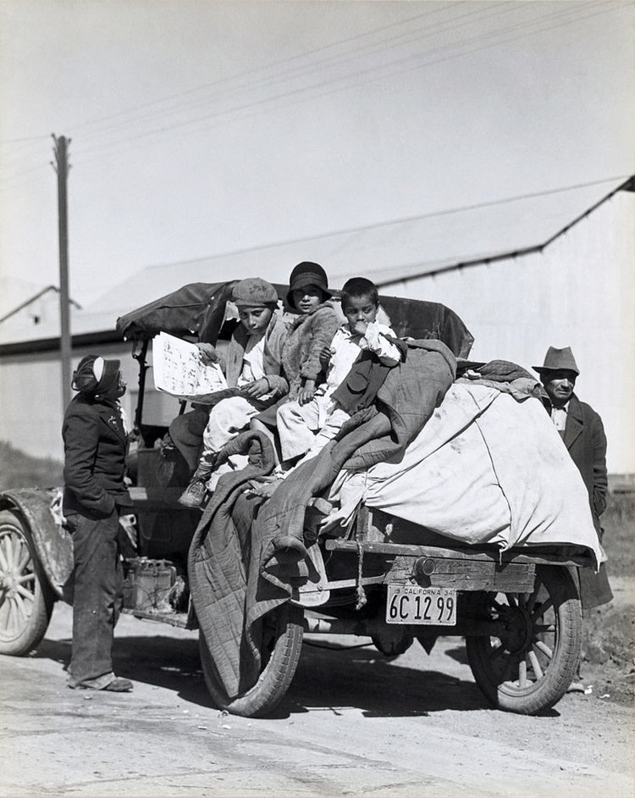
A migrant farm family in California, March 1935. They ended up in a rural rehabilitation camp for migrants in California.
Many of these families ended up in the Salinas Valley, where John Steinbeck lived most of his life. Some of the themes in his books are Dust Bowl migration, the creation of a Californian identity, and the human connection with the environment. These were all deeply personal topics for Steinbeck.
"This book is about a huge topic," said Susan Shillinglaw, a Steinbeck scholar and the author of "On Reading The Grapes of Wrath."
"It's about a migration of over 500,000 people coming into California and the environmental disaster that caused it. How do you write about weather patterns, drought, migration, and identity at once, as it is happening?"
Shillinglaw said Steinbeck met the challenge by telling the story of a family and wove in information that explained the larger cultural and historical context.
"He structured the book so that it moves from one family to many families, to the human experience," Shillinglaw said.
"The Grapes of Wrath" became very controversial. Congress held hearings that changed laws governing migrant camps.
In truth, though, families like the Joads faced awful living and working conditions throughout their migration.

Community reaction to migrants and the book
Lifelong Salinas’s resident Dorothy Wallace grew up next door to the Steinbeck family. Like Steinbeck and everyone else in her community, she saw migrant families like the Joads arrive in droves, many living in cardboard boxes in camps. She remembers how her community reacted to the migrants, and then to Steinbeck's book.
"If you were making money, you didn't like [Steinbeck]. If you were coming up through the classes, you were a fan of him. But even those that disliked him respected his writing. He just wrote things as they really were. I remember everything exactly as the way he wrote it," she said.
Wallace said that everyone disliked Okies, which was an insulting name for the migrants. "But his books helped people see that they were just here looking for work and trying to pull themselves up, and in the end they did."
She said that many of the migrants became very successful farmers in California, and then people's attitudes began to change.

California drought
"The Grapes of Wrath" still has a great influence today. California recently experienced a severe drought. Experts saw many similarities with the events in the book. It is not a bad idea to take notes from the past when moving toward the future.
As Ma Joad says in the book, "Up ahead they's a thousan' lives we might live, but when it comes it'll on'y be one."

