Welcome to 5th Grade Science!
Brewer Elementary School • Mr. Quinton Eberhardt • Eberhardt.quinton.j@muscogee.k12.ga.us • Room #13
Course Overview
Hello parents and students! I am the 5th grade Science Teacher and I am so excited to explore the world of science with your child. Our learning experience will be guided by the Georgia Standards of Excellence which require students to obtain, evaluate, and communicate what they learn in class in the real world. My goal is for all students to exit 5th grade having the knowledgebase and critical thinking skills to conquer other areas of science in middle school and beyond.
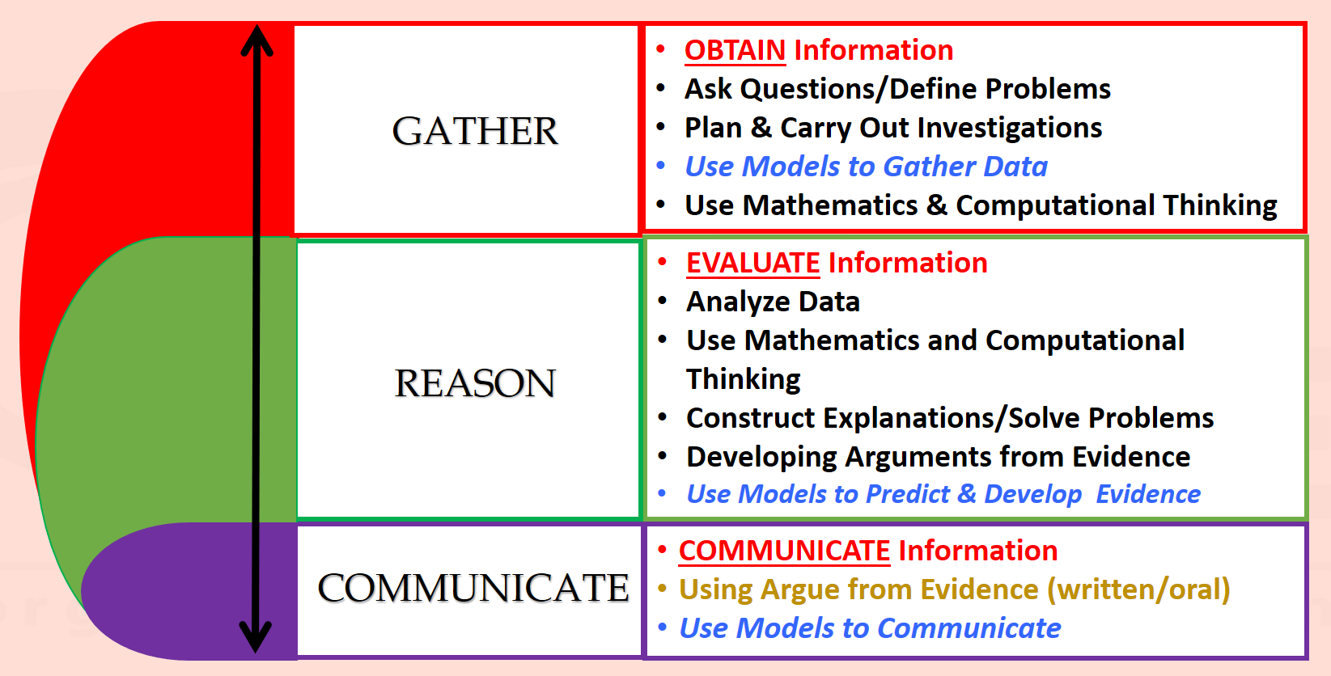
Classroom Expectations
In order to keep the classroom a safe and productive learning environment, please encourage your child to follow school/classroom expectations during the school day.
1. Be respectful. Respect all adults, respect your peers, respect your classroom, and respect yourselves.
2. Raise your hand and wait for permission to speak.
3. Stay in your seat unless you have permission to be up.
4. Keep hands, feet, and objects to yourself.
5. Follow directions the first time they are given.

Discipline Cycle
Step 1- Verbal or Nonverbal Warning
Step 2- Time out 10-15 minutes in another class with a reflection essay or assignment.
Step 3- Contact Parent (DOJO, call/text, note) and document.

Homework Policy
Homework will be given a minimum of one night out of the week. A due date will be posted at the top of the homework. It is important that your child completes their assignments when given. Practice outside the classroom is just as important. Individual homework assignments will not be graded, but students will receive an overall homework participation grade at the end of the nine week grading period.
Assignments, Quizzes, and Projects
The classroom will be 70% paperless. Assignments, quizzes, and some projects will competed through Canvas, www.kahoot.it , and www.quizizz.com. Assignments are to be completed within the given class period. It is the student’s responsibility to request to finish assignments; given they were on task during class time. Any incomplete assignments, quizzes, and projects will be graded accordingly. Parents will receive grades via the student’s take-home folder. It is the responsibility of the students to acquire and complete make-up assignments when they are tardy or absent.
Helpful Websites

- www.studyjams.com
- www.interactivesites.weebly.com/science.html
- www.ducksters.com/science/
- www.billnye.com/the-science-guy
- www.sheppardsoftware.com/science.htm

Arrival/Dismissal
- Breakfast begins at 7:15. This is the earliest your child should arrive to school as there will be NO staff to supervise until then.
- Students that arrive after 8:00 will be considered tardy. Parents/guardian must come in to check students in.
- Transportation: All changes in transportation MUST BE IN WRITING (or else they will be sent home the normal way).
- In case of an emergency, please call the office to notify us of a change at 706-748-2479.

Schedule
Teacher | 8:00-8:55 | 9:00-10:15 | 10:15-11:30 | 11:30-12:15 | 12:20-1:00 | 1:15-2:30
Boddie-Baker | Specials | Eberhardt  SCIENCE | Whittlesey  MATH | Walls  READING/ELA | Lunch | HR  SS
Whittlesey | Specials | Walls  READING/ELA | Boddie-Baker  SS | Eberhardt  SCIENCE |  | HR  MATH
Walls | Specials | Boddie-Baker  SS | Eberhardt  SCIENCE | Whittlesey  MATH |  | HR  READING/ELA
Eberhardt | Specials | Whittlesey  MATH | Walls  READING/ELA | Boddie-Baker  SS |  | HR  SCIENCE

What will we be learning?
AUG/SEP | PHYSICAL SCIENCE  S5P1. Obtain, evaluate, and communicate information to explain the differences between a physical change and a chemical change.  a. Plan and carry out investigations of physical changes by manipulating, separating and mixing dry and liquid materials.  b. Construct an argument based on observations to support a claim that the physical changes in the state of water are due to temperature changes, which cause small particles that cannot be seen to move differently.  c. Plan and carry out an investigation to determine if a chemical change occurred based on observable evidence (color, gas, temperature change, odor, new substance produced).
SEP/OCT | PHYSICAL SCIENCE  S5P2. Obtain, evaluate, and communicate information to investigate electricity.  a. Obtain and combine information from multiple sources to explain the difference between naturally occurring electricity (static) and human-harnessed electricity.  b. Design a complete, simple electric circuit, and explain all necessary components.  c. Plan and carry out investigations on common materials to determine if they are insulators or conductors of electricity.  S5P3. Obtain, evaluate, and communicate information about magnetism and its relationship to electricity.  a. Construct an argument based on experimental evidence to communicate the differences in function and purpose of an electromagnet and a magnet. (Clarification statement: Function is limited to understanding temporary and permanent magnetism.)  b. Plan and carry out an investigation to observe the interaction between a magnetic field and a magnetic object. (Clarification statement: The interaction should include placing materials of various types (wood, paper, glass, metal, and rocks) and thickness between the magnet and the magnetic object.)
NOV | EARTH SCIENCE  S5E1. Obtain, evaluate, and communicate information to identify surface features on the Earth caused by constructive and/or destructive processes.  a. Construct an argument supported by scientific evidence to identify surface features (examples could include deltas, sand dunes, mountains, volcanoes) as being caused by constructive and/or destructive processes (examples could include deposition, weathering, erosion, and impact of organisms).  b. Develop simple interactive models to collect data that illustrate how changes in surface features are/were caused by constructive and/or destructive processes.  c. Ask questions to obtain information on how technology is used to limit and/or predict the impact of constructive and destructive processes.  (Clarification statement: Examples could include seismological studies, flood forecasting (GIS maps), engineering/construction methods and materials, and infrared/satellite imagery.)
DEC/JAN | LIFE SCIENCE  S5L1. Obtain, evaluate, and communicate information to group organisms using scientific classification procedures.  a. Develop a model that illustrates how animals are sorted into groups (vertebrate and invertebrate) and how vertebrates are sorted into groups (fish, amphibian, reptile, bird, and mammal) using data from multiple sources.  b. Develop a model that illustrates how plants are sorted into groups (seed producers, non-seed producers) using data from multiple sources.  S5L2. Obtain, evaluate, and communicate information showing that some characteristics of organisms are inherited and other characteristics are acquired.  a. Ask questions to compare and contrast instincts and learned behaviors.  b. Ask questions to compare and contrast inherited and acquired physical traits. (Clarification statement: Punnett squares and genetics are taught in future grades.)
FEB/MAR | LIFE SCIENCE  S5L3. Obtain, evaluate, and communicate information to compare and contrast the parts of plant and animal cells.  a. Gather evidence by utilizing technology tools to support a claim that plants and animals are comprised of cells too small to be seen without magnification.  b. Develop a model to identify and label parts of a plant cell (membrane, wall, cytoplasm, nucleus, chloroplasts) and of an animal cell (membrane, cytoplasm, and nucleus).  c. Construct an explanation that differentiates between the structure of plant and animal cells.  S5L4. Obtain, evaluate, and communicate information about how microorganisms benefit or harm larger organisms. (Clarification statement: Possible microorganisms could include Tardigrades, Lactobacillus, Probiotics, Rotifers, Salmonella, Clostridium botulinum (Botox), E-coli, Algae, etc. Students are not expected to know these specific microorganisms. The list is provided to give teachers examples.)  a. Construct an argument using scientific evidence to support a claim that some microorganisms are beneficial.  b. Construct an argument using scientific evidence to support a claim that some microorganisms are harmful.

