

**Chemical Composition of Ocean Water**

**What does the word composition mean? __________________________________________________________________________________________________________________________________________________________________________**

**Label the diagram below using the power point.**



**Salinity**:

____________________ is the total amount of solid material dissolved in water. Because the proportion of dissolved substances in seawater is such a small number, oceanographers typically express ______________________ in parts per ___________________. Most of the salt in seawater is _______________________________, common ______________________________.

**From precipitation to the land to the rivers to the sea…**

The __________ that falls on the land contains some dissolved _________________________ from the surrounding air. This causes the rainwater to be slightly _____________________.

The rain ________________________ breaks down the rock and the acids _____________________ break down the rocks. Rain then carries the dissolved salts and minerals along as it flows. The __________ in the runoff are carried to the _______________ and _______________ and then to the __________________.

Many of the dissolved salts are used by __________________ in the ocean and are removed from the water. Others are not used up and are left for long periods of time where their concentrations _______________ over time.

**Salt from below…**

________________________________vents are recently-discovered features on the ocean seafloor that contribute _________________________________ to the oceans.

These ____________ are the “exit points” on the ocean floor from which sea water that has seeped into the rocks of the oceanic crust has become hotter, has ____________________ some of the minerals from the crust, and then flows back into the ocean.

**Eruption of Volcanoes Underwater…**

Similar to the previous process, during an underwater volcano __________________, seawater reacts with hot rock and some minerals are ___________________ into the sea water.

**Processes affecting salinity….**

Processes that decrease salinity:

_____________________________________________________________________________________

_____________________________________________________________________________________

Processes that increase salinity:

____________________________________________________________________________________

**Underwater Explorer**

Some parts of the ocean are too deep for ______________________ and so they must use special underwater equipment.

__________________ has been used to search for sunken ships, recover lost hydrogen bombs, and explore landforms on the ocean floor.

**Viewing the ocean floor with sonar….**

_____________ (sound navigation and ranging) is a technology based on echo-ranging behavior of bats.

We are can measure the ocean’s depth with sonar by sending high frequency sound ______________ to the ocean floor.

The _______________________________ off the ocean floor and back to the boat.

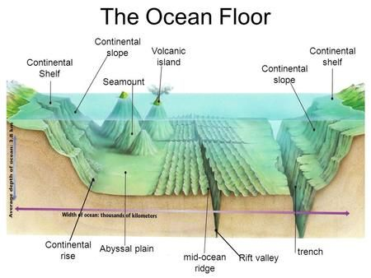

________________________________________ A gradually sloping area that edges each continent. It can range from a few kilometers to 1,300 kilometers.

________________________________________ The gradual drop off from the continental shelf that leads to the deep ocean floor. It reminds me of the transition from the shallow end to the deep end in a pool.

________________________________________The gently sloping base of the continental slope.

________________________________________ Relatively flat layer covered in a thick layer of sediment at the base of the continental rise.

________________________________________ Cone shaped undersea mountains of volcanic origins. The Hawaiian islands began as seamounts.

_________________________________________ Mountains of volcanic origins that have broken the surface of the water. An example are the Hawaiian Islands.

_________________________________________The deep undersea valley at the mid-ocean ridge.

_________________________________________ These are deep canyons caused at subduction zones in the ocean.

_________________________________________ The underwater mountain chain the winds through the ocean where divergent plate boundaries pull apart.