Tuesday
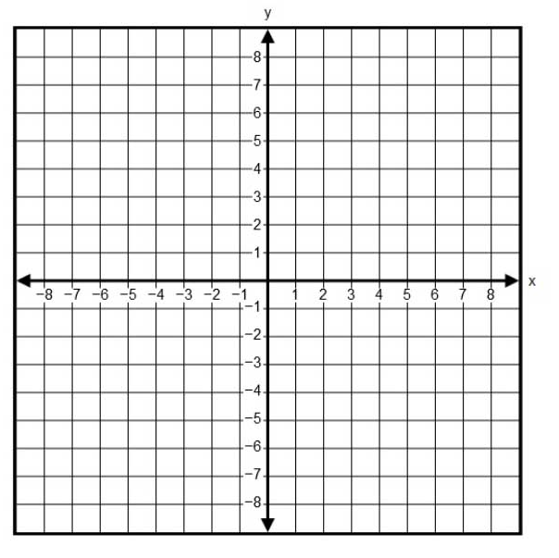  Solve by graphing.  $$y=-2x-5$$  $$y=-\frac{1}{4}x+2$$ | Solve by graphing  $$y=-\frac{2}{3}x-3$$  $$y=-\frac{8}{3}x+3$$
Solve by graphing  $$\left\{\begin{aligned}x+2y=6 \\ x-y=3\end{aligned}\right.$$ | Solve by graphing  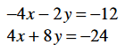
Solve using substitution:  $$y = 5x – 2$$  $$y = 3x + 8$$ | Solve the system using substitution.  $$-4x+3y=-7$$  $$y=2x-5$$

Wednesday
Solve each system using elimination.  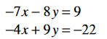 | Solve each system using elimination.  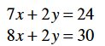
Solve each system using elimination.  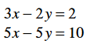 | Solve each system using elimination.  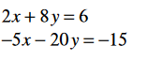
Solve each system using elimination.  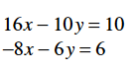 | Solve each system using elimination.  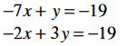

Thursday
The sum of two numbers is 47. Their difference is 19. Find the two numbers. | John has 60 coins consisting of quarters and dimes. The coins’ combined value is $9.45. How many quarters does John have?
During a Techno-Geek store sale, Ryder finds 6 blank video tapes and 12 blank DVDs cost $35.10. He then discovers that 8 blank video tapes and 3 blank DVDs cost $27.95. What is the cost of a blank DVD? | Tyler solves a system of equations and gets the answer 0 = -1. Does this mean that x = 0 and y = -1? If not, what does this answer mean?
If you graph a system of equations and have parallel lines, what is the answer?  If you solve a system and get an answer like: 8 = 8, what is the answer? | Cameron takes a test that is worth 100 points. Some questions are three points and some are worth eleven points. If there are 20 questions total, how many eleven point questions are there?

