Name: April 1-5 Teacher: Anders
Monday | Tuesday
If the function $m(x)$ goes through the point$(4, -6)$, then the function $m(x+5)$ must go through what point? | The function $y=-3x$ is reflected across the x-axis. What is the equation of the new function?
Use the arithmetic recursive rule to find the first five terms:  $$a_{n}=a_{n-1}-11$$  $$a_{1}=19$$ | Write a recursive formula for the sequence.  2, 6, 18, …
Is this sequence arithmetic? If so, what is the common difference? If not, why not?  $$\left(8x+1\right),\left( 6x+1\right),\left( 4x+1\right),…$$ | Write an explicit formula for the sequence.  4, 8, 16, …
Find the common difference and the next three terms of the arithmetic sequence:  $$-4, -7, -10, -13…$$ | Use the recursive geometric rule to find the first four terms:  $$a_{n}=-3∙a_{n-1}$$  $${ a}_{1}=\frac{1}{9}$$
Use the arithmetic explicit rule to find the first five terms:  $$a_{n}=5+\left(n-1\right)∙2$$ | Use the explicit geometric rule to find the first four terms:  $$a_{n}=3∙2^{n-1}$$
Use the arithmetic recursive rule to find the first five terms:  $$a_{n}=a_{n-1}-15$$  $$a_{1}=-20$$ | Use the recursive geometric rule to find the first four terms:  $$a_{n}=-2∙a_{n-1}$$  $${ a}_{1}=3$$
Write a recursive formula for the sequence.  1, 6, 11, 16, … | The number of infected zombies triples every hour. Write an explicit rule if there are 3 zombies in the first hour.  Use your rule to find the number of zombies after 15 hours.
Write an explicit formula for the sequence.

Wednesday
The function $y=2^{x}+6$ is shifted left 8 units and down 2 units. What is the equation of the new function? | If the function $t\left(x\right)$ goes through the point$(-3, -1)$, then the function $t(-x)$ must go through what point? | 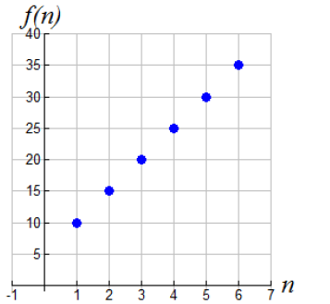  Write a formula for the sequence.
Convert the following explicit geometric rule into a recursive rule:  $$a_{n}=\frac{2}{3}∙6^{n-1}$$ | Convert the arithmetic recursive rule into an explicit rule.  $$a_{n}=a_{n-1}-7$$  $$a_{1}=9$$
Convert the following recursive geometric rule to an explicit rule:  $$a_{n}=-5∙a_{n-1}$$  $${ a}_{1}=4$$ | Convert the explicit arithmetic formula $a_{n}=8+\left(n-1\right)5$ into a recursive format.

Thursday

For each sequence below, write an explicit function. THEN, find the 50th term.
2, 6, 18, 54 …. | 2, 6, 10, 14, …
$$\frac{1}{81}, \frac{1}{27}, \frac{1}{9}, \frac{1}{3}, 1, …$$ | $$\frac{1}{2}, 1, \frac{3}{2}, 2, \frac{5}{2}, 3, …$$

