7th Grade English/Language Arts Syllabus
Mrs. Jones
Course Description
Seventh grade English Language is designed to foster students’ ability to read critically, write effectively, and communicate efficiently, providing the foundation for career opportunities. By reading various genres of literature, students will broaden, relate to, and share each other’s perspectives. Their voices will not only be heard through discussions about literature, but through their writing as well. Through encouragement, support, and fun, we will hopefully inspire our young writers and readers to become authors.

Course Outcomes
Areas of Study
Literature: Short Story, Novel, Poetry, & Non-Fiction
Writing: Narratives, Descriptive & Argumentative Essays, Literary Summary & Analysis Paragraphs & Essays
Grammar: Parts of Speech, Punctuation, Capitalization, & Spelling
Speaking: Oral Reading and Presentations, Debates & Skits

In accordance with each individual's capabilities and district, state, and national language arts standards, the student will:
- Identify the eight parts of speech and recognize correct usage of each grammatical form.
- Develop simple, compound, complex, and compound-complex sentences.
- Write narratives, expository, argumentative, and literary analysis essays.
- Develop proofreading techniques dealing with grammar, punctuation, spelling, and content.
- Define and utilize the elements of poetry, short story, novel, and non-fiction in critical analysis through writing.
- Expand vocabulary strategies and usage.
- Use a variety of reading strategies to summarize and evaluate a text.
- Deliver oral presentations.
9. Conduct research using various references.
10. Be given opportunities to participate in county, state, and
district writing contests.
Grading Scales:
A 90-100%
B 80-89%
C 70-79%
F 69% and
below

Grading System Categories
Formative Assessments: 50%
(Classwork/Homework)

Summative Assessments: 50%
(Performance Tasks/Tests)

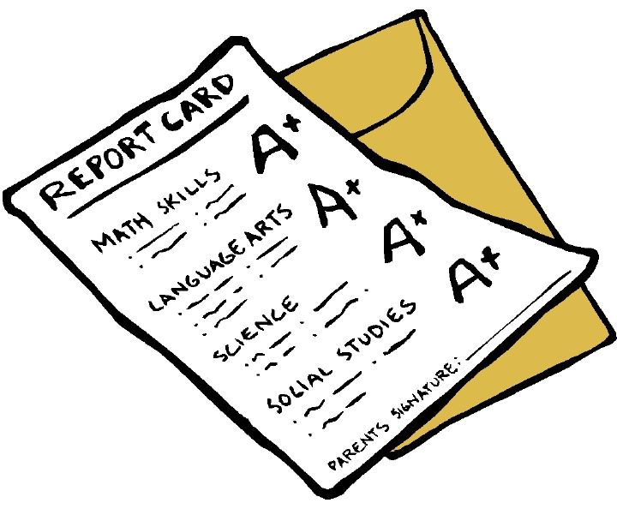
Assignment Policies:
Late Work

Assignments are expected on the due date. Late work will be accepted for full credit in the event of an excused absence only. You must turn in all late work within 3 days of your return. All other late assignments will receive a score no greater than 70. Daily assignments will be in the 7th grade folder located in the “Were You Absent” crate. It is the student’s responsibility to check the folder or Canvas for missing assignments upon their return to school. Additionally, it will be marked missing (m) in Parent/Student Portal. Please check your child's gradebook weekly.

Supply List (updated from Verification Day)
3-Ring Binder
5 Dividers
Paper
Pencils & Pens (Blue or Black)
Highlighter
Colored Pencils (recommended)
Glue stick (recommended)
Scissors (recommended)
Please choose one or two of the following for our ELA classroom (turn in for house points; not mandatory).
Glue sticks Hand Sanitizer
Sanitizing Wipes Paper Towels
Box of Kleenex

Contact Information
Jennifer Jones
Jones.Jennifer.T@muscogee.k12.ga.us
706-566-3801
Room 119
Planning- 6th period
Please feel free to contact me if you have any questions or concerns.

***For 5 extra credit points, please sign and return the bottom portion of this form no later than Friday, August 10, 2018.

Student Printed Name___________________________
Student Signature_______________________________
Parent Signature________________________________
Date__________________________________________

