**SGM Earth Science Review**

**Astronomy**: S6E1. Obtain, evaluate, and communicate information about current scientific views of the universe and how those views evolved.

**On your own sheet of paper, answer the following questions about astronomy:**

1. What are the geocentric and heliocentric models?
2. What type of galaxy is the Milky Way? Where is our solar system located in the Milky Way galaxy?
3. Compare the atmospheres of the four inner planets.

Mercury-

Venus-

Earth-

Mars-

1. What two factors work together to keep the Earth in orbit around the sun?
2. What is the Oort cloud?
3. How was Copernicus’s model of the universe difference than Ptolemy’s model?
4. What are the different parts of a comet?
5. What theory describes the formation of the universe? What does this theory state?
6. What is a quasar?
7. Compare and contrast asteroids, meteoroids, and comets.
8. Describes the contributions Tycho Brahe and Johannes Kepler made to modern astronomy.

**Choose the best answer for the following questions about astronomy:**

1. Venus has the highest surface temperature of all the planets in our solar system. Which is the best explanation for this?

A) Venus rotates on its axis very slowly.

B) Venus is very close to the Sun.

C) Venus revolves around the Sun relatively quickly.

D) Venus's atmosphere has thick clouds and carbon dioxide.

13. The asteroid belt is located between

A) the Sun and Earth. C) Neptune and Pluto.  
B) Mars and Jupiter. D) Saturn and Uranus.

14. Which planet is closest to the Sun?

A) Jupiter C) Venus  
B) Mars D) Mercury

15. We can be sure that the Milky Way galaxy we live in is a spiral galaxy rather than an elliptical galaxy because

A) it has curved arms. C) its stars are all about the same age.

B) it does not show any rotation. D) new stars are no longer forming.

16. How does the gravity on the Moon compare to the gravity on Earth?

A) Gravity is the same wherever you are. C) There is more gravity on the Moon.

B) There is less gravity on the Moon. D) Gravity depends on each person.

17. A hurricane-type cloud known as the Great Red Spot can be found on which planet?

A) Saturn C) Uranus

B) Mars D) Jupiter

18.

The chart shows the average distance of each planet from the Sun and the speed each planet travels in its orbit. Which conclusion should be drawn from this chart?

|  |
| --- |
| https://gofar.gadoe.org/QB/Temp/0bf90294-20a7-4112-943f-c76b98a1713e/Assessment/source/Content/images/mpsciaa61997.jpg |

A) The planets closer to the Sun travel around the Sun faster.  
B) The planets closer to the Sun absorb the Sun's energy and therefore move faster.  
C) The outer planets move slower because they are larger.  
D) The outer planets move slower because they have many moons.

19. The ozone layer in Earth's upper atmosphere is important to living organisms because it

A) absorbs harmful ultraviolet radiation from the Sun.  
B) breaks down harmful pollutants into normal atmospheric gases.  
C) supplies the oxygen living organisms require to carry on respiration.  
D) traps heat close to Earth's surface to maintain temperatures necessary for life.

20. NASA scientists recently discovered evidence of liquid water on

A) Venus. C) Jupiter.

B) Mars. D) the Moon.

21. Which planet has gases, land masses, and large amounts of surface water?

A) Earth C) Pluto

B) Mars D) Saturn

22. Terry was learning about an object in the Solar System that is made of frozen gases and solid rock. Which of these objects was she learning about?

A) a star C) a meteor

B) a comet D) an asteroid

23. Middle school science students in Georgia recorded the Sun's location in the sky every day at noon during September and February. Which of these MOST LIKELY describes what the students observed?

A) The size of the Sun changed. C) The force of gravity from the Sun changed.

B) The color of the Sun changed. D) The position of the Sun in the sky changed.

24.

This table shows data for major characteristics of the nine planets in the solar system. (One revolution is the length of time required for a planet to make one complete trip around the Sun; one rotation is the length of time required for a planet to make one complete turn on its axis.)

|  |  |
| --- | --- |
|  | Which of the following planets has the shortest day measured in Earth time? |

|  |
| --- |
| https://gofar.gadoe.org/QB/Temp/d1942112-0707-4f04-ba37-21ec731f6d9a/Assessment/source/Content/images/mpsciaa14168.jpg |

A) Pluto C) Jupiter  
B) Earth D) Mercury

25. The characteristics of objects in space vary greatly. A student constructs a table listing the characteristics of three objects found in space.  
  
Which data table has the characteristics of the objects listed correctly?

A) 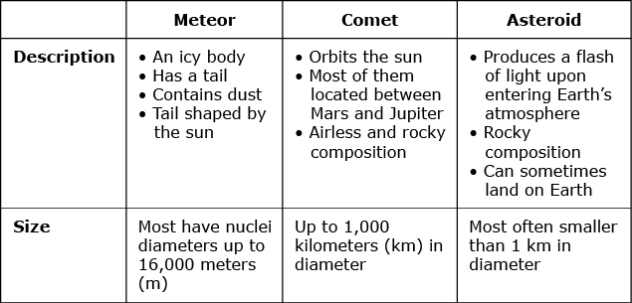 B) 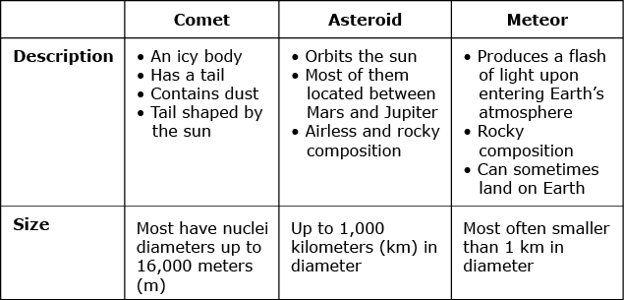  
  
  
C) 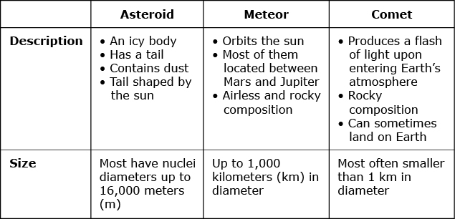 D) 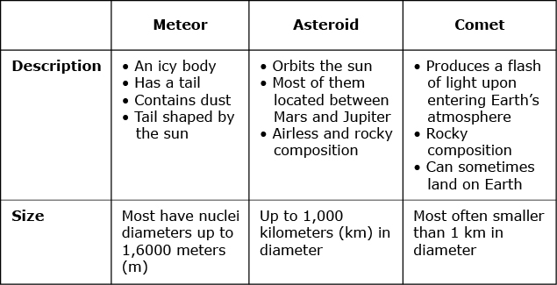  
  
  
26. The diagrams show the appearance of a comet at different distances from the Sun.

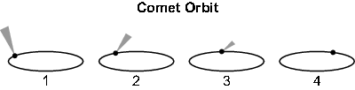

Which diagram shows the comet when it is closest to the Sun and why?

A) Diagram 1, because the Sun heats the ice and dust so it forms a tail  
  
B) Diagram 1, because the Sun heats the metal and rock so it forms a tail  
  
C) Diagram 4, because the Sun burns the ice and dust away so it has no tail  
  
D) Diagram 4, because the Sun burns the metal and rock away so it has no tail

27. Two students are investigating the conditions on Mercury. Their conclusions are shown in the chart. Which student is most likely correct?

A) Student 2, because all known living organisms need liquid water to survive  
B) Student 1, because the atmosphere on Earth is very similar to that on Mercury  
C) Student 2, because the rocks on Earth form in the same way as those on Mercury  
D) Student 1, because all living organisms need oxygen and carbon dioxide to survive

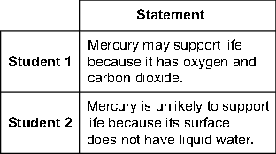

28. Juan's class is studying the Solar System. What causes the planets to orbit the Sun rather than drift off into space?

A) momentum C) the force of magnetism

B) the force of gravity D) heat energy from the Sun

29. Footprints made by astronauts on the Moon many years ago are probably still there because

A) the heavy astronauts left very deep footprints in the Moon's dust.

B) the dust on the Moon hardened into stone.

C) time passes much more slowly on the Moon.

D) the Moon has no weather.

30. Which planet is characterized by polar ice caps, a pink sky, a rust-colored surface, large volcanoes, and surface channels?

A) Uranus C) Mars

B) Pluto D) Saturn

31. Which picture demonstrates rotation?

A) 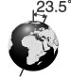 C) 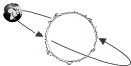  
  
  
  
B) 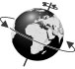 D) 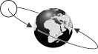

**Earth, Sun, and Moon**: S6E2. Obtain, evaluate, and communicate information about the effects of the relative positions of the sun, Earth, and moon.

**Answer the following questions about the Earth, Sun, and Moon:**

1. How many phases are there in a lunar cycle? What are they?
2. Why isn’t there a solar eclipse and a lunar eclipse every month?
3. What causes the moon to shine?
4. What are solstices and equinoxes? How are they related to the seasons?
5. Why do lunar eclipses only occur during a full moon?
6. How can you tell whether the moon is waxing or waning?
7. What is the difference between the umbra and the penumbra of an eclipse?
8. What is the difference between revolving and rotating?
9. Explain how the length of the day and year are related to Earth’s movement through space.
10. What causes the seasons?

**Choose the best answer for the following questions about the Earth, Sun, and Moon:**

1. A solar eclipse occurs when

A) Earth blocks the Moon from the Sun. C) the Moon blocks Earth from the Sun.

B) the first four planets are in a line. D) the last four planets are in a line.

43. When the Moon goes through Earth's shadow, we see a

A) solar eclipse. C) total eclipse.  
B) lunar eclipse. D) planetary eclipse.

44.

When the Sun, the Moon, and Earth are in the same line as shown, which of the following could occur?

|  |
| --- |
| https://gofar.gadoe.org/QB/Temp/8e9c835e-ea56-49e1-818f-2a8ffc3c2a73/Assessment/source/Content/images/mpsciaa14385.jpg |

A) an eclipse of the Sun C) The Moon could be pulled closer to Earth.  
B) an eclipse of the Moon D) The spin of Earth could be increased.

45. Why does the amount of daylight change during the course of a year?

A) The amount of light and heat radiated by the Sun changes at different times of the year.

B) The distance between the Sun and Earth changes from summer to winter.

C) The North Pole points more toward the Sun at one time of the year than another.

D) Earth rotates at different speeds at different times of the year.

46. Which change would result in the same season year-round, everywhere on Earth?

A) Earth moving at least twice as fast in its orbit as it does now

B) enlarging the diameter of Earth's orbit until it is much farther from the Sun

C) straightening the tilt of Earth's axis to be 90° to the plane of Earth's orbit

D) changing Earth's orbit so it would always be the same distance from the Sun

47. The average temperature in Atlanta in June is 25oC, but the average temperature in December is 7oC. Why is the average temperature in Atlanta higher in June than in December?

A) The Sun is hotter during June than it is during December.

B) Earth is closer to the Sun in June than it is during December.

C) Earth's axis is tilted so that Atlanta gets more direct sunlight in June than in December.

D) The atmosphere in Atlanta absorbs more heat from sunlight in June than in December.

48. There are about 24 hours in a day. What would happen to the length of a day if the rotation of Earth sped up?

A) The length of a day would be shorter. C) The length of a day would remain the same.

B) The length of a day would be longer. D) The length of a day would be unpredictable.

49. The Moon appears to change shape because

A) the Moon rotates. C) Earth revolves around the Sun.

B) Earth rotates. D) the Moon revolves around Earth.

50. Daylight in the Northern Hemisphere lasts longer in summer than in winter, and the change in the length of day happens in a predictable pattern. Which statement correctly explains this condition of Earth's environment?

A) The Sun moves closer to Earth in summer and farther away in winter.

B) Earth, with its tilted axis, moves around the Sun in a predictable way.

C) There is a predictable change in the amount of heat and light given off by the Sun.

D) Earth turns slower in summer than it does in winter.

51. It is about 28 days from one full moon to the next. This is because 28 days is about the time it takes for one

A) revolution of the Moon around Earth. C) rotation of the Sun.

B) revolution of Earth around the Sun. D) rotation of Earth.

52.   
  
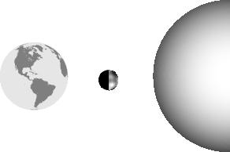

Look at the diagram below of the Sun, the Moon, and Earth. Which phase of the Moon would be seen by people on Earth?

A) full moon C) waxing gibbous  
B) new moon D) waning gibbous

53. Solar eclipses rarely occur because

A) the moon usually travels directly between Earth and the sun.

B) the moon's orbit is tilted in relation to the Earth's orbit.

C) the moon usually travels directly behind Earth.

D) the moon is too close to the earth.

54.

You observe the moon one night at midnight while camping, as seen in the image. Predict the location of the Moon in the diagram based on this observed moon phase.

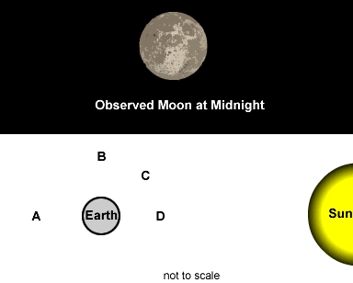  
  
A) A C) C  
B) B D) D

55.

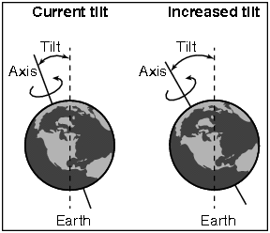

The diagram shows the current tilt of Earth as well as an illustration of how the tilt of Earth could change.

If the tilt of Earth changed as shown, how would seasons on Earth be affected?

1. Both winters and summers would be cooler.
2. Both winters and summers would be warmer.
3. Winters would be cooler, and summers would be warmer.
4. Winters would be warmer, and summers would be cooler.

56. Four students were studying lunar and solar eclipses. They recorded their descriptions in the table shown.

| **Eclipse Descriptions** | | |
| --- | --- | --- |
| **Student** | **Lunar** | **Solar** |
| 1 | Occurs when Earth comes between the Sun and the Moon | Occurs when Earth’s shadow falls on the Moon |
| 2 | Occurs when Earth comes between the Sun and the Moon | Occurs when the Moon’s shadow falls on Earth |
| 3 | Occurs when the Moon comes between the Sun and Earth | Occurs when Earth’s shadow falls on the Moon |
| 4 | Occurs when the Moon comes between the Sun and Earth | Occurs when the Moon’s shadow falls on Earth |

Which student is correct?

A) Student 1 C) Student 3  
B) Student 2 D) Student 4

**Hydrology**: *S6E3. Obtain, evaluate, and communicate information to recognize the significant role of water in Earth processes.*

**Answer the following questions about hydrology:**

1. What percent of Earth’s water is salt water? What percent is fresh water?
2. What are the three main steps of the water cycle? Explain each.



1. How does water return to Earth’s surface?
2. What is salinity?
3. Would cutting down trees effect the amount of evaporation in an area? Why or why not?
4. Why is so little of Earth’s water available for human use?



**Choose the best answer for the following questions about hydrology:**

1. What technology is used to measure the depth of the ocean?

A) submarines C) telescopes

B) radar D) sonar

64. On most ocean shorelines, the water rises slowly and covers the land twice a day. Then it slowly falls back. What is this movement called?

A) current C) tide  
B) wave D) drift

65. Ocean water differs from freshwater in that it has

A) a higher temperature. C) a higher concentration of sodium chloride.

B) a lower temperature. D) a higher concentration of silicon dioxide.

66. During the water cycle, when water vapor changes to liquid water, it is called

A) evaporation. C) freezing.

B) condensation. D) boiling.

67. Which two physical changes are essential processes in the water cycle?

A) oxidation and reduction C) mixing and separating

B) evaporation and condensation D) ebbing and flowing

68. Which of these BEST describes the cause of waves in the ocean?

A) high and low tides C) wind blowing across the surface of the ocean  
B) evaporation of water D) ridges and trenches on the bottom of the ocean

69. Which contains the greatest amount of Earth's freshwater?

A) groundwater C) lakes and rivers

B) oceans and seas D) glaciers and polar ice cap

70. The salts in the sea come from

A) weathering and erosion of rocks. C) particles falling from space

B) acid rain. D) organisms that live in the sea

71. What are the two dominant elements in Earth's atmosphere?

A) oxygen and carbon dioxide C) nitrogen and oxygen

B) hydrogen and helium D) silicon and hydrogen

72. Which step in the water cycle returns water to the atmosphere?

A) evaporation C) precipitation

B) condensation D) saturation

73. Water on Earth is found naturally as a solid, a liquid, and a gas. Where is MOST of the solid water on Earth?

A) deep in Earth's mantle C) in the outer atmosphere

B) in Earth's polar regions D) at the bottom of the ocean

74. Why are tides continually rising and lowering every day?

A) because deep ocean currents are constantly changing

B) because the position of the Moon is constantly changing

C) because rates of evaporation and precipitation are constantly changing

D) because the direction of the wind over the ocean is constantly changing

75. Ridges, tectonic plate boundaries, and hydrothermal vents are physical features found on our planet. Where are these features found MOST OFTEN?

A) in the middle of huge lakes C) at the bottom of Earth’s oceans

B) around the edges of deserts D) on top of mountains on continents

76. Which factor is MOST important in determining how much groundwater can be stored in underground rock?

A) the rock's location C) the rock’s hardness

B) the rock's porosity D) the rock’s geologic age

77. What are mid-ocean ridges?

A) They are areas where tectonic plates meet.

B) They are narrow valleys that run along the bottom of the oceans.

C) They are areas underwater where thick layers of sediment have accumulated.

D) They are areas of underwater mountain chains located near many active volcanoes.

78. Tropical seas have a high rate of evaporation. Because of this, the water in tropical seas will have higher:

A) wave crests. C) daily temperatures.

B) amounts of algae. D) salt concentrations

79.

Based on the data in the table, what is the most likely source of sample Y?

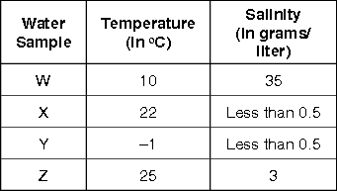

A) glacier C) ocean

B) lake D) river

80. Earth’s surface (including land, lakes, and rivers), the atmosphere, and the oceans are the parts of a system where water moves from one location to another in a process called the water cycle. Part of the water cycle is the formation of clouds as water changes form. Clouds can form at different rates depending on the atmospheric conditions and weather.

Which atmospheric condition or combination of conditions would MOST help clouds to form?

1. low humidity C) low temperature and high humidity

B) high temperature D) high temperature and low humidity

81. On a clear night, a student observes the ocean tides. She notices that the lit portion of the Moon is not visible.

Which best describes the tides the student will observe?

A) Both high and low tides will be at their lowest levels.

B) Both high and low tides will be at their highest levels.

C) High tides will be at their highest levels, and low tides will be at their lowest levels.

D) High tides will be at their lowest levels, and low tides will be at their highest levels.

82.

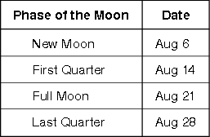

A student who lives near the seashore measures the level of the high tide each day and records it in a journal. The student then looks at a table showing the dates of the phases of the Moon.

On which days will the student's records show the highest tides?

1. August 6 and August 14 C) August 14 and August 28
2. August 6 and August 21 D) August 21 and August 28

**Meteorology**: S6E4. Obtain, evaluate, and communicate information about how the sun, land, and water affect climate and weather.

**Answer the following questions about standard four Meteorology:**

1. What are the 4 main layers of atmosphere? (Begin with the one closest to Earth)
2. Name the four types of fronts and describe the type of weather each brings.
3. How do thunderstorms form?
4. Give at least 2 important characteristics of **each** of the four main layers of the atmosphere.
5. Describe examples of conduction, convection, and radiation from your daily life.
6. How are mass and air pressure related?
7. Why do hurricanes weaken as they pass over land?
8. What is the greenhouse effect?
9. How does temperature change as height increases in the troposphere? Compare this to how temperature changes with height in the stratosphere.
10. How might Earth’s climates be different if Earth were not tilted on its axis?

**Choose the best answer for the following questions about meteorology:**

1. An air mass forms over the Gulf of Mexico and moves northeast across Georgia. What weather conditions are likely to prevail in Georgia?

A) cool and dry C) warm and dry

B) cool and humid D) warm and humid

94. Which is the warmest climate zone?

A) Arctic Zone C) Tropical Zone

B) Temperate Zone D) Intermediate Zone

95. Cold air masses that form at high latitudes are called

A) polar air masses. C) warm air masses.  
B) continental air masses. D) maritime air masses

96. Nearly 100 years ago, a large volcano erupted in the South Pacific. The following year, some northeastern cities in the United States recorded measurable snowfall every month of the year. Most of the Northern Hemisphere experienced a cold summer. Which explains how these events were related?

A) The eruption temporarily intensified the greenhouse effect.

B) Thermal energy released during the eruption caused a decrease in Earth's total heat energy.

C) The eruption damaged the ozone layer, causing a decrease in the amount of solar energy reaching Earth.

D) Atmospheric dust from the eruption caused a decrease in the amount of solar energy reaching Earth.

97. At the seashore late in the afternoon on a hot, sunny day, a person often feels a strong breeze coming in from the ocean. Which of the following is the reason for the breeze?

A) The pounding waves generate air currents.  
B) The warm air over the ocean rushes in to replace the cool air that rises over the land.  
C) The heavy, cool air over the ocean rushes in to replace the warm air that rises over the land.  
D) There are no clouds to block the wind coming in from the ocean.

98. Janet designed an experiment to determine whether the depth of water in a container had an effect on how quickly the water evaporated. In order to carry out her experiment, which variable would Janet need to change?

A) the amount of water in the container C) the location of the container  
B) the width of the container D) the material the container is made of

99. Suppose you are swimming in a lake when a thunderstorm approaches. Which of the following would be the **best** way to protect yourself from lightning?

A) diving underwater C) taking shelter in an automobile  
B) going fishing instead of swimming D) taking shelter under a tree

100. Which of the following is typical of a tropical climate?

A) cold, dry air C) hot, dry air  
B) cool, moist air D) warm, moist air

101.  
  
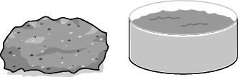

The picture below shows a large rock and a container of water. The rock and the water have the same mass and temperature.

What will MOST LIKELY happen when the rock and the water receive the same amount of heat energy?

A) The water will transfer heat to the rock. C) The temperature of the rock will rise faster.  
B) The rock will transfer heat to the water. D) The temperature of the water will rise faster.  
102.

Seattle, Washington is a highly populated city surrounded by the Pacific coast in the Northwest United States. Bismarck, North Dakota is a highly populated city in the North Central United States. They are both located at about the same latitude. Why does Seattle experience much less severe winters than Bismarck?

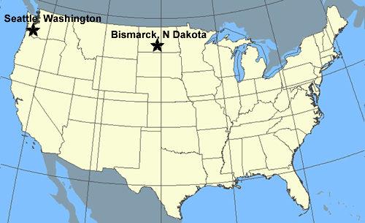  
  
A) Cold air masses settle away from bodies of water.  
B) It is warmer in the central part of the United States.  
C) The Pacific Ocean releases heat and keeps Seattle warmer.  
D) Seattle is slightly closer to the sun during the winter months.

**Geology**: S6E5. Obtain, evaluate, and communicate information to show how Earth’s surface is formed.

**Answer the following questions about standard five Geology:**

1. What are the 2 parts of the mantle called? What is a differing characteristic of each? (hint: think density)
2. What 5 characteristics must a substance have to be a mineral?
3. What are the three main types of rocks?
4. Compare and contrast mechanical and chemical weathering.
5. What is weathering? What is erosion? What’s the difference?
6. What is the theory of plate tectonics?
7. What are 2 things that scientists have learned from the fossil record?
8. What are the 5 agents of chemical weathering?
9. What are the 3 types of plate boundaries? Describe the type of movement that occurs at each type of plate boundary.
10. Why is it difficult to determine Earth’s inner structure?
11. Name 8 properties that can be used to IDENTIFY minerals.

**Choose the best answer for the following questions about geology.**

1. Cleavage of a mineral is related to a mineral's

A) chemical composition. C) luster.

B) streak color. D) crystalline structure.

115.

The diagram below shows the earthquake risks in a particular region. To minimize the damage to buildings during an earthquake, where should new buildings be built?

|  |  |
| --- | --- |
|  | https://gofar.gadoe.org/QB/Temp/c8f51e16-40d7-49fe-9f9f-adfe1731aebf/Assessment/source/Content/images/mpsciaa14689.jpg |

A) region A C) region C  
  
B) region B D) region D

116. Which kind of rock is formed when volcanic lava cools?

A) sedimentary C) igneous

B) metamorphic D) magma

117. Areas on Earth's surface that lie above the borders of tectonic plates are characterized by

A) frequent earthquake activity. C) stable temperate climate conditions.  
B) lengthy formations of sea arches. D) a lack of plant and animal life.

118. When Joe saw the Rocky Mountains for the first time, he exclaimed, "These mountains are much younger than ours back East!" Which feature supports his conclusion that the Rockies were relatively young mountains?

A) They have rounded tops. C) Weathering has not yet hardened the rock.  
  
B) Their sedimentary layers are still exposed. D) They have sharp peaks.

119. Rocks found on Earth are generally classified as sedimentary, metamorphic, or igneous. On which basis are these classifications made?

A) where the rocks are found C) the color and shape of the rocks  
  
B) how the rocks were formed D) the chemical composition of the rocks

120. The formation of metamorphic rocks depends on all of the following except

A) the composition of the parent rocks. C) temperature

B) Earth's magnetic field. D) pressure

121. There are several different layers in the soil along a bank of a creek. Two fossils are found in the bank, one near the bottom of the bank, close to the creek, and one higher up near the top. It can probably be said that the

A) fossil found near the bottom is older than the fossil found near the top.  
  
B) fossils are about the same age since they were found along the same creek.  
  
C) fossils could not have come from the same animal since they were separated.  
  
D) two different fossils are evidence of how animals adapt to their environment over time.

1. A boundary where two tectonic plates come together, or collide, is called a

A) divergent boundary. C) transform boundary.

B) convergent boundary. D) transfer boundary.

123. Earth's core is mainly composed of

A) iron and aluminum. C) iron and nickel  
  
B) silicon and hydrogen. D) silicon and oxygen.

124. Which accurately describes the relationship between earthquakes and volcanoes?

A) Earthquakes usually cause volcanoes to erupt.  
B) Volcanic eruptions usually cause severe earthquakes.  
C) Earthquakes and volcanoes often are located where tectonic plates meet.  
D) Earthquakes and volcanoes are not related in any way.

125. Which statement describes uniformitarianism?

A) In an undisturbed layer of rock, older rocks lie at the bottom and younger rocks lie at the top.  
  
B) The forces that act to change Earth's surface today are the same forces that acted upon Earth's surface in the past.  
  
C) The continents at one time were all part of a large landmass, but then they separated and moved apart.  
  
D) Layers of sedimentary rock contain more fossils than layers of metamorphic or igneous rock.

126.To find the absolute age of the fossil shells, the geologist would use

A) satellite imagery. C) seismic mapping.

B) radioactive isotopes. D) magnetic resonance imaging.

127.

|  |  |  |  |  |  |
| --- | --- | --- | --- | --- | --- |
| **mineral** | **hardness** | **way it breaks** | **luster** | **streak** | **Color** |
| Galena | 2.5 | cleavage | metallic | gray-black | silver, gray |
| Magnetite | 6 | fracture | metallic | black | Black |
| Hematite | 6 | fracture | metallic-dull | red-brown | red-brown, silver, black |

Susan wants to identify a dark, heavy mineral sample she found in the classroom collection. She notices there are three minerals in a chart in a reference book that might match her sample.

|  |  |
| --- | --- |
|  | Susan next observes that her sample mineral has flat, reflective surfaces that break into boxlike steps. She infers the mineral may be galena. If she is correct, one more test will verify her inference. Which property would to best for her to observe next? |

A) hardness C) streak

B) luster D) color

128. When rocks undergo weathering, they become

A) magma. C) sediment.  
  
B) igneous rocks. D) volcanic cones.

129. Igneous rocks are classified by where they are formed. Which type of igneous rock forms underground?

A) extrusive C) volcanic   
  
B) intrusive D) ash

130. When magma reaches Earth's surface it becomes

A) gas. C) energy.  
  
B) steam. D) lava.

131. The table shows the densities of Earth's layers.

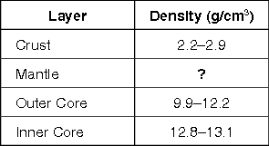

Which of these is most likely the density of Earth's mantle?

A) 1.5–2.2 g/cm3 C) 10.6–12.4 g/cm3  
  
B) 3.4–5.6 g/cm3 D) 13.5–15.2 g/cm3

132.

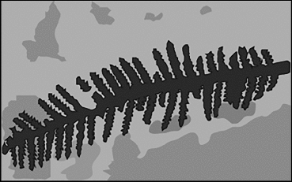

The diagram shows a leaf fossil that was found in Antarctica by a geologist. The geologist identifies the leaf as belonging to an extinct species that lived in near-tropical conditions.

Which of these BEST explains why a near-tropical plant fossil was found in Antarctica?

A) All of Earth had a much drier climate in the past, even the poles.

B) All of Earth had a much warmer climate in the past, even the poles.

C) Plate tectonics moved Antarctica away from where it was located when the leaf was alive.

D) Plate tectonics tilted Antarctica away from the Sun compared to when the leaf was alive.

**Conservation and Resources**: S6E6. Obtain, evaluate, and communicate information about the uses and conservation of various natural resources and how they impact the Earth.

**Answer the following questions about standard six Conservation and Resources:**

1. What is the difference between a renewable energy resource and a nonrenewable energy resource?
2. What are 3 ways to protect our natural energy resources?
3. What are two reasons that solar energy has not replaced energy from fossil fuels?
4. Why is soil valuable as a resource?
5. What are three possible effects of global warming?
6. What are hydrocarbons?

**Choose the best answer for the following questions about Conservation and Resources:**

1. Which of these objects was made from a nonrenewable resource?
2. paper bag C) cotton shirt
3. motor oil D) wooden table
4. Which of the following is a renewable source of energy?

A) Natural gas C) Oil

B) Coal D) Falling water

141. Wind power is not typically used to generate all of the electricity needed for large cities because the —

A) energy source is inconsistent. C) fuel expenses are too great.

B) waste products are unsafe. D) energy produced is not in a usable form.

142. A student is writing a report about an energy resource. She makes a list of information she finds.

• It takes millions of years to form.  
• It is formed by the decomposition of dead plants.  
• It is used as a fuel for power plants.

Which of these energy sources is the student studying?

A) wind C) sunlight   
  
B) wood D) natural gas

143. On sunny days, what causes the wind to blow from large bodies of water toward the neighboring land?

A) Earth's rotation on its axis  
  
B) Earth's revolution around the Sun  
  
C) unequal heating of the land and water by the Sun  
  
D) the gravity between the Sun and Earth's atmosphere

144. The figure shows the water cycle.

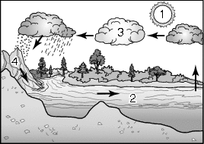

Which of these is the major source of energy that drives the water cycle?

A) 1 C) 3  
  
B) 2 D) 4

145. The graph shows the estimated availability of two different types of resources in the future.

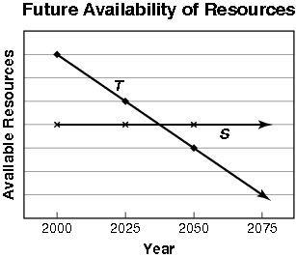

Based on the graph, which of these resources is most likely represented by line *S*?

A) oil C) wind  
  
B) coal D) natural gas

1. Two scientists performed independent investigations on electric school buses. At the end of their research, both scientists agreed that the use of electric school buses would help the environment.

Why did they most likely come to this conclusion?

A) It would help save metal, which is a renewable resource.  
  
B) It would help save plastic, which is a renewable resource.  
  
C) It would help save water, which is a nonrenewable resource.  
  
D) It would help save gasoline, which is a nonrenewable resource.

**Characteristics of Science**

**Choose the best answer for the following questions about the characteristics of science.**

1. What is an independent variable?
2. What is a dependent variable?
3. What is a control?
4. Mrs. Goodwyn wants to see if studying time affects test scores...She gives all 6 classes the same assignment but assigns different study times. What is the independent variable?
5. Study time C) Same assignment
6. Test score
7. Mrs. Goodwyn wants to see if studying time affects test scores...She gives all 6 classes the same assignment but assigns different study times. What is the dependent variable?
8. Study time C) Same assignment
9. Test score
10. Mrs. Goodwyn wants to see if studying time affects test scores...She gives all 6 classes the same assignment but assigns different study times. What is the control?
11. Study time C) Same assignment
12. Test score