Edgar Degas

Your Name_________________________________________ Class Period ____________Grade__________
Biography >> Art History
Occupation: Painter, Sculptor
- Born: July 19, 1834 in Paris, France
- Died: September 27, 1917 in Paris, France
- Famous works: The Dance Class, Dance Class at the Opera, The Bellelli Family, Two Dancers on a Stage, Orchestra Musicians
- Style/Period: Impressionism
Biography:
Where did Edgar Degas grow up?
Edgar Degas grew up in Paris, France where his mother was an Opera singer and his father a French banker. Edgar's parents had money and he was able to go to good schools growing up. His mother died when he was thirteen years old. Edgar showed a talent for drawing while young and wanted to become an artist.
Edgar's father loved the arts, but knew that it was a tough way to make a living. He wanted Edgar to become a lawyer. Edgar went to law school, but was soon begging his father to let him study as an artist. Eventually his father agreed to support his art career.
Learning to Paint
Edgar spent a lot of time at the Louvre, a famous art museum in Paris. He copied many of the masterpieces of classical artists like Raphael. He also attended art school at the School of Fine arts. Next, Edgar traveled to Italy to study artists like Michelangelo and Leonardo da Vinci. He stayed with his Aunt who was married to the Baron Bellelli. He later painted a famous picture of their family called The Bellelli Family.
Return to Paris
In 1859, Degas returned to Paris. He wanted to become a famous artist. Initially he painted traditional subjects including portraits and grand historical scenes. He submitted his paintings to the Salon. The Salon was the official art exhibition in France. In order to be considered a major artist, your paintings had to be accepted by the Salon. However, the Salon wasn't impressed with Degas' paintings.
Degas wanted to experiment and try new styles of painting. He wasn't interested in painting the same old thing that the Salon wanted. He began meeting with other artists who thought the same way. They wanted to paint ordinary scenes and explore light and color. This new group would soon be called the Impressionists.
Impressionists
When a number of new artists, including Degas, decided to part ways with the Salon and have their own art show, many people laughed at them. One critic said their paintings looked unfinished, as if they were "impressions" of a scene rather than finished paintings. The name stuck. Besides Degas, other artists that were part of this group included Claude Monet, Pierre Renoir, and Camille Pissarro.
Degas Style
Degas called himself a "realist". He wanted to paint scenes of real life and try to capture a moment, almost like a camera. His paintings may look spontaneous, but he spent a lot of time planning them out. He would study his subjects and make lots of sketches before starting on a painting.
Like many Impressionists, Degas liked to experiment with light, angles, and focus. Sometimes subjects would have their backs to the viewer or be cut off by the edge of the canvas. He would paint subjects off center and have them doing mundane things, like scratching their backs or even ironing clothes. He differed from many Impressionists in that he did not paint outdoors or study the effects of light on landscapes.
Ballet Dancers
One of Degas' favorite subjects was the ballet dancer. He loved to paint the dancers practicing in rehearsals or backstage before a show. He wanted to capture their energy and grace, but also their hard work and effort. During his career he created more than a thousand pictures of dancers.
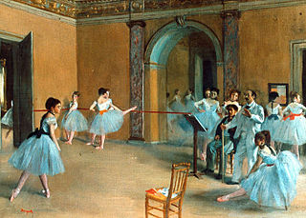
Rehearsal of the Scene
(Click image to see larger version)
Legacy
Most people know Degas as the painter of ballerinas. Art historians today consider him one of the founders of the Impressionist movement. Many of his paintings are in major museums throughout the world.
Interesting Facts about Edgar Degas
- When he was younger his family spelled their last name "de Gas". He changed it to Degas when he was older.
- His eyesight failed later in life making it difficult for him to paint with oils. During this time he painted using pastels.
- He very seldom considered a painting complete, always wanting to improve them.
- He was never married.
- His most famous sculpture is called The Little Fourteen Year Old Dancer. It is the only sculpture that he exhibited during his lifetime.
- He once said "Art is not what you see, but what you make others see."
More examples of Edgar Degas' Art:
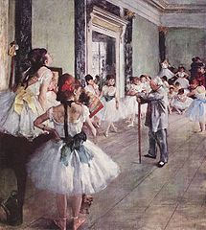  The Dance Class  (Click to see larger version) | 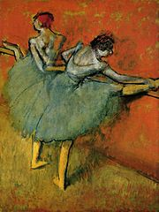  Dancers at the bar  (Click to see larger version) | 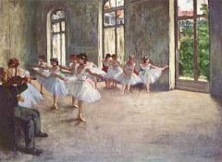  Ballet Rehearsal  (Click to see larger version)
