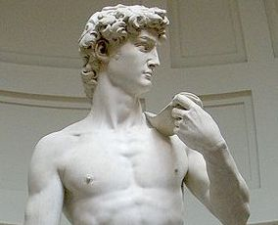
Michelangelo's David
MICHELANGELO – Your Name- ______________________________Grade______Period___

David became Michelangelo's most famous work of art. It is thirteen feet tall and was the largest statue made since Ancient Rome. It is considered by many experts in art to be a near perfect sculpture. Today the statue resides at the Academy of Fine Arts in Florence, Italy.
Sistine Chapel
In 1505 Michelangelo returned to Rome. He was commissioned by the Pope in 1508 to paint the ceiling of the Sistine Chapel. Michelangelo considered himself to be a sculptor, but agreed to paint the Sistine Chapel for the Pope. He worked for four years, painting upside down on a scaffold in order to finish the painting. The painting was huge (141 feet long by 43 feet wide). It contained nine scenes from the Bible down its center and over 300 people.
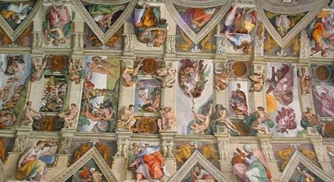
A part of the ceiling of the Sistine Chapel
The most famous of all the scenes is The Creation of Adam. At the center of the scene, God's hand and Adam's hand nearly touch. This is one of the most recreated scenes in all of art and, along with the Mona Lisa, is one of the most famous paintings in history.
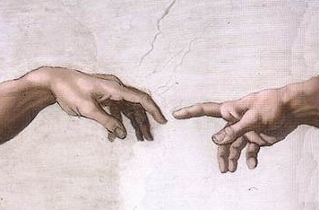  The Hands of God and Adam | 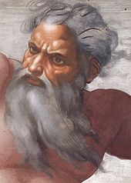  The Face of God
Architect
Advertisement | Report Ad
Michelangelo was a brilliant man of many talents. He also worked as an architect. In this way he was a true "Renaissance Man" along the lines of Leonardo da Vinci. He worked on the Medici Chapel, the Laurentian Library, and even the military fortifications of the city of Florence. Perhaps his most famous work was St. Peter's Basilica in Rome.
Interesting Facts about Michelangelo
- His full name was Michelangelo di Lodovico Buonarroti Simoni.
- When he was seventeen he was hit on the nose by fellow artist Pietro Torrigiano in an argument. His nose was severely broken as can be seen in the portraits we have of Michelangelo.
- He thought that the painter Rafael convinced the Pope to have him paint the Sistine Chapel out of jealousy over his sculptures.
- He also painted The Last Judgment, a famous painting on the wall of the Sistine Chapel.
- No two of the 300 people painted on the ceiling of the Sistine Chapel look alike.
- He was also a poet who wrote over 300 poems
Michelangelo was a brilliant man of many talents. He also worked as an architect. In this way he was a true "Renaissance Man" along the lines of Leonardo da Vinci. He worked on the Medici Chapel, the Laurentian Library, and even the military fortifications of the city of Florence. Perhaps his most famous work was St. Peter's Basilica in Rome.
Interesting Facts about Michelangelo
- His full name was Michelangelo di Lodovico Buonarroti Simoni.
- When he was seventeen he was hit on the nose by fellow artist Pietro Torrigiano in an argument. His nose was severely broken as can be seen in the portraits we have of Michelangelo.
- He thought that the painter Rafael convinced the Pope to have him paint the Sistine Chapel out of jealousy over his sculptures.
- He also painted The Last Judgment, a famous painting on the wall of the Sistine Chapel.
- No two of the 300 people painted on the ceiling of the Sistine Chapel look alike.
- He was also a poet who wrote over 300 poems.

