MONDAY
Use Order of Operations to simplify.  8 + 7(4² –3) | 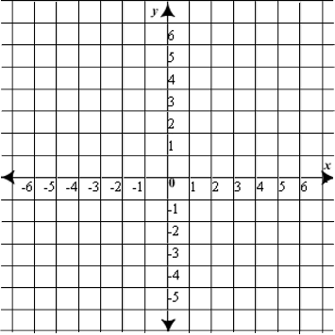  Plot the following points  (4,3); (--2,3); (-2,-1); (4,-1)
List the factors of 20.
Evaluate the expression if a = 3, b = 4 and c = 5  ab – c | Simplify.
Find the value of g.  g + 8 = 24 | Simplify.  6.7 + 3.2

TUESDAY
Use Order of Operations to simplify.  2³ – (30 ÷ 5) + 9 | Plot the following points to  create a rectangle. Find the  missing vertex.  (3,6); (-1,6); (-1,-6); ?
List the factors of 32.
Evaluate the expression if a = 3, b = 4 and c = 5  ab + ac | Simplify.  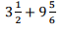
Find the value of m.  m – 7 = 11 | Simplify.  13.2 + 4.61

WEDNESDAY
Use Order of Operations to simplify.  (5+22) x (35–27) + 6² | Plot the following points and find the area of the figure.  (3,5); (-1,5); (-1,-3); (3,-3)
List the factors of 17.
Evaluate the expression if a = 3, b = 4 and c = 5  $$\frac{12c}{ab}$$ | 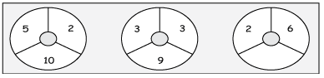  What number  goes  in the missing space?
Describe a situation that could model this number:  $$-30$$ | Find the value of g.  17 = g + 10

THURSDAY
Use Order of Operations to simplify.  7² + 3[81 – (4x6)] | Plot the following points to create a rectangle. Find the missing vertex.  (6,1); (-4,1); (-4,-3); ?
Classify the numbers below as rational, integers, whole numbers and natural numbers. List all that apply.

1.25

0

$$\frac{12}{3}$$

$$-6$$
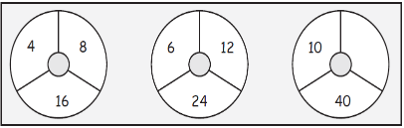
What number
goes in the
missing space?

Explain why the number 5 is a rational number. | Find the value of v.  5 = v – 4

