MONDAY
Find the length of the missing side 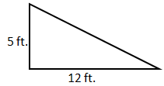 | Jeff is recovering from a torn ligament. He is able to walk 160 inches in 65 seconds. How many feet per minute can Jeff walk?
Find the quotient.  12 ÷ $\frac{5}{6}$ = | Using the problem above, how long would it take Jeff to walk 2500 feet?
.  How many days is 560,889 seconds? | Simplify the following:  Hint: squares and square roots are inverses of each other.  $$\sqrt{144x^{2}}$$
A gas station in the US is charging $1.299 per gallon of gas. What would this price be in Scotland if $1 equals 0.775 English Pounds and gas is measured in Liters? (Pound per Liter) | Simplify the following:  $$2\sqrt{81x^{2}}$$

TUESDAY
Mr. Two brought in cookies for his class. He gave out half of them in the morning. At lunch, he gave out 14 more. He then had 8 cookies left. How many cookies did he start with? | Simplify:  $$\sqrt{250}$$
Saffron, a spice from the flower of a crocus is the most expensive spice available. It costs $368.00 per ounce. Determine the cost per gram. (Hint: kg to pounds) | Simplify:  $$\sqrt{188}$$
Simplify:  $$\sqrt{68}$$ | Simplify:  $$\sqrt{20}$$
Simplify:  $$\sqrt{72}$$ | Simplify:  $$\sqrt{128}$$

WEDNESDAY
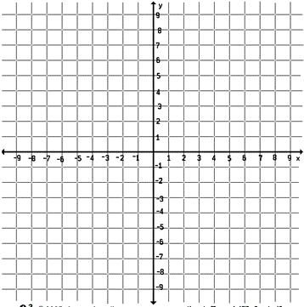  Graph the equation:  $y=2x-3$ | Graph the equation:  $$y=\frac{1}{2}x+4$$
Simplify the radicals without a calculator.  $$\sqrt{162}$$  $$\sqrt{725}$$ | Simplify the radicals without a calculator.  $$-2\sqrt{18}$$  $$5\sqrt{125}$$
Simplify the radicals without a calculator.  $$\sqrt{36x^{2}}$$  $$\sqrt{x^{3}y^{8}z^{5}}$$ | Convert 15 miles per hour to feet per second.

THURSDAY
Review: Simplify using exponent rules  $$\frac{x^{5}∙x^{3}}{x^{2}}$$ | Review: Simplify using exponent rules  $$2^{-3}∙2^{x}∙2^{x+2}$$
Review: Distribute to simplify the following:  $$3x\left(2x+6\right)$$ | Simplify:  $$\sqrt{188x^{7}y^{8}}$$
Simplify the following:  $$\sqrt{280x^{2}}$$ | Simplify  $$\sqrt{14}∙\sqrt{7}$$
Simplify the following:  $$2\sqrt{80x^{3}}$$ | Simplify:  $$\sqrt{18}∙\sqrt{2a^{2}}$$

